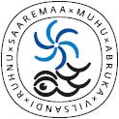
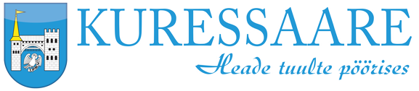
Smart Island Project
Baltic Sea Islands –Saaremaa Island – Estonia

Programme (tbc) - Meeting and technical visits*
27 June 2016

Day 1 – Mission

7h pick up at the hotel

09h05 Ferry from the mainland to the island

10h45 Part I- Saaremaa and smart solutions, Merikotka 35, Kuressaare
- Welcome address and presentation by Mr. Rainer Paenurk
- Presentation of the project entitled "smart islands" by EESC Members
- How SPA-tourism is developed at Saaremaa by Grand Rose SPA head of reception Ms. Helen Kruut
- Smart maritime solution „Marina Ahoy“ by Mr. Hannes Koppe
- NGO Islands Co-operation Board, "Made in Saaremaa"

12h -12h30 Exchange of views: "Smart islands turn educational and social"

13h- 14h Visit #1 - Baltic Workboats/shipyard

14h – 14h45 Lunch break

15h – 16h Visit #2 - VIRTU/ELVI social care via electronic means

16h – 18h Visit #3 - Small craft competence centre

18h-19h Visit #4 - Angla Windmill Mount

19h Diner

Day 2 – Optional Return with morning ferry back to the mainland

Morning Flight departure to Brussels

13h – 14h Meeting at Estonian Ministry in charge of Public Administration and regional development (currently under Ministy of Finance)

18h05 Flight departure to Brussels

* The working language will be EN. Interpretation is arranged for 27th June.

EESC Participants
- Mr. Meelis Joost
- Mr. Charles Vella
- Mr. Petr Zahradnik
- Mr. Cédric Cabanne, Adminstrateur, EESC Secretariat

