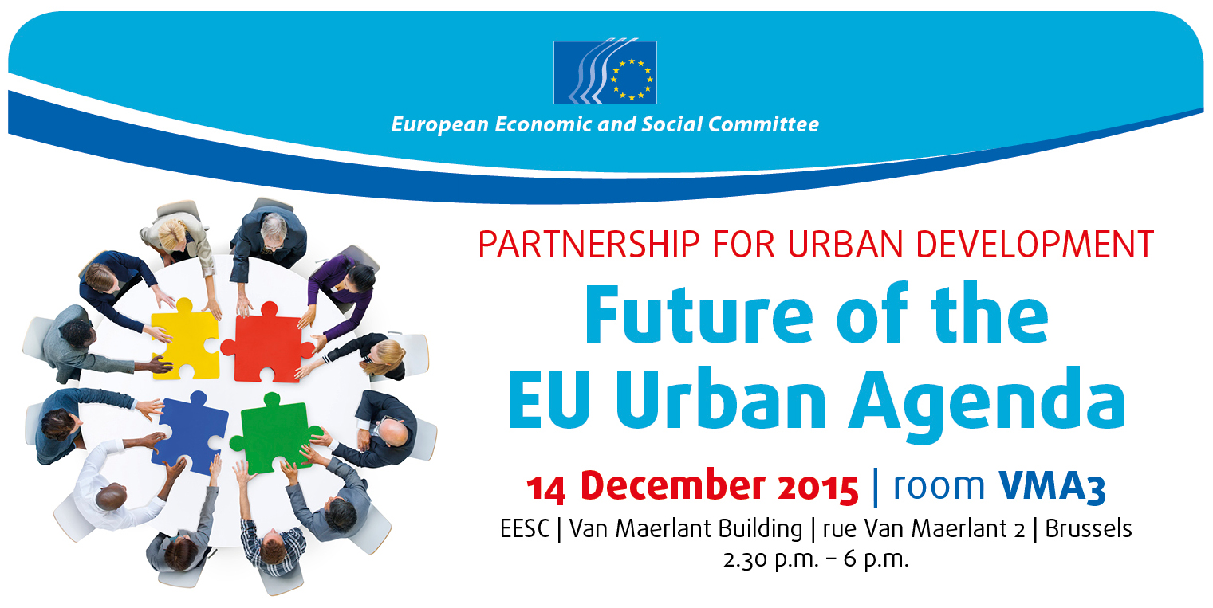
14.30 | Welcome address and introduction  - Joost van Iersel, President of the ECO Section, European Economic and Social Committee (EESC)  Keynote speaker:  - Nicolaas Beets, Dutch Urban Envoy, Ministry of the Interior and Kingdom Relations in the Netherlands
14.45 | The role of civil society organisations in the EU Urban Agenda  Kick-off statement: Ivan Tosics, Principal, Metropolitan Research Institute  - Lambert van Nistelrooij, Vice-president of URBAN Intergroup, European Parliament  - Olivier Baudelet, Team leader in charge of urban policy, DG REGIO – European Commission  - Bas Verkerk, Rapporteur of the opinion "Towards an Integrated Urban Agenda for the EU", Committee of the Regions  - Barbara Steenbergen, Head of office, International Union of Tenants, member of EESC Liaison Group  Moderator: Joost van Iersel, President of the ECO Section, EESC  Debate
16.00 | The implementation of a partnership-based EU Urban Agenda  Kick-off statement: Peter Ramsden, Pole Manager, URBACT  - Alberto Marchiori, Delegate for EU Policies, Confcommercio, Italy  - Claude Denagtergal, Advisor, European Trade Union Confederation  - Jan Olsson, Co-President, Reves – European Network of Cities and Regions for the Social Economy, delegate to the EESC's Consultative Commission on Industrial Change  - Christian Saublens, former Director, Eurada  - Levente Polyak, Managing Director, Eutropian  Moderator: Stefano Palmieri, President of Study Group "Future of the EU Urban Agenda", EESC  Debate
17.30 | Conclusions  - Roman Haken, Rapporteur of the opinion "Future of the EU Urban Agenda", EESC
18.00 | Small reception
Interpretation from ES/CS/EN/FR/IT/RO to CS/EN/FR/IT/RO

