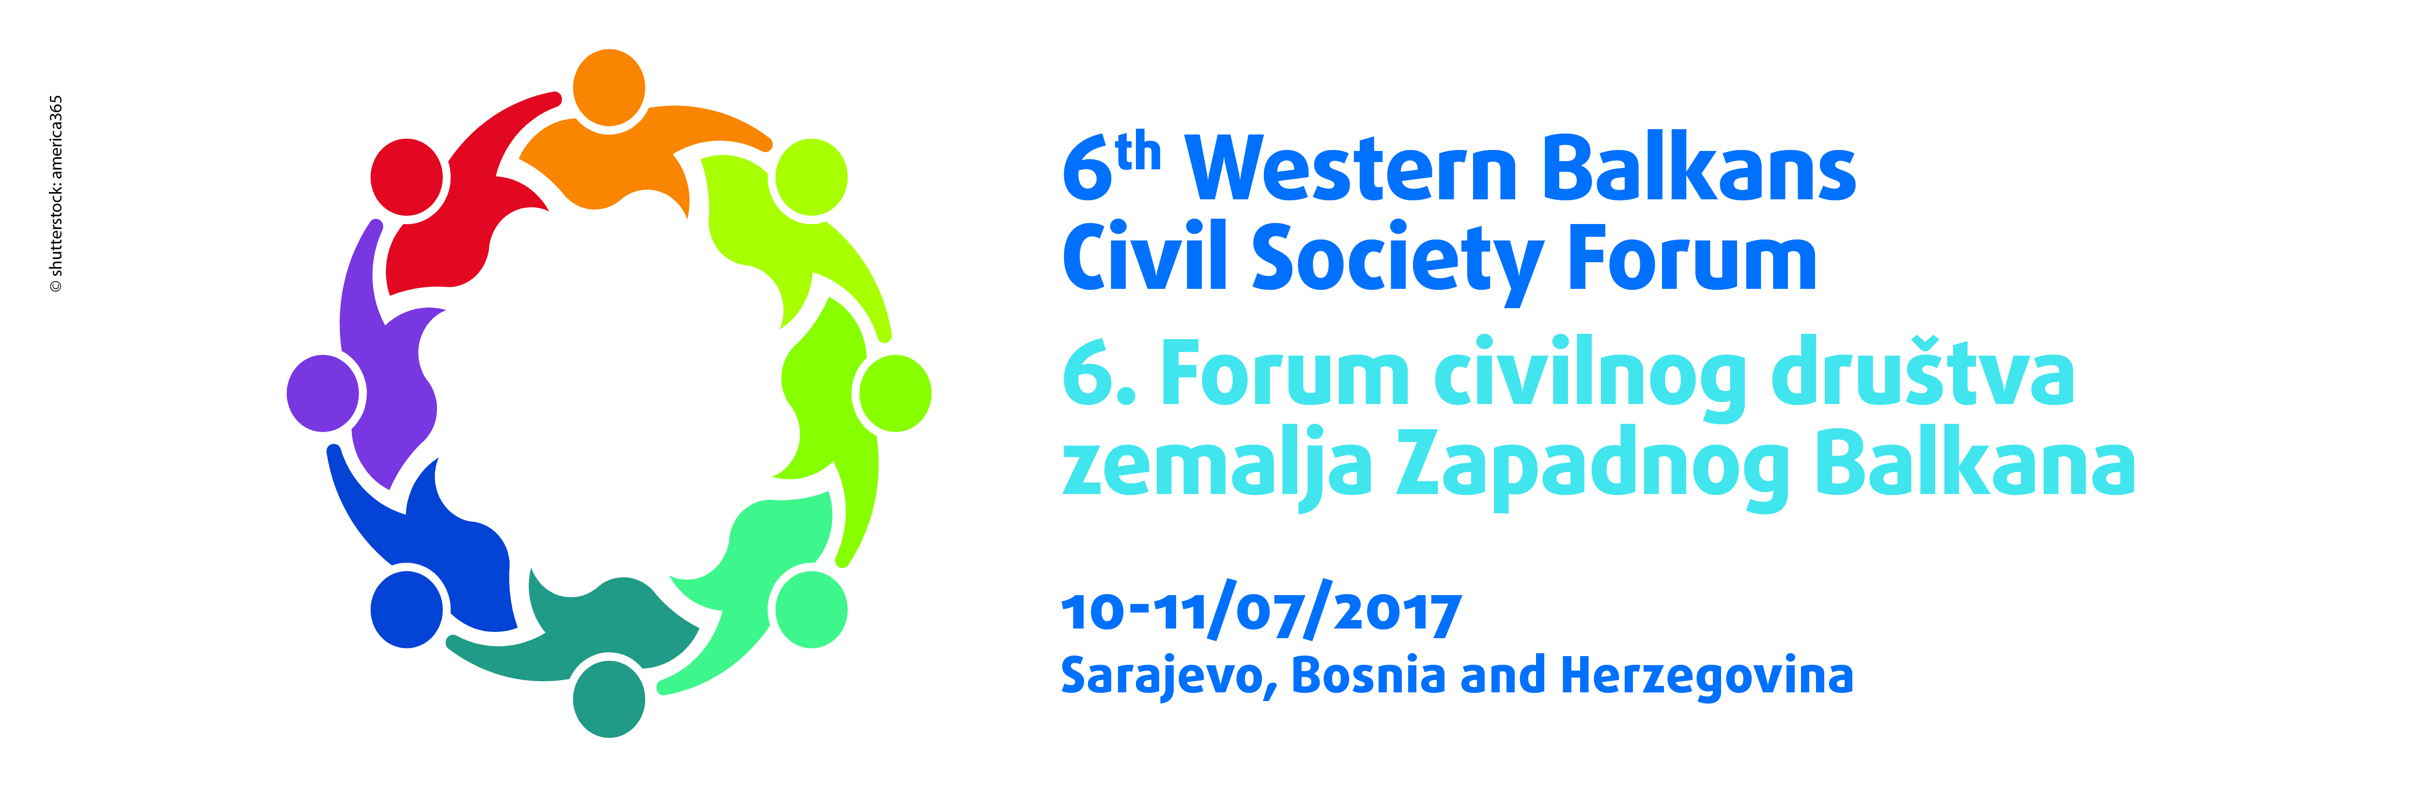

PROGRAMME

EN
First day
8 a.m. |  | Preparatory meeting with panel chairs
9 a.m. |  | Registration of participants
9.30 a.m. |  | Inaugural session  Welcome addresses:  - Milan Trivić, Deputy mayor of Sarajevo  - Andrej Zorko, President of the EESC's Western Balkans Follow-up Committee  Inaugural speeches:  - Georges Dassis, EESC President  - Goran Svilanović, Secretary General of the Regional Cooperation Council  - Srđa Keković, Secretary General of Union of Free Trade Unions of Montenegro  - Morten Jung, Senior Adviser for the Western Balkans, European Commission  QUESTIONS AND ANSWERS
11 a.m. - 11.30 a.m. |  | Coffee break and press conference
11.30 a.m. - 1 p.m. | State of play: assessment and perspectives of the relations between the EU and the Western Balkans  Chair: Ionuţ Sibian, EESC member  - Jan Snaidauf, Head of Political and Economic Section in the EU Delegation to Bosnia and Herzegovina  - Bojana Selaković, Programme manager, Civic initiatives, Serbia  - Aida Daguda, Director, Center for Promotion of Civil Society, Bosnia and Herzegovina  DISCUSSION
1 p.m. - 2.30 p.m. | Lunch at the invitation of the EESC
2.30 p.m. - 4.30 p.m. | The role of social partners and other civil society organisations in promoting sustainable growth and employment  Chair: Samira Nuhanović Ribić, Director of Social Business Incubator at Mozaik Foundation, Bosnia and Herzegovina  - Aleksandar Krzhalovski, Executive Director, Macedonian Center for International Cooperation  - Nebojša Atanacković, President of Serbian Association of Employers  - Ismet Bajramović, President of the Confederation of Independent Trade Unions of Bosnia and Herzegovina  - Antonio Graziosi, Director of ILO Decent Work Technical Support Team and Country Office for Central and Eastern Europe  DISCUSSION
4.30 p.m. - 4.45 p.m. | Coffee break
4.45 p.m. - 6.30 p.m. | Migration in the Western Balkans – what role for the civil society?  Chair: Dilyana Slavova, EESC member  - Vladimir Petronijević, Executive Director, Group 484, Serbia  - Delfinë Elshani, Group for Legal and Political Studies, Kosovo  - Ivica Sivrić, Association for the Economic Development of Herzegovina (REDAH)  - Peter van der Auweraert, IOM Sub-regional Coordinator for the Western Balkans  DISCUSSION
 | End of Day 1
6.30 p.m. | Cocktail offered by the Regional Cooperation Council and the European Economic and Social Committee

Second day
9 a.m. - 10.30 a.m. | Freedom of expression and media in the Western Balkans  Chair: Radka Betcheva, Senior Project Manager, European Broadcasters Union  - Momčilo Radulović, President of European Movement Montenegro  - Naser Selmani, President of Association of Journalists of Macedonia  - Dinko Gruhonjić, Programme Editor, Independent Journalists Association of Vojvodina, Serbia  - Ilina Neshikj, Executive Director, Balkan Civil Society Development Network  DISCUSSION
10.30 a.m. - 10.45 a.m. | Coffee break
10.45 a.m. - 12.15 p.m. | Rights and empowerment of women in the EU and in the Western Balkans  Chair: Zoran Mihajlović, Vice-president of Confederation of Autonomous Trade Unions of Serbia  - Nora Latifi-Jashari, Executive Director, GAP Institute, Kosovo  - Aleksandra Petrić, Executive Director, Udružene žene, Banjaluka, Bosnia and Herzegovina  - Madi Sharma, EESC member  DISCUSSION
12.15 p.m. | Adoption of the Final Declaration  Chair: Andrej Zorko, President of the EESC's Western Balkans Follow-up Committee  - Presentation of the Forum conclusions

Useful information:
Meeting venue: Holiday Hotel Sarajevo, Bosnia and Herzegovina
Interpretation: FR, MK, EN, BS-HR-SR and SQ into FR, MK, EN, BS-HR-SR and SQ
Twitter: #EESC_WBForum

