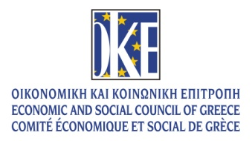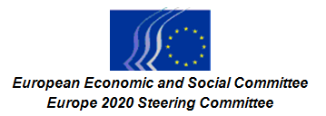
EN

Reforms needed to re-launch Greek competitiveness

3 October 2016

Venue: Economic and Social Council of Greece
9, Amvr. Frantzi Str., Athens

Draft Programme

9.30–10 a.m. Welcome of participants and coffee

10–10.50 a.m. Opening Remarks

George Vernicos, President of the Economic and Social Council of Greece (ESC of Greece)
Georgios Dassis, President of the European Economic and Social Committee (EESC)
George Katrougalos, Minister of Labour, Social Security and Social Solidarity
Dimitris Dimitriadis, Vice-president of Europe 2020 Steering Committee

First Session
10.50 a.m.–12.30 p.m. Τhe need for a new business environment: fewer barriers, more investment and quality employment

The first session concentrates on the business environment, support for SMEs, financing and options for cutting red tape. Attention has to be paid to opportunities created by developing the green economy, using renewable energy and following sustainable development principles in the reform process. The focus will be on tools to help the economy to become competitive. The overarching question is what makes the economy (and enterprises) produce more and better jobs? How can the conditions for them be improved?

- Investment and growth:, changing the economic policy of the Eurozone, Carmelo Cedrone, EESC member
- Policy reforms to promote private productive investment, speed up recovery and create new jobs, Harry Kyriazis, member of the Executive Committee of the ESC of Greece
- Removal of barriers for SMEs' access to financing, Dimitris Dimitriadis, EESC member (rapp for ECO/372 Access to finance for SMEs)
- Development prospects for key sectors of the Greek economy, Georgios Kavathas, President of the Hellenic Confederation of Professionals, Craftsmen & Merchants (GSEVEE)
- The transition to the circular economy: challenges and opportunities for a major boost to competitiveness, European Commission representative (tbc)

Chair: Georgios Goniotakis, Vice-president of the ESC of Greece

Public Debate

12.30–2 p.m. Standing buffet lunch

Second Session
2–3.40 p.m. The social aspects of competitiveness

The second session will take an in-depth look at employment, social security and the status of social services. As Greece has the lowest employment rate in the EU (49.5%), it is most urgent to find labour market tools to stimulate employment. How to address youth unemployment and how to develop partnerships between civil society and universities in designing more content for education that matches the skills needed in the labour market. Further insight could be given on social innovation and social investment to develop human capital in view of greater convergence.

- The importance of investment in employment and social policies, Adam Rogalewski, EESC member
- Social Partners' views on the Greek Labour Market Reforms, Giannis Panagopoulos, President of the General Confederation of Greek Workers (GSEE) and Vassilios Korkidis, President of the Hellenic Confederation of Commerce (ESEE)
- Opinion of the ESC of Greece on the Reform of the Social Security System, Georgios Karanikas, Vice-president of the ESC of Greece
- Tackling youth unemployment and the role of civil society in redesigning the transition from education to training and employment, Panagiotis Gkofas, EESC member

Chair: Fotis Koleventis, Vice-president of the ESC of Greece

Public Debate

3.40–4 p.m. Coffee break

4–4.30 p.m. Closing Remarks

Etele Baráth, President of the Europe 2020 Steering Committee

George Vernicos, President of the ESC of Greece

Interpreting: Greek/English/French/German into Greek/English/French

_____________

