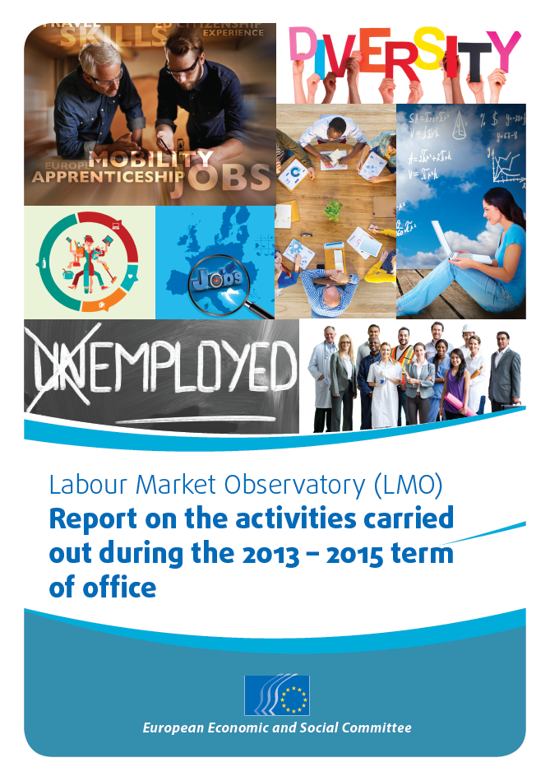

Christa Schweng, President of the Labour Market Observatory
Section for Employment, Social Affairs and Citizenship

Labour Market Observatory (LMO)
Report on the activities carried out during the 2013-2015 term of office

Introduction

The Labour Market Observatory (LMO) was set up following a decision by the EESC Bureau on 10 July 2007 and was confirmed at an EESC plenary session in 2013. The LMO operates within, and reports to, the SOC Section. It has a five-year term of office, with a mid-term revision clause.

The Observatory was set up with a mandate to "identify and analyse labour market trends and challenges, bringing added value to the work of the SOC Section and the Committee". As a general rule, the LMO deals with complex issues requiring longer and more in-depth consideration than is possible using a normal study group working method.

According to its founding decision, the Observatory meets up to five times a year.

It is composed of 33 members (see Annex I), including a president and two vice-presidents, rotating every two and a half years between the three Groups. The current president is Ms Christa Schweng, from Austria, Employers' Group. The vice-presidents are Mr Denis Meynent, from France, Workers' Group and Mr Krzysztof Pater, from Poland, Various Interests Group.
EN
All but three LMO members are also part of the SOC Section.

Overview of activities carried out between 2013 and 2015

The Labour Market Observatory's practical work during the term of office was governed by working methods agreed between the LMO president and vice-presidents and discussed during the first LMO meeting of the mandate (see Annex II). These foresee the possibility for the LMO to organise internal meetings, public events, fact-finding missions in the context of an impact study, and to work as a study group to prepare opinions.

The LMO also drew up yearly work programmes, which contained topics for events and impact studies. The topics for 2013-2014 and 2015 (see Annex III) were proposed by the LMO president and vice-presidents after consultation and debate with all LMO members and were approved by the SOC Section bureau.

The Observatory held nine public events (six in Brussels and three abroad), carried out an impact study which also involved study trips and meetings in six Member States and dealt with all the topics stated in its work programme.

Each conference tried to foster exchanges between EESC members and EU or international institutions experts, national experts and practitioners, elected members of the European Parliament and the Committee of the Regions, social partners and civil society organisations. Their aim was to present different aspects and views of each matter and strike a balance between theoreticians and practitioners as well as the EU and the grass roots levels.

- Conference on “Skills and mobility for competitiveness” organised in cooperation with CEDEFOP (European Centre for the Development of Vocational Training) on 3 December 2013 in Thessaloniki

This event looked into which skills are needed in the labour market, the matching of skills and jobs, and the need for recognition of qualifications, traineeships, apprenticeships and mobility.

The panels featured high-level speakers from CEDEFOP, the European Commission, the European Network on Regional Labour Market Monitoring, the Point College (the top vocational and educational school of Finland), the European Centre for Women and Technology, the Iperia Institute of the European Federation for Family Employment, the Austrian Institute IBW on Research & Development in VET, the Greek Public Employment Service, the European Youth Forum and the company Cross Border Talents. In addition, the participants could also listen to interventions from social partners at the EU and Greek levels, the Economic and Social Council of Greece and the National Confederation of Disabled People of Greece.

- Conference on “Tapping the full potential of diversity in the workplace: culture, age, gender and disability aspects” organised on 21 February 2014 and hosted by the EC Representation in Berlin

This conference looked at how diversity can be recognised, respected and valued. Practical examples from across the EU showed how diverse workplaces could be beneficial for all: businesses, employees and society in general. The event also examined the question of the intra-EU mobility of workers and their integration in host Member States. Debates concretely contributed to the SOC/495 opinion on "Supporting the migration of young job seekers" and synergies were created with members of the study group.

Speakers included representatives from the European Commission, Eurofound, University of Tübingen, Adecco Group, MaiValueConsulting, Ashoka (leading social enterprise), Berlin State Office for Equal Treatment and against Discrimination, the German Federal Employment Agency, the Austrian Federal Economic Chamber, the Spanish Labour Foundation for the Metal Industry and the Polish Social Council in Berlin.

- Public hearing on the “Implementation of EU youth employment policies at national level” organised on 1 April 2014 in Brussels

The event's topic was one of the highest priorities at EU level and its organisation was very well-timed, as the Member States were beginning to implement several EU policies for youth employment (such as the Youth Guarantee). Therefore, it was important to assess the level of involvement of civil society organisations in these policies, to recall the significant role that these organisations can play and to put forward their recommendations and best practices.

This public hearing dealt with the situation at the EU level but also in a selection of six Member States (Austria, Croatia, Finland, Greece, Italy and Slovakia), as the event was also closely linked to an impact study that the LMO carried out in those countries (see below). The event was an occasion to publicise the first findings of the study, contribute to the final report and to the EESC June plenary that was partially dedicated to the topic of youth unemployment.

The event involved high-level representatives from the European Parliament, the European Commission, Eurofound, EU social partners, the European Policy Center, the European Youth Forum and several national youth organisations.

- Conference on “Towards a better work-life balance” organised on 24 September 2014 in Brussels

This LMO conference was an opportunity to take stock of the existing policies and efforts undertaken by policymakers, public authorities and companies to achieve work-life balance and gender equality. Concrete examples and best practices on family-friendly policies were showcased and the substantial returns on social investment were demonstrated. The event's organisation was very timely, in a moment when discussions were taking place on a possible withdrawal of the draft maternity leave directive which was blocked by the Council for four years.

Speakers included representatives from the European Commission, Eurofound, the Committee of the Regions, the Vienna Chamber of Labour, the Confederation of Family Organisations in the European Union, the European Women’s Lobby and Make Mothers Matter.

- Conference on “Supporting start-ups to create growth and employment” organised on 13 November 2014 in Brussels

This LMO conference looked into existing and further measures for start-ups and SMEs to help hem create jobs. Discussions took place on topics such as EU legislation, the single market for services, the internationalisation of SMEs, financial incentives, business climate, procurement rules, labour law. Representatives of various European start-ups and enterprise networks shared their experiences on start-ups' aspirations and the challenges they face. They also stressed the difficulty of finding young people who have the skills that enterprises need. The event was an occasion to recall the importance of work-based learning and of entrepreneurial education. It also highlighted the key role of social enterprises, female entrepreneurs and the need for strong involvement of social partners in education.

Panelists included representatives from start-ups and their networks, including social enterprises, the European Parliament, the European Commission, Eurofound and social partners.

- Conference on “Taking action on long-term unemployment: national and European perspectives” organised on 11 March 2015 in Zagreb, Croatia

This event was dedicated to tackling long-term unemployment, one of the most urgent challenges that Europe faces today. The aim was to look into what good practices are already in place and what further measures are necessary to tackle this problem and to provide opportunities for those most at risk of social exclusion. The presentations and discussions focused on the situation at both EU and national level.

The event took place at a crucial moment, when the European Commission was preparing a proposal for a Council Recommendation on the integration into the labour market of the long-term unemployed. The Commission was seeking views and insights from stakeholders and the LMO's debates contributed to the Commission's work on this topic. The conference's conclusions were included by the Commission in their impact assessment carried out in view of the legislative proposal.

High-level speakers included the Croatian Minister for Labour and the Pension System, members of the Croatian Parliament, the European Commission, Eurofound, the President of the Labour and Employment Section of the French Economic, Social and Environmental Council, the University of Exeter’s Marchmont Observatory (UK), the European Network of Public Employment Services, social partners and civil society.

- Conference on “A Europe of talents – giving new impetus to skills acquisition through mobility for apprentices” jointly organised with the European Parliament on 2 June 2015 in Brussels (EESC)

This high-level conference, jointly organised by the LMO and the European Parliament (MEP Jean Arthuis, Chair of the BUDG Committee) was dedicated to the topic of apprenticeships and the mobility of apprentices.
This event looked into how the mobility of students and recent graduates of the Vocational Education and Training (VET) systems can be further facilitated and supported – building on the example of the Erasmus mobility for university students.

Speakers included the EESC President, the President of the EP Committee on Budgets, several other MEPs, the Director of CEDEFOP and representatives of the European Commission, social partners and the European Youth Forum. Grassroots experience was also shared by several managers of mobility networks, apprentices and regional ESCs.

The presentations and debates during the conference contributed to fine-tuning a pilot project request that was introduced at the level of the European Parliament by a group of MEPs, led by the President of the BUDG Committee. This project aims at promoting apprenticeships using two delivery systems: mobility and a single regulatory framework covering all the EU's twenty-eight Member States. The EESC could further contribute to the pilot project, notably during the mapping out phase for the current situation regarding mobility practices for apprentices. The Committee could for example assess the use of the Erasmus + programme from a civil society point of view and highlight stakeholders' good practices and recommendations.

- Conference on “Integrating migrants into the labour market: a win-win situation for all” jointly organised with the EESC Permanent Study Group on Immigration and Integration (IMI) on 25 June 2015 in Brussels

This conference was co-organised with the EESC's IMI Group and was dedicated to the integration of legal migrants into the labour market (third-country nationals coming to the EU for family reunification, work or study). The event took stock of the current situation in the EU regarding labour market participation of migrants and recalled the benefits of their integration. It also looked into remaining challenges such as the divergence of legal frameworks that apply to migrants and the recognition of skills and qualifications acquired outside the EU. Finally, the participants could listen to examples of successful integration measures and see the role that can be played by employers, trade unions and civil society organisations in this field.

The panels featured several members of the European Parliament, experts from the OECD, the European Commission, CEDEFOP, Eurofound, Migration Policy Institute, European Network of Migrant Women (ENoMW), the European Trade Union Confederation (ETUC) and the Deputy-Mayor of Ixelles and Member of the Brussels Parliament and of the French Community Parliament.

The conference was well-timed and provided a concrete input to the European Commission's work on a new policy on legal migration from third countries and on the revision of the Blue Card Directive. Indeed, the event's conclusions were shared with the informal Expert Group on Economic Migration set up by the European Commission.

It was also the first opportunity to cooperate with the European Parliamentary Research Service (EPRS) in the framework of the Cooperation Agreement between the Parliament and the EESC. The EPRS prepared a briefing on the conference's topic and widely communicated on it.
As anticipated in its work programme, in 2014 the Labour Market Observatory also conducted an in-depth impact study focusing on the views and recommendations of organised civil society on European and national policies put in place to help young people find work. The study focused on a selection of six Member States with a variety of patterns and approaches to helping young people in the labour market (Greece, Croatia, Italy, Austria, Slovakia and Finland).

The LMO's study provided clear added value to the mass of existing European documents by going directly to the stakeholders and asking for their views on issues such as the implementation of the Youth Guarantee and the effectiveness of the traineeship and apprenticeship systems. Indeed, LMO members conducted interviews on the ground in the Member States to get a direct insight into good practices and the ideas and possible concerns of public authorities and civil society stakeholders, including social partners.

This work has been well recognised by the European Parliament and the European Commission and the LMO members have widely communicated the study's findings and recommendations at both EU and national levels.

Further activities between 2013 and 2015 included:

- the LMO’s contributions to the Pilot study on the workings of the Services Directive in the construction sector and the meat sector carried out by the Single Market Observatory (SMO) – the LMO contributed during their preparatory phases (e.g. questionnaire), the fact-finding missions and the reporting phases;
- the LMO's participation in the “My Europe… Tomorrow!” project related to youth employment in Austria and Estonia. The project aims to use organised civil society to start a structured dialogue with citizens on European issues;
- the LMO’s contribution to the EESC’s input in view of the mid-term review of the Europe 2020 strategy.

Cooperation within the EESC and with external partners

The Observatory cooperated internally with Sections, the CCMI, the other Observatories and the Europe 2020 Steering Committee, and provided input to rapporteurs and other EESC members.

The LMO has enhanced its cooperation with institutional and other external partners. These were regularly updated on its activities and were involved in them. For instance:

- Members of the European Parliament participated as speakers in LMO events organised in Brussels. The event on mobility of apprentices was jointly organised with the EP. The impact study was widely communicated at the Parliament and the EP took the initiative to include the link to it on its website. The LMO has also started its concrete cooperation with the European Parliamentary Research Service (EPRS), which prepared a briefing at the LMO's request, on the topic of the most recent conference.
- The European Commission consistently provided speakers for LMO events and included the conclusions of the LMO event in Croatia in its ex-ante impact assessment for the draft recommendation on long-term unemployment that is under preparation. Numerous interactions at the level of the LMO members and the secretariat have taken place with various DGs and the cabinets of Commissioners Andor, Thyssen and Navracsics.
- Regarding EU agencies, in 2013 the LMO started concrete cooperation with CEDEFOP (European Centre for the Development of Vocational Training) which hosted one of the Observatory’s events, and it continued its excellent relations with Eurofound (European Foundation for the Improvement of Living and Working Conditions), which regularly provided speakers and moderators to the LMO’s conferences. Consequently, CEDEFOP and Eurofound decided to organise their 40th anniversary in cooperation with the EESC on 19 November 2015.
- A member of the Committee of the Regions also took part as a speaker in one of the LMO’s events, and several visits from regional and local authorities were organised at the EESC with the Observatory’s participation.
- Contacts have been maintained with EU presidencies and with permanent representations of several Member States.
- The LMO has deepened cooperation with the OECD, which presented its work at one of the conferences.
- The LMO also cooperated with some national ESCs, such as those in Greece, Italy and France. In addition to invitations to the Observatory’s events, these Councils hosted LMO meetings or participated by providing speakers for events.
- Personal contacts have been developed with several think-tanks such as Bruegel, Centre for European Policy Studies (CEPS), Confrontations Europe, Friends of Europe, Migration Policy Institute. The LMO is also part – through its president and the LMO secretariat – of the current task force set up by the European Policy Center (EPC) on youth unemployment.
- Regarding other observatories, since 2013 the LMO has had strong cooperation with the European Network on Regional Labour Market Monitoring that has established, via its members, strong ties to reality on the ground. This collaboration could be further deepened, which would entail the participation of three LMO members in one or two meetings per year. Furthermore, since 2015, the LMO established interesting contacts with the Marchmont Labour Market Observatory in the UK.
- Many other civil society and social partner organisations were regularly involved in the LMO’s work (European Youth Forum, European Anti-Poverty Network (EAPN), European Women’s Lobby (EWL), Confederation of Family Organisations in the European Union (COFACE), Make Mothers Matter (MMM), European Federation for Family Employment (EFFE), European Network of Migrant Women (ENoMW), ETUC, BUSINESSEUROPE, UEAPME, EUROCHAMBRES, etc.)

Communication

The Observatory's role, its composition, work programme and all its activities are presented on the LMO's web pages.

In addition, within the EESC, the SOC/LMO newsletter allows members to follow the work of other members and provide updates on interesting documents.

The EESC Vice-President on Communication participated to the first meeting of the term of office and the LMO regularly cooperateswith the EESC’s communication department for press invitations, press releases, professional photographers, videos, etc. Regarding social media, the LMO initiated the systematic use of Twitter for events organised by the SOC Section.

_____________

Annexes

Annex I – List of the LMO members
Annex II – LMO Working methods
Annex III – LMO Work Programme June 2013-2014 and January-October 2015

Annex I
List of the LMO members

Labour Market Observatory Presidency & Members

Group I | Group II | Group III
President  Christa Schweng (AT)  ECO, SOC, EU2020 | Vice-President  Denis Meynent (FR)  INT, SOC, EU2020 | Vice-President  Krzysztof Pater (PL)  ECO, SOC
Dorthe Andersen (DK)  ECO, SOC | Peter Coldrick (UK)  ECO, TEN | Gunta Anča (LV)  CCMI, ECO, SOC, TEN
Christian Ardhe (SE)  ECO, SOC | Søren Kargaard (DK)  ECO, SOC, TEN | Grace Attard (MT)  CCMI, INT, SOC, REX
Ana Bontea (RO)  ECO, SOC | Marian Krzaklewski (PL)  CCMI, SOC, TEN | Lalko Dulevski (BG)  ECO, SOC
Vladimíra Drbalová (CZ)  REX, SOC | Liviu Luca (RO)  ECO, TEN | Giuseppe Guerini (IT)  INT, SOC
Giancarlo Durante (IT)  INT, SOC | Veselin Mitov (BG)  CCMI, INT, REX | Renate Heinisch (DE)  INT, SOC
Lubomir Hadjiysky (BG)  SOC, TEN | Daniela Rondinelli (IT)  INT, NAT | Meelis Joost (EE)  ECO, REX, SOC
Jan Klimek (PL)  INT, SOC | Oliver Röpke (AT)  INT, SOC, EU2020 | Kinga Joó (HU)  REX, SOC
Irini Ivoni Pari (EL)  ECO, SOC | Dana Štechová (CZ)  REX, SOC | Mette Kindberg (DK)  ECO, REX, SOC
Eve Päärendson (EE)  ECO, REX, SOC | Xavier Verboven (BE)  REX, SOC, EU2020 | Ingrid Kössler (SE)  SOC, TEN
José Isaías Rodríguez  García-Caro (ES)  REX, SOC | José María Zufiaur Narvaiza (ES)  REX, SOC | Eugen Lucan (RO)  NAT, SOC

_____________

Annex II
LMO Working methods

Labour Market Observatory
Working methods 2013-2015

PRELIMINARY REMARKS

The present document aims to set out the working methods of the Labour Market Observatory (LMO) for the 2013-2015 mandate. It builds on a number of documents, such as the SOC section's working methods, Optimising EESC working methods and opinions adopted by the Committee Bureau in December 2012, the Rules of Procedure and its Implementing Provisions, the 2008 paper on Assistance to members in their consultative work, and the Consolidated guide to preparing opinions (2010 version).

FRAMEWORK

The Labour Market Observatory was set up by a decision of the EESC Bureau in July 2007 with a mandate to "identify and analyse labour market trends and challenges, bringing added value to the work of the SOC Section and the Committee". The LMO operates within, and reports to, the SOC Section. As a general rule, the LMO does not duplicate the work of the SOC Section but rather deals with complex issues requiring longer and more in-depth consideration than is possible using a normal study group working method.

2013-2015 MANDATE ACTIVITIES

Activities under the current mandate will build on the LMO's successful experience and therefore make use of its specific know-how as regards organising events in Member States and in Brussels in order to collect information about good practices or to look into issues of specific concern. Furthermore, it has very much assumed the role of a vehicle for taking national debates to the European level.

According to the 2007 Bureau decision, the LMO will draw up a yearly work programme. The topics will be proposed by the LMO bureau after consultation with the LMO members of the three groups and submitted for approval to the SOC Section. The annual programme should allow some flexibility in order to adapt to internal SOC and EESC needs and to new developments on labour markets.

The Observatory meets up to 5 times a year and reports to the SOC Section. Meetings/events will be planned well in advance, so members can organise their schedules. If possible, the dates of at least the next two LMO meetings/events should be established.

According to the 2007 Bureau decision, "the LMO's activities should include:

- observing labour market challenges and trends
- collecting examples of best practices
- stimulating discussion by organising hearings with institutional, socio-professional stakeholders, civil society organisations and academia
- producing pro-active investigating reports or studies on selected topics
- analysing cross-cutting issues."

In carrying out these activities, the LMO will closely cooperate with the Commission, the Parliament, the Council, Eurofound, CEDEFOP, EU-OSHA and the network of national ESCs and similar institutions.

The LMO's activities will encompass a mix of various forms of work. Some examples can be found in the table below.

Examples of possible forms of work,
to be carried out over the 2½ year term of office
No. | Form | Details and outcomes
1 | PUBLIC EVENTS (HEARINGS, CONFERENCES, etc.) | A maximum of four public events could be organised each year, at least one of them in a Member State ("going-local event").  All LMO members are invited to such events.  The duration varies according to requirements (half-day, full day).  Such events are proposed by the LMO bureau to the SOC section and organised by the secretariat.  In the case of going-local events, their organisation depends entirely on the commitment of the members from the respective Member States.  If possible, the going-local event should be organised in cooperation with the national Economic and Social Council or a similar organisation or body.  The outcome of public events consists of an event report that should be concise and convey the main messages/conclusions of the event. It will be prepared by the secretariat shortly after the event, under the responsibility of the LMO bureau.  Combined with fact-finding missions (see below), public events could serve as a kick-off or closing event, in order to prepare impact assessments. Impact assessments aim to collect information from people on the ground, in selected Member States, in order to give an up-to-the minute account on a certain topic. One such assessment will be prepared each year.
2 | FACT-FINDING MISSIONS TO MEMBER STATES | These missions are carried out by delegations of 3 members (one member per group, not necessarily from the Member State visited; one of the members is designated as rapporteur for the fact-finding mission). A limited number of such missions can be carried out each year.  They are organised by the secretariat in cooperation with EESC members from the Member State concerned.  Their aim is to identify national best practices or difficulties and gather grassroots information from Member States.  Outcome: mission reports that feed into impact assessments.
3 | WORK AS A STUDY GROUP | Based on a decision by the SOC section, the LMO might exceptionally act as a study group for opinions which are not subject to a tight deadline.  The resulting draft opinion shall be submitted to the SOC section for adoption.
4 | INTERNAL MEETINGS | If necessary, LMO members will meet internally in order to discuss topics such as the annual work programme, which has to be submitted to the SOC section for approval.

Communication regarding the activities

All the LMO's activities will be detailed on the Observatory's website. This website is part of the general EESC website and contains descriptions of upcoming events, registration information, conclusions and reports of past events. These web pages mainly target the general public but are also used to provide information to LMO, SOC and other EESC members.

Details of the events, mission reports and impact assessments are sent out by the secretariat in a swift, targeted and regular way to:

- The LMO and SOC section members, by means of, for example, an e-mail containing the link to the LMO's website or of a specific link in the SOC & LMO Newsletter, which needs to be sent to members on a more regular basis, for instance 9 times a year.
- SOC members, who could be regularly updated about the LMO's activities via concise, written information provided during SOC section meetings, hinting at new developments or publications by European institutions and other organisations.
- EESC members who are not members of the LMO or SOC should be given the option of receiving the SOC & LMO Newsletter. Rapporteurs from other sections, to whom recent work of the LMO is relevant, should be informed by the secretariat.
- Relevant external partners (speakers in events, selected MEPs, representatives of presidencies and staff of the European Commission, the European Parliament, the Council, and other organisations such as Eurofound, CEDEFOP and EU-OSHA) should be informed regularly about recent and upcoming LMO work.

_____________

Annex III
LMO Work Programme June 2013-2014 and January-October 2015

Labour Market Observatory (LMO)
Work programme June 2013-2014

FRAMEWORK
In accordance with the EESC Bureau's decision of 2007 that founded the Labour Market Observatory, the latter operates within the SOC Section and does not have its own policy programme. Topics dealt with by the LMO are in line with the SOC section programme and the Observatory's aim is to bring added value to the work of the SOC Section and the Committee. The LMO is mandated to identify and analyse labour market trends and challenges, as well as to deal with complex issues requiring longer and deeper reflection than is possible in the framework of normal study group work.

WORK PROGRAMME JUNE 2013-2014

In line with the 2007 Bureau decision, the LMO draws up a yearly work programme. This programme should leave some flexibility in order to allow for adaptation to internal SOC and EESC needs and to new developments on labour markets.

The Observatory meets up to five times a year and reports to the SOC Section. Meetings and events will be planned well in advance, so members can organise their agenda. If possible, the dates of at least the two forthcoming LMO meetings or events will be known at any time.

The various forms of activity of the Observatory (public events, in Brussels or in Member States, fact-finding missions, meetings) and their intended outcomes (reports, impact assessments) are detailed in the document entitled Labour Market Observatory - Working methods for the mandate 2013-2015.

The topics presented below have been proposed by the LMO Presidency (the LMO President Christa Schweng and the Vice-presidents Denis Meynent and Krzysztof Pater), in consultation with the members of their respective groups. They were discussed at the LMO meeting on 11 June 2013 and were approved by the SOC Section on 26 June 2013.

When dealing with each of these topics, attention will be dedicated to cross-cutting issues, such as job quality, equality and non-discrimination (gender, disability, age, etc.) and the principles of good governance (transparency and accountability of organisations, stakeholder participation in the planning, implementation and evaluations of proposed initiatives, inclusion, efficiency and impact).

- Skills and mobility for competitiveness: Do education systems equip young people with the right skills to enter the labour market and get their first job? What are good and bad examples in the Member States? What skills will be needed in the future? How does the mutual recognition of qualifications work in practice? Best practice examples of the informal recognition of qualifications – are they comparable? What are the drivers of mobility, and how can they be encouraged? What role does EURES play in promoting mobility?
Schedule: This topic will be dealt with in 2013.

- Instruments for tackling youth unemployment: What instruments are in place to help young people to find their first job? Are examples of best practices from other Member States used and adapted to national needs? To what extent and how do Member States make use of ESF funding in order to fight youth unemployment?
Schedule: This topic could be looked into in the form of an impact assessment, which could be completed at the beginning of 2014.

- Managing diversity within enterprises: What can enterprises do to manage diversity within enterprises successfully? This concerns workers from different cultural backgrounds but also touches on issues such as gender, age, and the needs of people with disabilities. Best practice examples from the shop floor (work organisation and working environment including health and safety at work) should be highlighted and the benefits for companies and their stakeholders demonstrated.
Schedule: To be decided

- Reconciliation of work and family life and social investment: How do reconciliation policies contribute to increasing the employment rate of women and men? Which support measures should be provided by the state? Which instruments exist at company level? What are the benefits? How can social investment for reconciliation policies (child care facilities, elderly care, social infrastructure, etc.) be maintained in times of crisis? How can their effects be measured?
Schedule: This topic could be looked into in the form of an impact assessment. Date to be decided.

- Support for business start-ups to foster growth and job creation: What can be done to support start-ups? What measures are in place to encourage the employment of the first employee? What instruments are in place to support young entrepreneurs in fulfilling their social responsibilities towards their employees (e.g. social security, health and safety at work)? What are the special needs of social economy enterprises, how do they contribute to job creation? A hearing, with the participation of young entrepreneurs, should highlight existing measures, policies and instruments and their contribution to easing the consequences of the economic crisis.
Schedule: To be decided

- Tackling long-term unemployment: Long-term unemployment has regularly increased since the beginning of the crisis in 2008. What type of tools, which examples of policies and best practices should be mobilised in order to fight against this plea, which stealthily undermines social cohesion in Europe? How can people who are furthest away from the labour market be reintegrated?
Schedule: An event on this topic may be organised in 2014 or early 2015, depending on the availability of resources.

In addition to the topics to be dealt with from June 2013 to the end of 2014, the LMO could contribute to the EESC's input in view of the Mid-term review of the Europe 2020 strategy through joint work between the SOC and ECO sections and the Europe 2020 Steering Committee on the key issue of the investment programme on growth and quality jobs in Europe. This could take place at the beginning of 2014 in order to deliver timely input to the new Commission.

Labour Market Observatory (LMO)
Work programme January-October 2015

FRAMEWORK

The Labour Market Observatory (LMO) was set up following a decision by the EESC Bureau in 2007 with the mandate to "identify and analyse labour market trends and challenges, bringing added value to the work of the SOC Section and the Committee".

The Observatory operates within, and reports to, the SOC Section and meets up to five times a year.

WORK PROGRAMME JANUARY-OCTOBER 2015

The LMO Presidency (the LMO President Christa Schweng and the Vice-presidents Denis Meynent and Krzysztof Pater) has decided to select topics for the first three meetings of 2015, leaving the remaining two LMO meetings for the future term of office.

The topics presented below have been discussed and approved by the LMO members on 24 September 2014 and consequently by the SOC Bureau.

- Tackling long-term unemployment: the event would look into policies and good practices that can be mobilised in order to tackle long-term unemployment and reintegrate people who are furthest away from the labour market.
Schedule: First trimester 2015
- Education and training, to equip people with relevant skills: the event would focus on vocational education and training and would look into how the mobility of apprentices can be further facilitated.
Schedule: April / May 2015

- Active labour market measures to support the integration of migrants into the labour market: this conference would showcase good practices for the integration of legal migrants in the labour market and could be organised in synergy with the EESC Permanent Study Group on Immigration and Integration (IMI)
Schedule: June 2015

When dealing with each of these topics, attention will be dedicated to cross-cutting issues, such as job quality, equality and non-discrimination (gender, disability, age, etc.) and the principles of good governance (transparency and accountability of organisations, stakeholder participation in the planning, implementation and evaluations of proposed initiatives, inclusion, efficiency and impact).

_____________

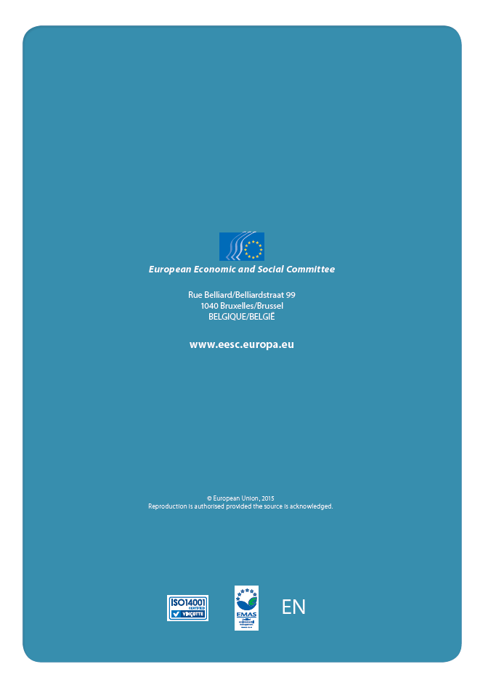

Decision of the EESC Bureau of 10 July 2007, R/CESE 921/2007 rev.
CES2371-2013_04_00_REF_NB pt. 4a) Appendix 3: “Organisation of EESC working groups and bodies”.
Decision of the EESC Bureau of 10 July 2007, R/CESE 921/2007 rev.
Decision of the EESC Bureau of 10 July 2007, R/CESE 921/2007 rev.
Decision of the EESC Bureau of 10 July 2007, R/CESE 921/2007 rev.
Decision of the EESC Bureau of 10 July 2007, R/CESE 921/2007 rev.
Decision of the EESC Bureau of 10 July 2007, R/CESE 921/2007 rev.
Document CES 3189-2013.
Decision of the EESC Bureau of 10 July 2007, R/CESE 921/2007 rev.

