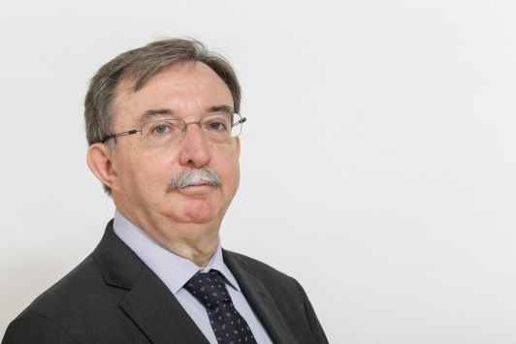
HERNÁNDEZ BATALLER Bernardo (ES)

Representation: Spain

Languages: Spanish, French, Portuguese, English

E-mail: bernardo.hernandezbataller@eesc.europa.eu / bernardo@auc.es

My Organisation:

Asociación de Usuarios de la Comunicación (AUC)
Cavanilles, 29 - 2ºD
28007 Madrid
SPAIN -

+ 34-91-501.67.73
+ 34-91-501.87.66

The Association of Communication Users (Asociación de Usuarios de la Comunicación - AUC) is a non-profit and independent organisation, whose main aim is to defend the interests of citizens as users of the mass media, receivers of the messages disseminated by them and possible "targets" of their content. The AUC's importance during the past few years shows the growing importance of communication in everyday life, thanks to both its technological advances and the risks involved in the abuse of these developments.

What do I do?

I am the Secretary-General of the Association of Communication Users (AUC) and I specialise in communications media. My main responsibilities are to oversee the implementation of the main objectives of the AUC, which include:

- the right to receive true and accurate information
- the right to honour and privacy
- the right to non-discrimination on grounds of sex, age or belief
- protection of children and young people
- the right of organised consumers to take part in public decision-making
- to denounce any possible breaches of the laws within the field of communication: advertising, television, Internet, telecommunications, etc.
- to carry out activities in the field of education, in raising social awareness and in creating public opinion (the training of teachers, cross subjects to taking part in all types of meetings and conferences, etc.)
- to prepare reports and research on the trends in the content of television, advertising, information's society and other media

URL: http://www.auc.es/

