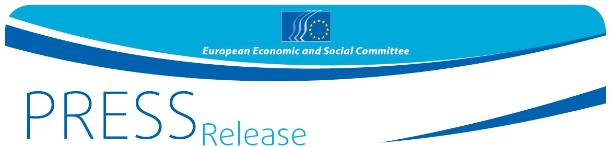
Nº 76/2015 | 14 December 2015
EN
Cycling heroes of the Camino de Santiago inspire Europe and the UN to bring down remaining barriers to disability
80 million people live with disability in the EU – new European Accessibility Act published in December

The European Economic and Social Committee, partnering with the United Nations in Brussels, today heard from two very special achievers about the day to day realities of living with disability. Taking place just after the publication of the new EU Accessibility Act (http://europa.eu/rapid/press-release_IP-15-6147_es.htm), Gerardo and Antonio (represented by his father) attended a special hearing to tell the EESC about their wonderful journey in life and what they had achieved in completing the Camino de Santiago while living with the day to day challenges of severe disability. Partnering with the United Nations Information Centre (UNRIC) and the UN Office on Human Rights, the EESC also hosted a special Cine ONU screening of the film "El desorden de los sentidos" (Disorder of the senses) with the film's protagonists and producers https://vimeo.com/54042747

The two families from Andalusia and Galicia told the Committee that although they had achieved great things, some of the very simple things in life remained a real challenge for people living with disability. Very basic issues, such as access to public places, the labour market and social and public services, such as health and education, were a continual struggle.

Pavel Trantina, the President of the EESC Social Section which invited Gerardo and Antonio to the EESC, said: "The European Union still has a lot to do to come fully in line with the UN Convention on the rights of persons with disabilities (UNCRPD). The European Commission's long awaited publication of the EU Accessibility Act is a step in the right direction but we need to bring real people living with disability, such as Gerardo and Antonio, into the picture and ensure that their needs are met."

The EESC, which represents the voice of civil society, will prepare an Opinion on the new EU Accessibility Act in early 2016 and the testimony of Gerardo and Antonio's father today will serve as inspiration for the members of the Committee. The EESC has also set up a permanent study group on disability rights to monitor the implementation of the UNCRPD, to contribute to EU policy making on the topic and to facilitate the participation of civil society, in particular organisations representing persons with disabilities.

_____________________________________________

Antonio, then 13 years old and Gerardo, then 34 years old, both disabled undertook the "camino de Santiago" on bike with their families in 2013. A crazy idea coated in love, support and finally success. The team is now reaching up to Brussels to raise awareness about the difficulties encountered by disabled persons in their daily activities and influence upcoming EU legislation, notably the European Accessibility Act, in the context of the European Disability Strategy 2010-2020.

Will Brussels be harder than Santiago? The EESC, determined to support the project, will hear from the two families in its Social Section meeting and will also host the screening of the documentary "El Desorden de Los Sentidos", released in 2013, for the first time in an EU institution. It will hold a debate with EESC Members and the team, and will accompany them throughout their action on EU legislation.

The film team and families testified on the lack of consideration for disabled people and their needs and the courage and continual struggle required to further the cause of people with disabilities.

Speakers available for interviews (ES, EN):
- Irene Hens, Film Producer
- Alejandro González Salgado, Film Director
- Javier Pitillas, coach of Gerardo Fernández Costa
- Javier Luque, father of Antonio Luque Aumente
- Jan Jarab, Regional Representative for Europe of the United Nations High Commissioner for Human Rights
- Gunta Anča, Member of the EESC - Permanent study group on disability rights

Event moderated by Pavel Trantina, Member of the EESC - President of the Section for Employment, Social Affairs and Citizenship (SOC)

Background pack on the film: https://eldesordendelossentidos.files.wordpress.com/2012/05/edds_dossier-de-prensa_18jul.pdf

For more information, please contact:
Alun Jones, Head of EESC Press Unit
E-mail: press@eesc.europa.eu
Tel: + 32 2 546 8641 / +32 475 75 32 02
@EESC_PRESS
_____________________________________________________________________________
The European Economic and Social Committee represents the various economic and social components of organised civil society. It is an institutional consultative body established by the 1957 Treaty of Rome. Its consultative role enables its members, and hence the organisations they represent, to participate in the EU decision-making process. The Committee has 350 members from across Europe, who are appointed by the Council of the European Union.
_______________________________________________________________________________

