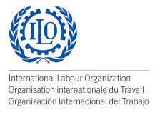
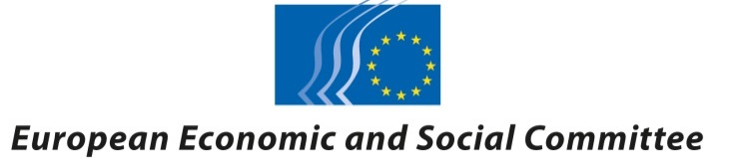

15 November 2016

Globalisation, climate change, technological advances and rising inequality: European social partners and civil society to discuss the future of work

BRUSSELS - The European Economic and Social Committee (EESC) and the International Labour Organization (ILO) have started a two-day high-level dialogue on the future of work bringing together more than 300 representatives of the social partners and civil society in Europe. They are expected to map out the main drivers of change which are transforming jobs and the economy in Europe.
Participants will discuss possible solutions to future of work challenges and examples of good practice that will feed into the ILO’s Centenary Initiative on the Future of Work. The contribution of civil society in Europe to this debate will be crucial in shaping a world of work that will best serve people and the economy.
European workers and employers are facing major challenges induced by increased globalisation, non-standard forms of employment and sweeping technological change which affect the very nature of work. According to the Spring 2016 Eurobarometer, job security is a major concern for European citizens in this context - with 47% of Europeans considering that “the worst is still to come” in terms of the impact of the economic crisis on jobs.
EESC President Georges Dassis, ILO Director-General Guy Ryder and European Employment and Social Affairs Commissioner Marianne Thyssen addressed the opening session of the event.
"The twin forces of technological change and globalisation are reshaping the global economy. Nowhere are their effects more pronounced than in labour markets creating both opportunities and risks for workers and enterprises. To shape a better future of work for all, it is our task to ensure that civil society takes an active part in addressing the challenges and exploiting the opportunities arising from these profound transformations", EESC President Georges Dassis said.
Insisting that “the future of work is not pre-determined”, ILO Director-General Guy Ryder said: “It is up to us, up to the actors and institutions in the labour market, governments and social partners, to forge the kind of future we want. I believe the ‘future of Europe’ is very much dependent upon the future of work in Europe.”
European Commissioner Thyssen said that "the consultation on the European Pillar of Social Rights plays a very important role in this debate. The Pillar identifies essential principles for labour markets and welfare systems that are fair and that function properly. Since its launch in March, Member States, social partners, civil society representatives and citizens have been giving their views and it is clear that there is a strong demand for policy answers which address the broad agenda of social fairness in the context of a transforming world of work."
During the conference, panel discussions will focus on the place of work in society, changing work patterns and working conditions, and the effects of technological innovation and globalisation in the workplace and in governance of the world of work, among other topics.
Follow the conference via web streaming

For more information, please contact:
Caroline Alibert-Deprez, EESC Press Officer
press@eesc.europa.eu
Tel: + 32 2 546 9406 / +32 475 75 32 02

Fleur Rondelez, ILO Press Officer
rondelez@ilo.org
Tel: +32 499 55 50 74

