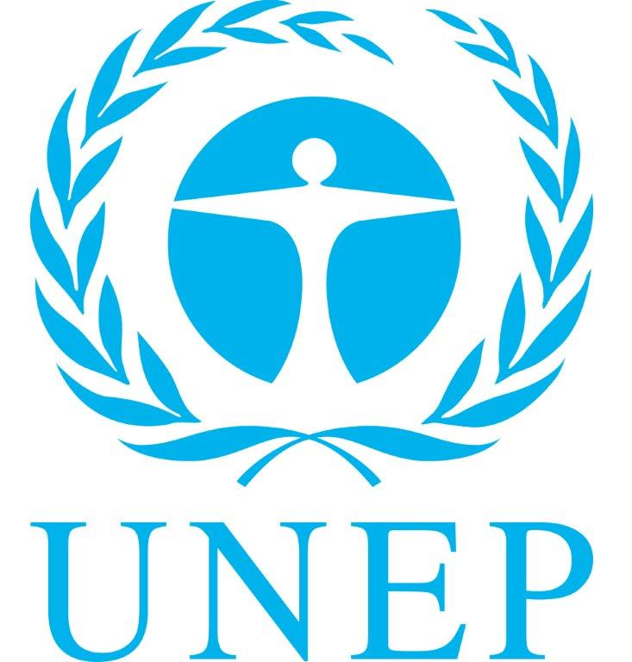
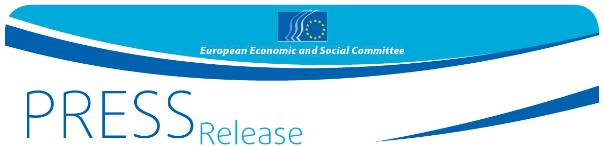
No 64/2015 | 16 November 2015
EN

Sustainable Development – a globalized, but also a European Agenda
"It is the people who will drive the SD-Goals" says EESC/UNEP/EEB conference
Joint EESC-UNEP Press Release

The first step is done – in September 2015 heads of governments and states agreed on the 2030 Agenda for Sustainable Development as pathway toward more inclusive, prosperous and sustainable societies. This marks an evolution in both the maturity and ambition of the international community in pushing forward new models of greener and more inclusive prosperity for all. Now is the time to translate the 17 Sustainable Development goals into common and individual public policies all over the world.

The Economic and Social Committee (EESC) and the United Nations Environment Programme will work together in order to ensure that civil society is fully involved into the SDG's implementation.

In order to initiate and facilitate an open dialogue platform, the EESC, UNEP and the European Environmental Bureau (EEB) jointly organised on 12 and 13 November in Brussels a two-day conference on "Sustainable Development Goals - Implementation in Europe" and preparations for the second session of the United Nations Environment Assembly (UNEA2) in 2016. The message of the more-than-220 participants representing a wide range of stakeholders was very clear: Business as usual will not work, because the 2030 Agenda is also an agenda for Europe and much has to be done in order to comply with the 17 SDGs. Citizens have to be informed, listened to, involved and included in all necessary steps, because in the end it is the citizens who transform the goals into reality. Strategies and actions have to be set now.

"The European Union together with all other regions in the world must embrace the 2030 Agenda and see it as a unique opportunity to drastically reduce inequalities, eradicate poverty, reduce or erase the carbon footprint while at the same time generate growth and create new jobs. This will need common efforts – even more – it will need a new form of governance with a driving role for civil society. This change is only possible with the people", was the plea of EESC President Georges Dassis in his opening speech.

"The stake is high and it will not be an easy task to align, synchronize and accelerate efforts of 7 billion, soon to be 10 billion people towards a low or zero carbon economy. But every challenge is also an opportunity. This is a tremendous opportunity for economic transformation, but also of geopolitical consensus building", said Achim Steiner, Executive Director of UNEP in his video message.

The Commission's announcement of an initiative on "Next steps for a sustainable European future" that would be released in 2016 created a lot of expectations among economic, social and environmental stakeholders present at this conference. They clearly stated that the EU must fully adhere to the 2030 Agenda.

"It is the Commission's and the Council's duty to put forward urgently a roadmap for a European 2030 strategy with a detailed action plan that makes states and governments accountable. The EESC and civil society in general are ready to assist at all levels of its area of influence", urged Brenda King, the EESC's SDO-President.

She called for the creation of a European civil society forum including representatives from businesses, trade unions, farmers and NGOs that focus on development, social, environment and consumer protection as a means to giving civil society a voice and defined role in the setting of the roadmaps for implementation and in monitoring progress. The conference was a promising start to this common endeavour for a radical transformation of our economies, societies and mind-sets.

Major Groups and stakeholders (MGS) across Europe also deliberated on the preparations for the second session of the United Nations Environment Assembly (UNEA-2) that will be held under the theme of "Delivering on the Environmental Dimension for the Post-2015 Development Agenda" in May 2016. The MGS and their networks present at the meeting shared views and put forward a set of recommendations on the topic of the UNEA ministerial policy review on “Healthy environment- Healthy people”, and the Symposium on “Mobilizing resources for sustainable investments”. They also reflected on how UNEA can support the review framework of the post-2015 agenda. Jan Dusik, UNEP Regional Director for Europe and former environment minister of the Czech Republic underlined the important role of UNEA in the implementation of the SDGs and stressed UNEP's efforts to open its doors for more stakeholder engagement. He called on major groups and stakeholders to make use of the recently launched online tool called myUNEA.org to actively participate and contribute to the e-discussions with a view to bringing diverse ideas and actors in the lead up to UNEA2.
More on the speeches, proposals and background documents can be found on the EESC website.

For more information, please contact:
Silvia Aumair
E-mail: press@eesc.europa.eu
Tel: +32 2 546 8141
@EESC_PRESS

______________________________________________________________________________
The European Economic and Social Committee represents the various economic and social components of organised civil society. It is an institutional consultative body established by the 1957 Treaty of Rome. Its consultative role enables its members, and hence the organisations they represent, to participate in the EU decision-making process. The Committee has 350 members from across Europe, who are appointed by the Council of the European Union.
_______________________________________________________________________________

http://www.eesc.europa.eu/?i=portal.en.publications.36851

