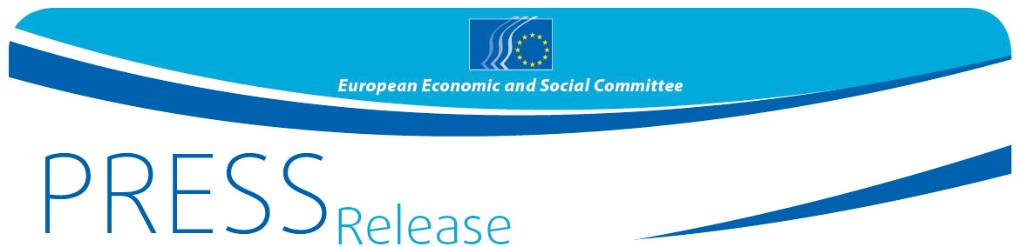
No 60/2016 | 7 October 2016

Civil Society proposes to step up measures to fight money laundering and terrorist financing

EESC debate also calls for safeguards against misuse of data collected

An EESC debate this week on fighting money laundering, terrorist financing and tax evasion called for a number of policy proposals aimed at "making the lives of criminals more difficult and their actions impossible". The Brussels event made a clear distinction between tax fraud, tax avoidance and money laundering and brought forward policy proposals including enhanced control through cooperation of financial intelligence units, a centralised European register of bank accounts, more transparency on the beneficiaries of companies and trusts and tackling the anonymity of financial transactions made with prepaid cards.

The ECO Section of the EESC (the EU body representing organised civil society) held a debate entitled "The fight against money laundering, terrorist financing and tax evasion" on 5th October. Joost van Iersel, the Section's President, opened the debate: "The fight against terrorism and money laundering requires closer cooperation between the various intelligence and security services of the Member States, as well as Europol.

The rapporteur on the EESC opinion on the Anti-Money Laundering Directive, Javier Doz Orrit, said "The list of high-risk third countries, published on 14th July, does not include many of the countries which are believed to be acting as tax havens for money laundering, in particular, those mentioned in the Panama papers. And second, given that the enhanced due diligence measures are applied only to third countries which are deemed to be high-risk, the EESC proposes that either a new list of high-risk third countries be drawn up, or the scope of the measures be broadened". He then proposed that free trade and economic partnership agreements should include chapters to tackle money laundering, tax fraud and tax avoidance.

Petru Sorin Dandea, rapporteur for the EESC opinion on Access to anti-money-laundering information by tax authorities, said "The legal treatment - definitions and penalties - of all offences relating to money laundering, tax fraud, corruption and the financing of terrorism and its connections should be harmonised at European level, as should penalties resulting from failure to comply with the AML directives. It is vital that the Member States ensure that their tax administrations have the human, financial and logistical resources needed to successfully implement the new anti-money-laundering rules. Measures to tackle unfair tax competition should also be put in place."

Isabelle Ioannides is author of the European Parliamentary Research Service (EPRS) report 'The inclusion of financial services in EU free trade and association agreements: Effects on money laundering, tax evasion and avoidance. Ex-Post Impact Assessment'. She presented a list of policy recommendations, including: improving the scope and content of financial provisions of EU Free Trade Agreements; strengthening the effectiveness of provisions on tax cooperation; refining the wording of financial services provisions; and strengthening Anti-Money Laundering and Countering Financing of Terrorism (AML/CFT) safeguards.

"Even though both are priority European issues, money laundering should be distinguished from tax evasion and avoidance", reminded Alexandra Jour-Schroeder, acting director of the EC's DG JUST. "The Anti Money Laundering Directive wants to make the lives of criminals more difficult and some of their actions impossible".

In the same line, Roger Kaiser, senior adviser at the European Banking Federation (EBF), warned against "mixing up the avoidance of paying taxes and actions to clean illegally acquired funds – as it is vital to explore synergies in the differing means to tackle the two. A risk-based approach should be respected. The banking federation calls against disproportionate measures, as client privacy, massive data flows and unrealistically short deadlines may negatively affect the efficiency of tackling financial wrongdoing".

"We need to ensure that citizens have a dignified life - and look at the proportionality of the measures and their results. Especially with the rise of low-cost terrorism", said Olivier Jérusalmy, managing director of the European Financial Inclusion Network (EFIN). He then reminded of the importance of prepaid cards for certain segments of the population that are excluded from having a bank account.

The debate was organised by the EESC's ECO Section (on Economic and Monetary Union and Economic and Social Cohesion), as the EU is stepping up its fight against money laundering, terrorist financing and tax evasion. The Committee strongly supports the EU's ambition to lead the way in the global fight against money laundering and terrorism, but underlines that this is only possible if all stakeholders join forces. With the aim to protect the privacy of innocent citizens, the EESC also calls for strong sanctions and penalties for misuse of the date collected. Participants included EESC Members and representatives of a number of stakeholder organisations.

For more information, please contact:
Milen Minchev
E-mail: press@eesc.europa.eu
Tel: +32 2 546 8753
@EESC_PRESS

The European Economic and Social Committee is an institutional consultative body established by the 1957 Treaty of Rome. The Committee has 350 members from across Europe, who are appointed by the Council of the European Union. It represents the various economic and social components of organised civil society. Its consultative role enables its members, and hence the organisations they represent, to participate in the EU decision-making process.

