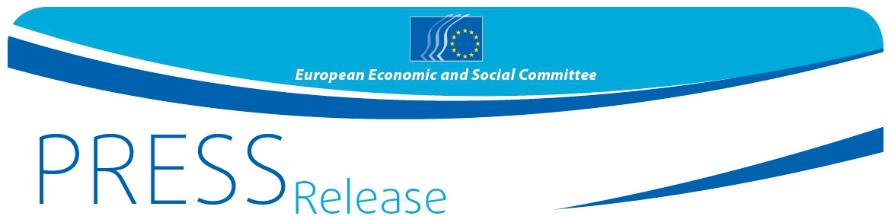
No 17/2017 | 31 March 2017

Your Europe, Your Say! 2017
EESC asks European youth: EU@60: Where to next?

"You are our present and future, and Europe needs you": with these words, EESC Vice-President Gonçalo Lobo Xavier welcomed 99 young people to the yearly Your Europe, Your Say! event organised by the European Economic and Social Committee (EESC). The Vice-President encouraged them to use this "unique chance" to mingle with their European peers, apply their foreign language skills, learn about each other and make new friends that can change their lives and perceptions about this magnificent project called European Union.

On 30-31 March, the EESC is holding its annual youth event Your Europe – Your Say!, and on this 60th anniversary of the European Union and of the European Economic and Social Committee itself, the EESC is asking these young people: "EU@60: Where to next?". From over 680 applications, 33 schools were selected, each sending three pupils and a teacher to Brussels to discuss the future of Europe, indeed their own future, from a teenager's perspective.
President Georges Dassis said in his opening speech that since the financial crisis – "which did not even have its origin in Europe, but in the US" - the image of the EU project had been somewhat tarnished. "Europe has lost its shine. One of the reasons is that people sometimes have the impression that this Europe only belongs to big industries and banks, but Europe belongs first and foremost to European citizens." Recalling his own youth and how he had to go to work at the age of 12 - as many of his generation did -, he also reminded young people to take up their responsibility: "From the seventies on, we have experienced steadily growing prosperity. But things that you today take for granted did not fall from the sky. Older generations –your parents and grandparents– have built Europe's prosperity, often at the cost of great sacrifices. Now it is your task to ensure that this Europe stays a continent of welfare and peace and it's also your task to react and stand up against populists who want to demolish our Europe."
In welcoming the young people, European Commission Vice-President Jyrki Katainen referred to this week's final Brexit decision: "It is a sad moment when one member of a community leaves, but we must also see this as an opportunity to create a new EU with 27 countries and possibly other countries joining us in the future." Referring to the Your Europe, Your Say! discussions today, he encouraged the young people to talk about the Europe they want and keep in mind that "the logic behind the EU is that so many global challenges, such as security, climate change or migration, cannot be tackled by one single member states but need the combined forces of 27 states."
During this one and a half day event, the young people are working together in break-out groups and plenary sessions to trace their course for the future of Europe and work out proposals on how to achieve their goals. At the end, they will vote and the three most voted proposals will be sent to the Commission, which, Mr Katainen, stressed, is keen to hear their feedback on the five scenarios for the future of Europe set out in Juncker's White Paper.
There is also some leisure time left for the youngsters to socialise, have fun together and be exposed to the different cultures they represent.
The EESC is organising this event for the 8th consecutive time and the ever growing number of applications as well as young people's enthusiastic participation confirm that there is a need for events like Your Europe, Your Say! in order to give young people a platform where they can make their voice heard.
More info on Your Europe, Your Say! is available on the EESC webpage.

For more information, please contact:
Silvia Aumair
E-mail: press@eesc.europa.eu
Tel: +32 2 546 8141
@EESC_PRESS
VIDEO: How has the EESC made a difference

The European Economic and Social Committee is an institutional consultative body established by the 1957 Treaty of Rome. The Committee has 350 members from across Europe, who are appointed by the Council of the European Union. It represents the various economic and social components of organised civil society. Its consultative role enables its members, and hence the organisations they represent, to participate in the EU decision-making process.

If you no longer wish to receive these messages, please send an e-mail to: press@eesc.europa.eu

