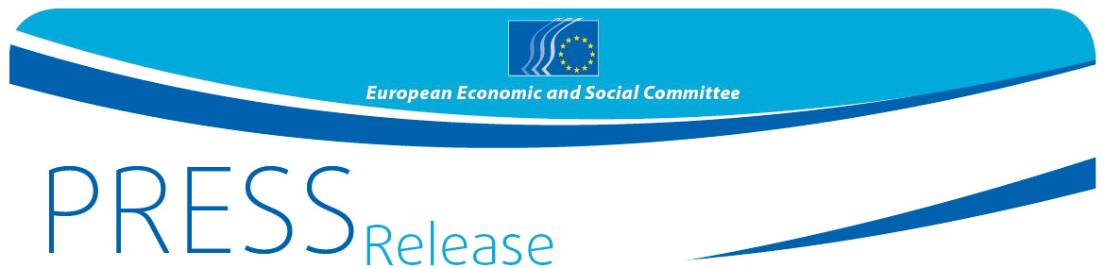
No 17 | 17 March 2016
EN

EESC calls for new thinking to prevent radicalisation and limit access to weapons in Europe

Closer cooperation needed to defeat terrorism, curb firearm access

The European Economic and Social Committee (EESC) has adopted today an opinion calling for the development of new tools to prevent radicalisation, as part of a broader EU anti-terrorism strategy, and for access to firearms to be significantly curbed. The opinion on the European Agenda on Security (Rapporteur: Cristian Pîrvulescu), responds to both the Commission’s EU Action Plan against illicit trafficking in and use of firearms and explosives, and a proposal for a Directive on combating terrorism.

The Committee underlines that it is possible to be both secure and free in Europe, and considers it dangerous for any democracy to legislate against anticipated crimes. Article 3(2)(i) of the proposal [on threatening to commit a terrorist act] should therefore be removed to avoid confusion between justice and security. In its opinion, the Committee also urges the EU institutions and Member States to abide by the proportionality principle, and to reflect the seriousness and intention of actions when criminalising and combating them.

With regard to criminalising the act of travelling abroad for terrorism, the Committee finds the definition of “for terrorism” in the proposal to be extremely unclear. While someone organising an attack or taking part in training can be more easily defined as a “terrorist”, this is not necessarily the case when someone carries out cyber-terrorism or takes part in an armed rebellion or civil war, such as in Syria or Libya. The use of vague terminology – together with the difficulty of establishing “terrorist intent” – risks creating a conflict between security and human rights.

Cristian Pîrvulescu, rapporteur on the opinion on the European Agenda on Security said: “Fundamental rights and the need to maintain a stable, functional democratic environment despite the threat of terrorism must be given priority. In addition, the role of civil society is crucial in dealing with the conditions which foster radicalisation and the use of violence. A deeper understanding of the social, economic and psychological effects of terrorist attacks on communities, individuals and industries should be prioritised.”

Recent events have shown that terrorism – particularly religiously motivated terrorism – has become globalised. Europe’s foreign policy in the Middle East and North Africa (MENA) must become better coordinated, and the Committee wants to see a clearer commitment to stabilisation, development and democratisation in that region. The Committee is pleased that the Commission intends to enhance operational activities and enlarge the scope of the EU-South East Europe Action Plan, and to strengthen cooperation with MENA.

The Committee also considers that drastically curbing access to firearms and explosives should be prioritised. Institutional cooperation between Member States must be significantly improved, both as regards information exchange and linking up existing databases.

The Committee wants to see the Commission support closer cooperation between Europol, INTERPOL, the main iTRACE actors and other relevant bodies, such as customs and firearms import-export licensing authorities. However, while the Committee encourages the pooling of resources, increasing the number of European and national safeguards could have a cumulative effect and harm fundamental rights. If fundamental rights are undermined, the EU puts at risk one of its guiding principles.

For more information, please contact:
Siana Glouharova - EESC Press Unit
Email: press@eesc.europa.eu
Tel: +32 2 546 92 76/ Mob: + 32 (0) 473 53 40 02
______________________________________________________________________________
The European Economic and Social Committee represents the various economic and social components of organised civil society. It is an institutional consultative body established by the 1957 Treaty of Rome. Its consultative role enables its members, and hence the organisations they represent, to participate in the EU decision-making process. The Committee has 350 members from across Europe, who are appointed by the Council of the European Union.
_______________________________________________________________________________

