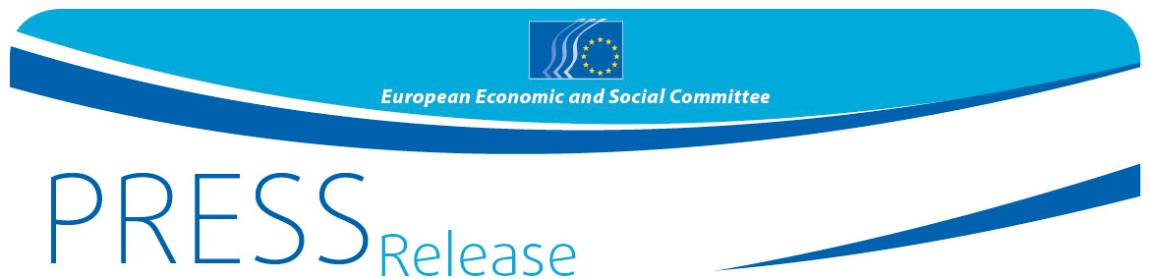
No 7/2017 | 22 February 2017

EU must take lead in linking trade in agriculture with the SDGs
Time to breathe new life into the WTO process

Trade in agriculture and in agricultural products has never been so important – or so controversial. Back in the spotlight with the recent EP vote in favour of CETA, global attention in agriculture is also turning to the forthcoming WTO Ministerial Conference later this year. Once again trade in agriculture is expected to dominate that: once again the EU must play a key role.
However, trade in agriculture must also play a core role in the implementation of most of the 17 Sustainable Development Goals (SDGs). "We must get the sustainable development goals right, but we must also get trade in agriculture right, and we look to the EU to lead the way here", says the EESC.
The SDGs will have a direct and profound effect on trade in agriculture. Agriculture in turn will have a key role in achieving more than half of the SDGs. All countries share responsibility in this. The SDGs in turn specifically identify many of the tools needed to gain a successful outcome – and trade is specifically mentioned in nine of them. At least 13 SDGs also refer to climate change: both are deeply interwoven. Agriculture plays a critical role here too - as both a cause and a victim of climate change.
The EU must take the lead
The EU is well positioned positively to lead this process. It is the largest exporter and importer of agricultural products, it has a proven interest in trade and sustainable development and it has the credibility to play an effective bridging role between developed and developing countries. "It is time for the EU to take the driver's seat in order to bring this agenda forward globally", said Jonathan Peel, rapporteur of the EESC opinion on Agriculture in trade negotiations, adopted on 22 February. "The EU should build on several recent reforms of the CAP. It has already shown at the previous WTO Ministerial Conference (held in Nairobi in 2015) that it has the ability to produce fresh and balanced thinking – crucial when so few were expecting a positive outcome there. Once more we look to the EU to be one step ahead of our trading partners".
Reinvigorate the spirit of Doha
The decision to effectively eliminate agricultural export subsidies at the 10th WTO Ministerial Conference in Nairobi, with the EU playing a leading role, already meets one of the key targets set for SDG 2, to end hunger. This decision, which the WTO Director General describes as "the most significant outcome in agriculture" in 20 years, is also proof, that the WTO remains a viable and effective forum for multilateral trade negotiations, and that this can be reinvigorated, especially with agriculture. The EESC argues that the "spirit of Doha" - as a concept for trade dialogue between developed and developing countries - must be preserved and enhanced. The EESC is advocating a global approach, although regional or bilateral negotiations also have a part to play. In such cases it is important to avoid overlapping or even conflicting rules.
An urge for global progress
However, before taking on this task, the EU needs to build a clear picture of what impact these commitments will have. Therefore the EESC is urging the Commission to undertake an impact assessment of the possible effects on EU agriculture and trade policy resulting from the implementation of the Sustainable Development Goals (SDGs) and the Paris Agreement as well as the impact of recent EU trade agreements and trade globally.
"It is now time for a fresh and balanced approach. The sustainable development goals are a global challenge and must form the basis of a fairer and more sustainable development of agriculture and trade of agricultural products", said Mr. Peel. Support schemes, market access, the way we grow crops, the challenge of food security and sustainability – all these challenges call for new and better solutions which only can be achieved in a common effort. In its opinion the EESC provides recommendations for multilateral progress in agriculture.

For more information, please contact:
Silvia Aumair
E-mail: press@eesc.europa.eu
Tel: +32 2 546 8141
@EESC_PRESS

The European Economic and Social Committee is an institutional consultative body established by the 1957 Treaty of Rome. The Committee has 350 members from across Europe, who are appointed by the Council of the European Union. It represents the various economic and social components of organised civil society. Its consultative role enables its members, and hence the organisations they represent, to participate in the EU decision-making process.

EU – Canada Comprehensive Economic and Trade Agreement

