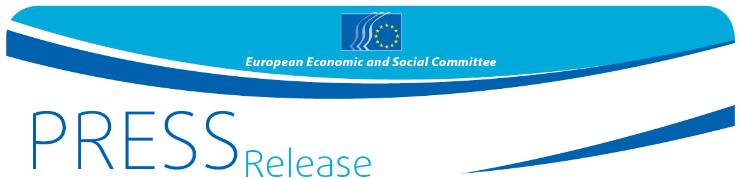
03/2017 | 26 January 2017

In a debate with Commissioner Moscovici, EESC members call for completing the architecture of the euro to ensure lasting prosperity and stability for the whole of Europe

The European Economic and Social Committee held a debate today on the state of the European economy and the prospects for deepening the Economic and Monetary Union (EMU) with Pierre Moscovici, European Commissioner for Economic and Financial Affairs, Taxation and Customs. The EESC members sent through Commissioner Moscovici a clear message to the upcoming Eurogroup, Ecofin and European Council meetings that the European citizens and economic actors urgently need to see a sense of ownership and direction by the European leadership – notably when discussing the missing blocks of a genuine EMU. The EU integration process and the euro in particular can only be sustainable if the economic, fiscal, financial, social and political aspects move forward together, even if this requires a possible Treaty change.

"Taking stock of past achievements at successive European Summits is welcome but not enough", stated Joost van Iersel, President of the EESC's economic section. "We call on the European political leaders to approve a transparent and time-bound roadmap for completing EMU and to make a clear EU-wide commitment to its implementation. In the current political turmoil, more than ever we need stability, credibility and predictability within a concept of a European sovereignty. This is the only way to reassure citizens and investors of the irreversibility of the euro and of our common European future."

Commissioner Moscovici presented an overview of the economic situation in the EU, expecting 1.6% growth in 2017 and 1.8% in 2018. In his address, he stated: "I am in favour of ensuring that we have powerful instruments that can be used in the Eurozone, such as a European Treasury. My vision is for a Europe that is unified both socially and fiscally and that can counter populism and work simultaneously for upward economic convergence and social progress of its citizens. As the euro is expected to be the currency of the whole European Union, there is an absolute necessity for its architecture to be completed, and the EESC's contribution to this discussion will be much appreciated."

The EESC – the only institutional representative of organised civil society in Europe – has repeatedly called for the process of deepening EMU to be further accelerated in order to ensure more convergence among the Member States and to make the EU as a whole more prosperous, competitive and resilient to external shocks, within a concept of shared sovereignty. In its opinions on EMU (see below), the EESC has already reached a consensus on specific recommendations addressing all the various elements that need consideration.

However, the Committee has also warned that EMU can only be completed if all Member States concerned, the European institutions and civil society stakeholders cooperate actively and without delay in this process. In today's debate, the EESC pointed out once again that there is no viable alternative to a more political Eurozone, focusing more on the big priorities that matter for its citizens than on specific numerical targets and technical issues.

In light of the forthcoming Commission's White Paper on the future of the EU, including the future of EMU, the EESC intends to carry today's discussion forward. As a first step, on 2nd February 2017, its economic section is organising a public debate entitled What future for the euro? Threats and opportunities for stage 2 of deepening EMU.

Related EESC opinions:
- Completing EMU - the EESC proporals for the next European legislature
- Completing EMU – The role of taxation policy
- Completing EMU: The political pillar
- The community method for a democratic and social EMU
- Economic governance review
- Steps towards Completing EMU

For more information, please contact:
Milen Minchev - EESC Press Unit
E-mail: press@eesc.europa.eu
Tel: +32 2 546 87 53

The European Economic and Social Committee represents the various economic and social components of organised civil society. It is an institutional consultative body established by the 1957 Treaty of Rome. Its consultative role enables its members, and hence the organisations they represent, to participate in the EU decision-making process. The Committee has 350 members from across Europe, who are appointed by the Council of the European Union.

