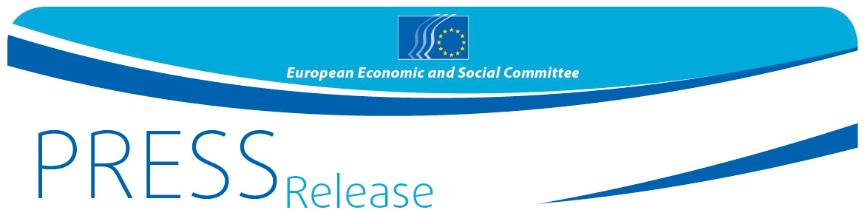
No 1 /2016 | 15 January 2016
EN

Your Europe, Your Say! 2016 school debate kicks off
33 schools from across Europe selected to come to Brussels to discuss migration

The European Economic and Social Committee (EESC) has selected 33 secondary schools from across Europe to participate in this year's edition of Your Europe Your Say! which will take place in Brussels on 17-19 March 2016. One school from each of the 28 EU Member States and the 5 candidate countries, for the first time from Albania, the former Yugoslav Republic of Macedonia, Montenegro, Serbia, and Turkey, were chosen from over 400 applications.
Gonçalo Lobo Xavier, EESC Vice-President for Communication, who oversaw the draw with fellow EESC members, Renate Heinisch and Adam Rogalewski, said "We are debating fundamental issues in Brussels which will affect young people for years to come. Through this initiative, future generations will have a clear voice in their own future."
This year's edition will focus on migration which is one of the most important issues concerning Europe at the present time and which will continue to feature high in the Committee's agenda. Each school will send a delegation of three 16- to 17-year-old students and a teacher to Brussels to participate in a youth plenary session on 17-19 March, back to back with the EESC's own plenary session. In Brussels the students will work together, debate and propose practical action that could be taken in schools and youth organisations to help young migrants integrate more effectively and raise awareness about of the importance of effective integration, especially for younger refugees.

The first phase of the YEYS initiative will begin soon with EESC members visiting the selected school in their own country to help students prepare for the youth plenary, introducing them to the EESC's functioning and activities and explaining its role in the EU's architecture.

Through this initiative the EESC, which represents the voice of civil society, is acting to ensure that the views, experiences and ideas of the younger generation, are heard in EU policy making.
For more information, please contact:
Daniela Marangoni - EESC Press Unit
E-mail: press@eesc.europa.eu
Tel: +32 2 546 84 22

______________________________________________________________________________
The European Economic and Social Committee represents the various economic and social components of organised civil society. It is an institutional consultative body established by the 1957 Treaty of Rome. Its consultative role enables its members, and hence the organisations they represent, to participate in the EU decision-making process. The Committee has 350 members from across Europe, who are appointed by the Council of the European Union.
_______________________________________________________________________________

