[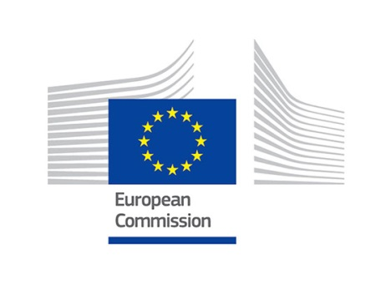](http://www.google.be/url?sa=i&rct=j&q=&esrc=s&source=images&cd=&cad=rja&uact=8&ved=0ahUKEwjk6cqttJLTAhXJK8AKHXVKDFEQjRwIBw&url=http://eksistenz.eu/?paged%3D2&bvm=bv.152174688,d.ZGg&psig=AFQjCNGbpChPC433_94nc5LB5YVt3HsfOA&ust=1491656660285439)[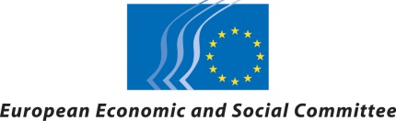](http://www.google.be/url?sa=i&rct=j&q=&esrc=s&source=images&cd=&cad=rja&uact=8&ved=0ahUKEwiDv5TCtJLTAhUpDcAKHeKjCM8QjRwIBw&url=http://www.eesc.europa.eu/design/takepart7.html&bvm=bv.152174688,d.ZGg&psig=AFQjCNGQBp9aXU16Wf92AmPFKqKC2CrCYA&ust=1491656726280309)

**Circular Economy: one year after adoption, working together for the future**

[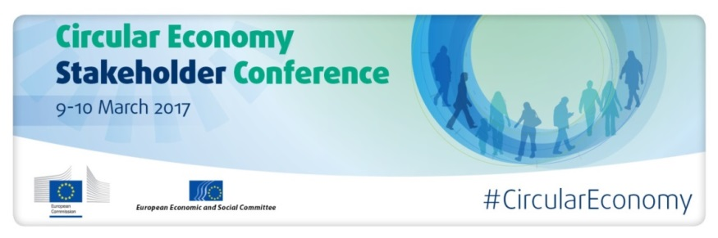](http://www.eesc.europa.eu/?i=portal.en.events-and-activities-circular-eco-future)

**Highlights from the Circular Economy Stakeholder Conference, 9-10 March, Brussels**

On 9 and 10 March 2017, the European Commission and the European Economic and Social Committee co-organised a Circular Economy Stakeholder Conference with a view to discussing the implementation of the EU Circular Economy Action Plan (CEAP) and launching a European Circular Economy Stakeholder Platform.

This conference followed the publication by the European Commission of a [report](http://ec.europa.eu/environment/circular-economy/implementation_report.pdf) on the CEAP one year after its adoption. The report highlighted main progress made so far and the developments in the pipeline for the near future.

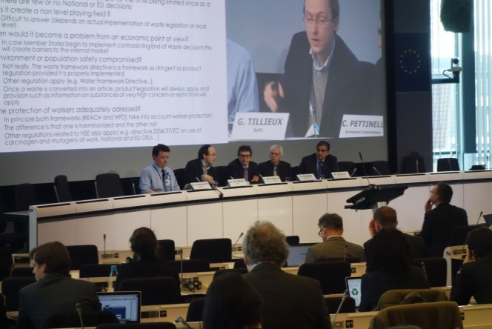

The first day of the conference focused on showcasing key deliverables already achieved on debating future deliverables with stakeholders.

*Day one: parallel session 'Options for the interface between chemicals, products and waste legislations'*

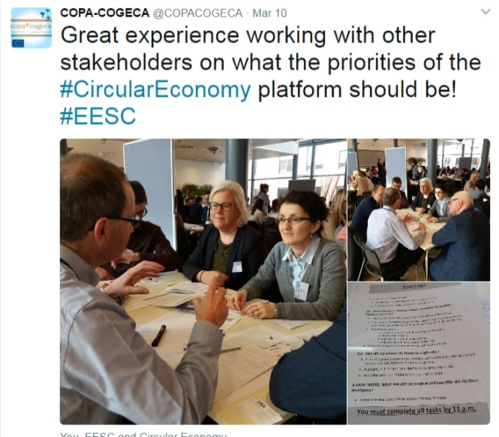

During the second day, the process leading to a Circular Economy Stakeholder Platform was officially launched.

*Day two: participatory workshops with stakeholders on vision and objectives for the future platform*

The Platform will contribute to achieving the transition towards a circular economy, by facilitating exchange of knowledge, processes, best practices and problem-solving solutions, as much as providing for better feedback towards policymakers.

It should ensure that the deep and sometimes highly technical transformations that a circular economy requires can be put in place smoothly to the benefit of all.

*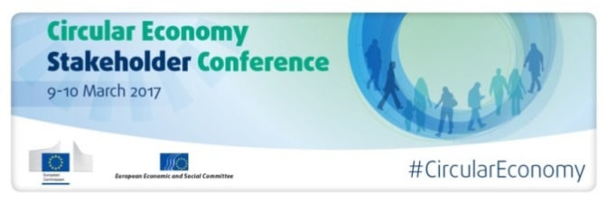****9 March - Round-up on circular economy: a passionate conversation***

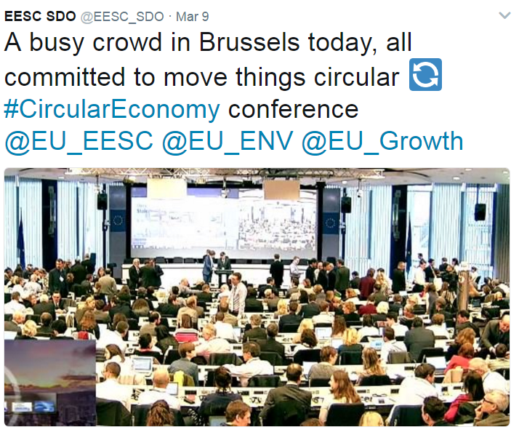Stakeholders from different sectors gathered in Brussels during the first day of the conference to discuss the deliverables of the Circular Economy Action Plan.

Opening speeches were delivered by [**Frans Timmermans**](http://ec.europa.eu/avservices/video/player.cfm?ref=I134693&videolang=INT&devurl=http://ec.europa.eu/avservices/video/player/config.cfm), **Georges Dassis** and [**Karmenu Vella**](http://ec.europa.eu/avservices/video/player.cfm?sitelang=en&ref=I134696&videolang=INT)**.**

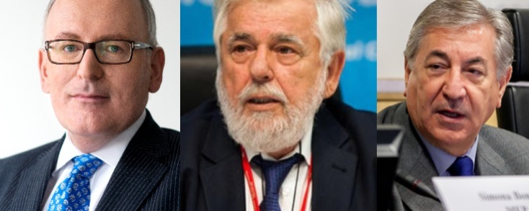

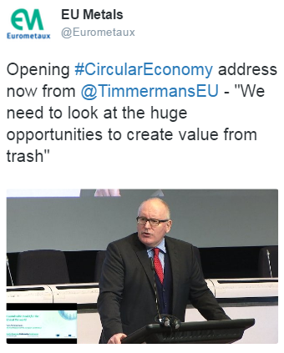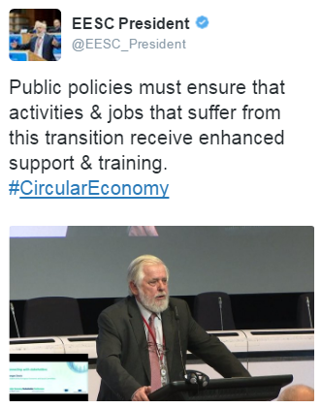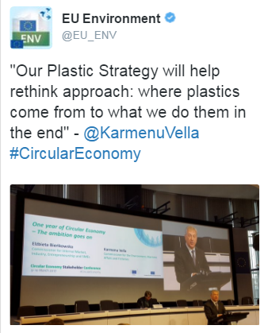

Moderator **Peter Woodward** invited participants to kick off discussions and to start the debate.

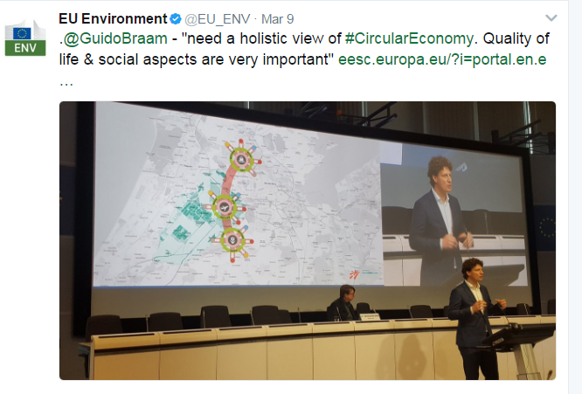

Keynotes speechesgave voice to cities with Guido Braam ([Amsterdam](https://www.amsterdam.nl/bestuur-organisatie/organisatie/ruimte-economie/ruimte-duurzaamheid/making-amsterdam/circular-economy/report-circular/)) and **businesses** with Reinhard Schneider (Werner & Mertz). Both speakers explained their role in the transition towards a circular economy.

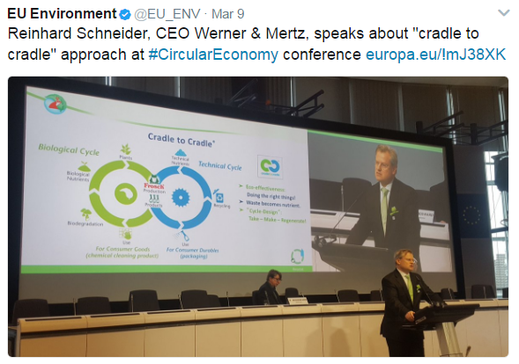After their interventions, the first panel discussion presented a balanced mix with **Ladeja Godina Košir** representing the city of Ljubljana and the Circular Change network, **Ursula Pachl** for BEUC, EESC Sustainable Food Permanent Study Group President **Peter Schmidt**, and **Alexandre Affre** for Business Europe. They agreed that achieving a circular economy in Europe requires the commitment of all stakeholders: public authorities, businesses and citizens.

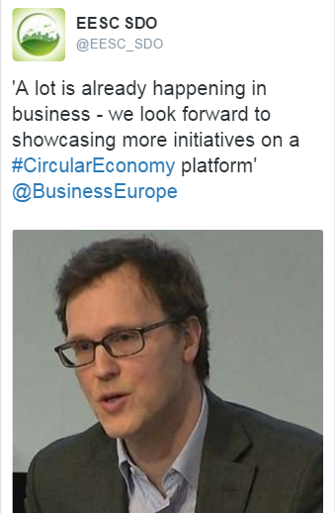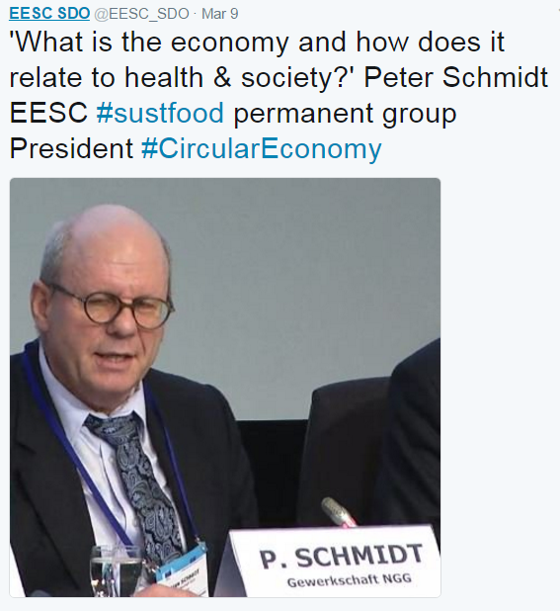

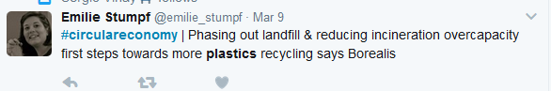[Specific sessions](http://ec.europa.eu/environment/circular-economy/index_en.htm) were organised in the afternoon with contributions from experts.

|  |
| --- |
| #1-**The Plastics Strategy** |
| #2-**Monitoring Framework** |
| #3-**Promotion of water reuse** |
| #4-**Options for Interface between chemicals, products & waste legislations** |
| #5-**Innovation for Circular Economy** |
| #6-**Product policy for resource efficiency, how to make progress?** |

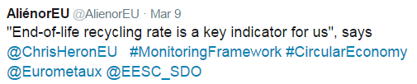

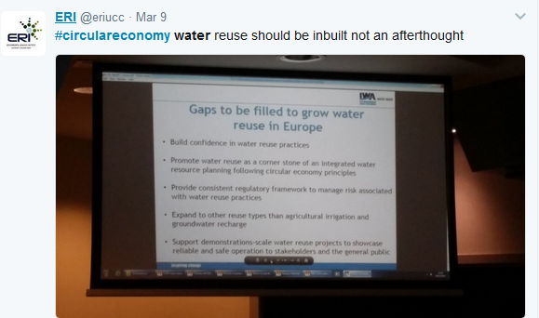

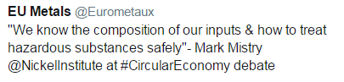

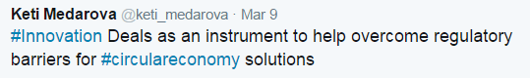

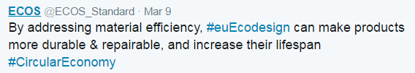

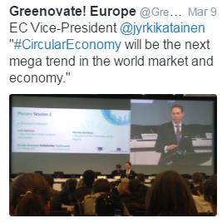

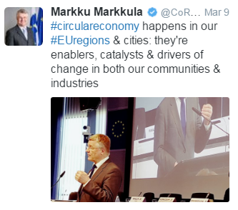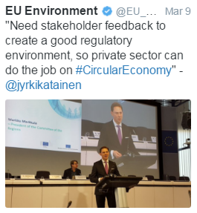A plenary session closed the day on the subject of **financing the circular economy**, with opening interventions from Vice-President [**Jyrki Katainen**](http://ec.europa.eu/avservices/video/player.cfm?sitelang=en&ref=I134698) and President of the Committee of the Regions **Markku Markkula**. Vice-President Katainen made a point of circular economy's medium term profitability. President Markkula emphasised the importance of local governance and gaining citizens' adhesion, another important leverage to drive investment.

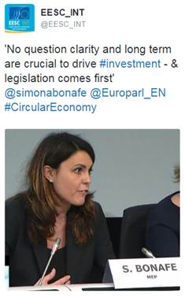Their interventions highlighted the importance of unlocking investments in the circular economy at European, regional and local level. They were followed by a moderated panel discussion featuring **Simona Bonafè,** Member of the European Parliament, **Constance Kann** from the European Investment Bank, **Sławomir Mazurek** from the Polish Ministry of Environment, **Rik Plomp**, Senior Investment Manager at PGGM and **Michael Steurer**, Eurochambres.

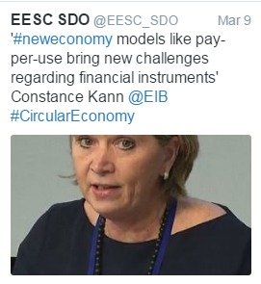

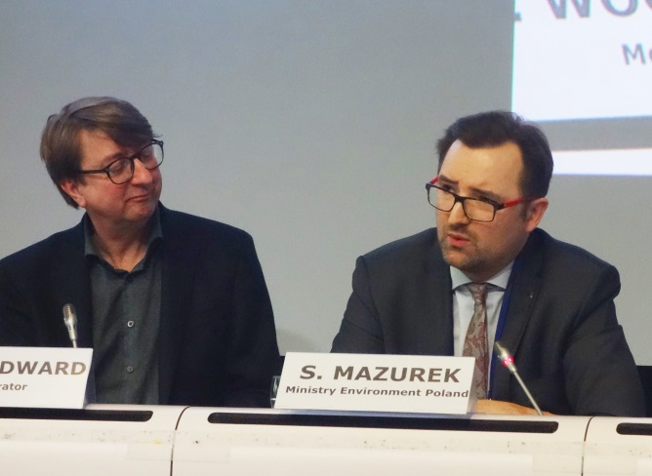

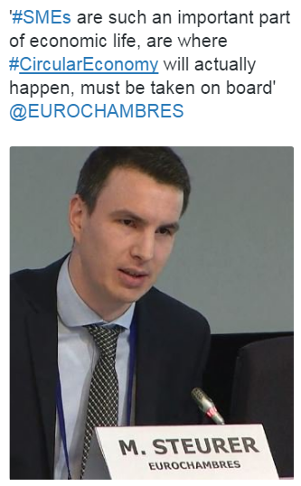

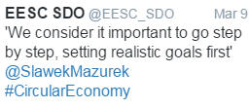

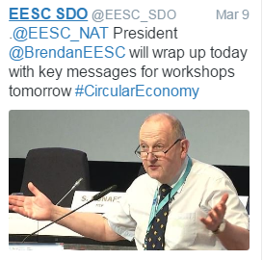  
The final word of the first day came from EESC NAT Section's President **Brendan Burns**, who reiterated how the European Circular Economy Stakeholder Platform coming into existence is a true accomplishment of interinstitutional cooperation. It voices civil society's expectations and represents a great example of collaboration between the European Commission and the European Economic and Social Committee.

'The transition has already started, with the civil society. This truly is a multi-stakeholders' endeavour!'  
 *Brendan Burns, President of the EESC's NAT Section*

***10 March - Stirring up ideas in the 'world café', working together   
for the future Platform***

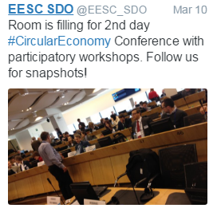

A participatory format, led by Moderator Peter Woodward, was chosen for this second day of the conference. It gave the many attendees the opportunity to work together to answer essential questions:

1/ Which top priorities should the future Platform focus on?

2/ Making it operational: what to do, what to avoid?

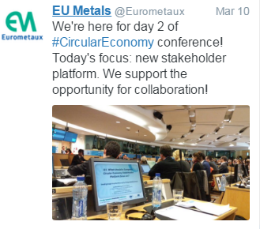

Opening statements were made by **Luca Jahier**, President of EESC Group for Various Interests, and **Cillian Lohan**, Rapporteur on Circular Economy EESC Opinions, to an attentive and visibly committed audience.

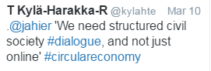

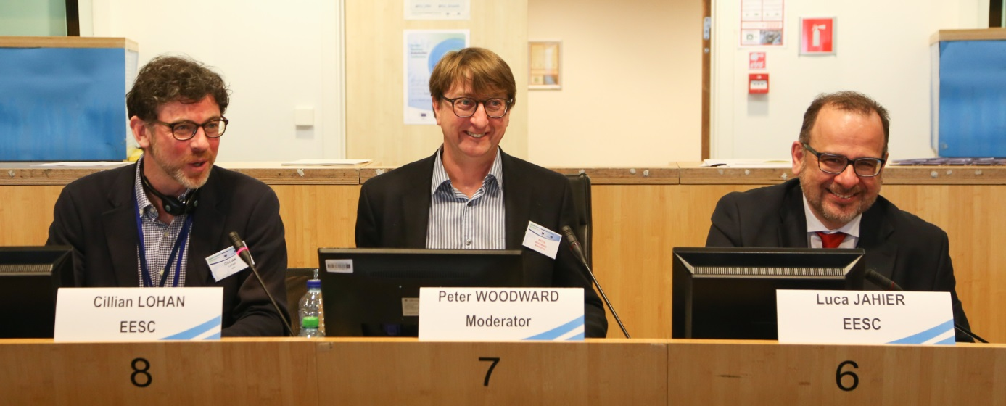

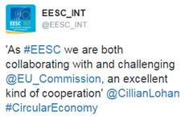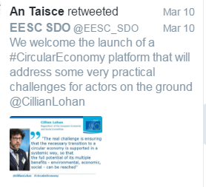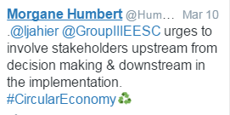

Participatory workshops swiftly moved into action. 60 tables of 6 to 8 participants were set up in the Jacques Delors building. Each table designated its own rapporteur and conclusions were later collected for display.

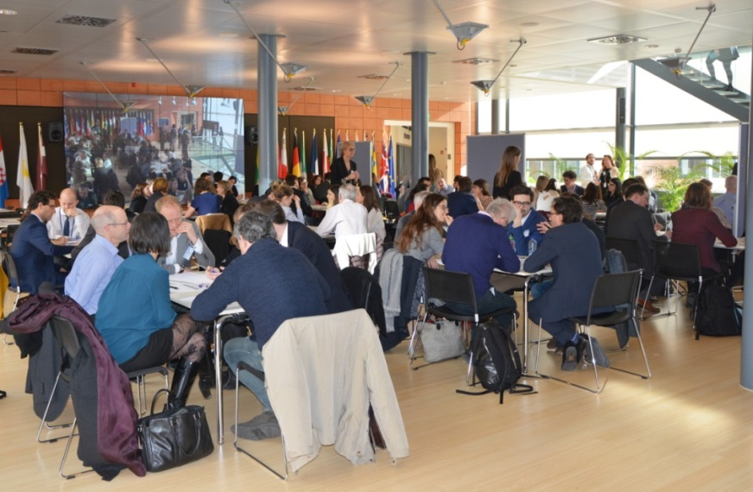

After the two sessions, answers from the tables were harvested first for display for everyone to browse, then for analysis to bring results to the concluding Plenary session.

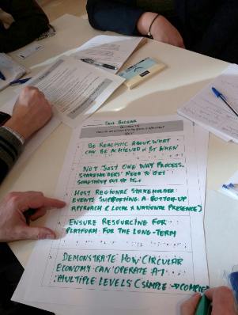

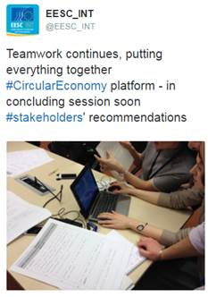

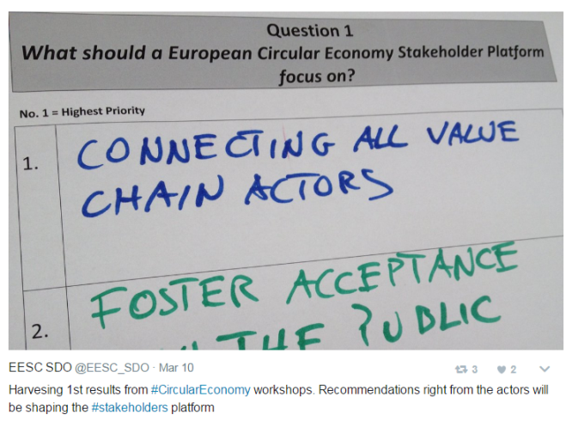

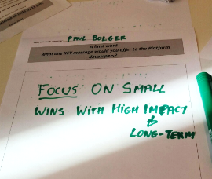

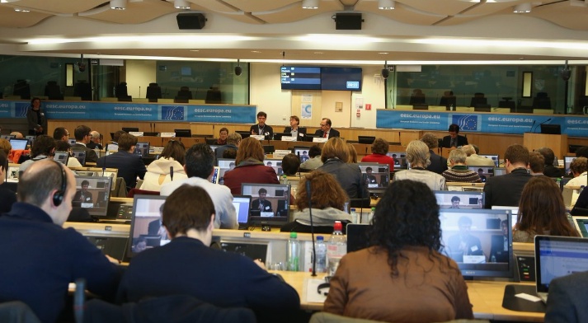The concluding Plenary Session went through all the findings of the morning via interactive exchange with the audience and the panellists:

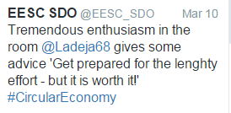**Ladeja Godina Košir**,   
Circular Change, Slovenia

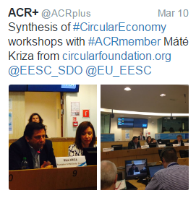**Adrian Deboutière**,   
Institut de l'économie circulaire,   
France

**Máté Kriza**,

Chairman, Foundation   
for Circular Economy, Hungary

**Arthur ten Wolde**,

De Groene Zaak & Ecopreneur, The Netherlands

Closing remarks were delivered by Brenda King,   
President of the EESC Sustainable Development Observatory, and Daniel Calleja Crespo, Director-General for the Environment in the European Commission.

'The platform will act as a solution hub to facilitate   
the exchange and roll-out of circular economy models;

a bridge supporting networks and stakeholders

advocating and raising awareness on the circular economy'

*Brenda King,   
President of the Sustainable Development Observatory*

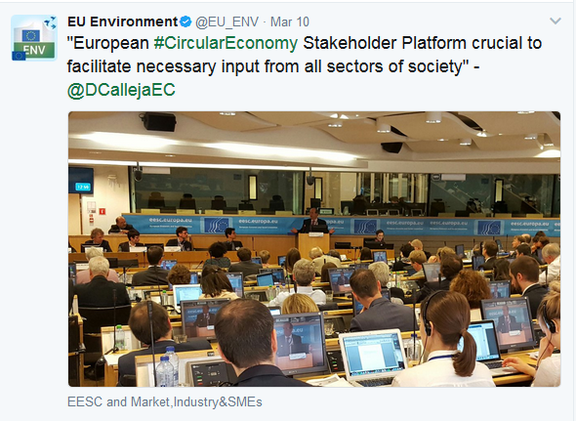

'I see the Platform as place for knowledge on the circular economy   
and place for dialogue among stakeholders. The Circular Economy deserves the best Platform,   
not another Platform. We cannot   
settle for the second best!'

*Daniel Calleja Crespo,   
Director-General for the Environment, European Commission*

***Quick view: Participants' recommendations to Q1***

