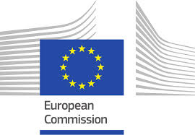
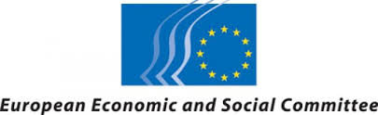
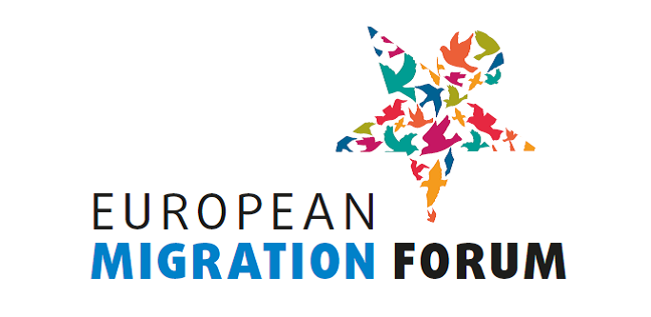

BUREAU OF THE EUROPEAN MIGRATION FORUM
Minutes of the meeting of 28 January 2016

Participants:

Bureau members:
- Irini Pari, European Economic and Social Committee (EESC)
- Laura Corrado, European Commission (EC), DG Home Affairs
- Yonous Muhammadi (Greek Forum of Refugees), Bureau member representing civil society organisations at national level
- Eyachew Tefera (ENAR), Bureau member representing civil society organisations at European level
- Eve Geddie (PICUM), Bureau member representing civil society organisations at European level – replacing Kadri Soova

Staff:
- Justyna Głodowska-Wernert, European Commission (EC), DG Home Affairs
- Valeria Setti, European Commission (EC), DG Home Affairs
- Barbara Walentynowicz, European Economic and Social Committee (EESC)
- Annemarie Wiersma, European Economic and Social Committee (EESC)
- Anna Kraśny, European Economic and Social Committee (EESC)

Guests:
- Matthieu Kleinschmager, European Commission (EC), DG HR, Internal consultant

- Discussion on the draft programme of the 2nd meeting of the Forum on 6-7 April 2016, its precise title and the subjects of the workshops

At the beginning, to set the scene, the EC presented the recent and planned initiatives in the field of (legal) migration:
- European Dialogue on Skills and Migration (meeting on 28/1)
- Communication on migration management – stock-taking of medium- and long-term measures of the European Agenda on Migration (planned for early March)
- Legal Migration package, including proposal for revised directive on the Blue Card and an action plan on integration (planned for end of April [later changed to early June])
- Agenda for New Skills (in general, but with a reference to the skills of migrants and refugees) (end of May, [later changed to early June])

The EESC mentioned its fact-finding missions on migration to 11 Member States. Their synthesis report will be presented at EESC plenary on 16 March.

The Bureau discussed the suggested subjects for workshops (based on the results of the consultation with NGOs on 14 September 2015). In the discussion it was suggested to: put more focus on integration (even two workshops); to move from problems to proposals, to use clear wording in order to avoid confusion; to offer more subjects.

The title of the 2nd Forum meeting should be broad and inspiring. It should reflect the following concepts: labour migration; solution-oriented approach; civil society.
The title "Long-term approach to labour migration and successful integration – the voice of civil society" was suggested and approved by the members.

- The new participatory format of the 2nd meeting of the Forum – presentation by Mr Matthieu Kleinschmager, member of the EC "Art of Hosting" team and discussion

Mr Kleinschmager explained the basics of the participatory methods and explained that the hosting team (ca. 10 people) would help preparing and hosting the dialogue. He briefly presented the examples of successful events of similar size, organised with participatory approach: 2011 European Volunteering conference and the 2015 meeting of the European Platform for Roma inclusion. Two important rules of the methods were underlined: 1/ everybody has meaningful input, 2/ the importance of collecting results and prioritising them. It is best to have one, strategic question, related to the purpose.
As for the workshops, there are different methodologies. They range from the 'Open Space' with a blank agenda, where participants can suggest topics for workshops themselves and chose which one to join on the spot, to workshops on set topics using different participatory ways of collecting feedback.
What requires decision is the level of openness vs. the need to frame the discussion, in order to steer it for solutions and feedback in specific fields.
The Bureau members felt that results need to be relevant for organisations; the subjects can be broad, but some framing is important.

Advice:
- Create a useful background document, with a summary of the participatory approach and a lot of concrete content (but questions are not necessary)
- Set the scene in the opening session, with core issues mentioned in the welcome speeches.
- During the discussions focus not on problems, but on “things to be changed” and solutions,
- The Forum should work on collective outcomes, relevant both for the institutions (recommendations) and for the participants
- Participants who are experienced in the use of participatory methods can facilitate the debates as well.
- Trust-building is essential.
- Do not force consensus – reflect the diversity of views.
- It is very important to properly collect the results and think in advance how to report from the workshops/ the whole event. The main outcome should present the results of the collective reflection.

Logistical issues, like interpreting possibilities and available spaces and their set up were also briefly discussed.

- Presentation and confirmation of the list of selected participants, following the public call

Annemarie Wiersma of the Forum Secretariat explained that ca. 170 applications were received, but it was not possible to review all of them before the Bureau meeting. The selection procedure was the following:
The responses to 3 questions about expertise and motivation are ranked on the scale from 0 to 3. The maximum score is 9. The results are sorted in a scoring table. All the applicants who score 6 points or more are accepted. The total number of selected applicants is to be 120. Therefore, to complete the final group, a selection should be made among those who scored 5 points. The criteria used to select applicants from this group are: priority for migrant-led organisations, geographical balance, thematic experience balance.
The lists of the selected and non-selected participants would be sent to Bureau members for approval about 17 February. The invitation should be sent about 24 February. The registration deadline is 17 March.

The Bureau members discussed the issues of other types of participants:
To avoid any misunderstandings and allow for smooth participation, the rule should be strictly to allow one representative per organisation.
Each Member State can have one representative, from a relevant ministry or from the Permanent Representation in Brussels.
No spaces for participants from outside the EU are foreseen, unless space is available.
Potential participants from other international organisations (IOM, UNHCR, OECD etc.) or other EU institutions (namely assistants to MEPs) should be informed about the participatory method and the need to participate actively (no coming for listening only; report will be published).
The role of rapporteurs of workshops should be given only to representatives of civil society.
The Forum should particularly be an opportunity for small, local NGOs, as big platforms have more opportunities to dialogue with the EU institutions.

- Forum Bureau matters
- Preparations of the partial Bureau elections

During the April Forum, two new members will be elected: one representing EU-level organisations, to replace Eyachew Tefera (ENAR), and one representing organisations at national level, to fill the empty seat, vacated by Ezequiel Iurcovich (Rete G2, Italy).
The Secretariat will inform the selected participants about the elections and the possibility to stand as candidate when sending out the invitations. A space should be foreseen in the programme of the first day where candidates can present themselves. The elections, and presentation of their results, should take place on the second day.

- Communication on Bureau activities

The minutes of the Bureau are published on the dedicated EMF page of the EESC website: http://www.eesc.europa.eu/?i=portal.en.immigration-and-asylum-european-migration-forum-bureau.

It was decided that more information on the Bureau should be available there as well: composition, presentation of the Bureau members (photo, short text) and a way to contact the Bureau members.

5. AOB

The members were informed of the possibility of organising a (partial) video-conference instead of a meeting in Brussels. The members based outside of Brussels preferred meeting physically, but the option of a video-conference could be used in case of incapability to travel.

No decision was taken on the next meeting, which could be organised before the April Forum if necessary.
_____________

