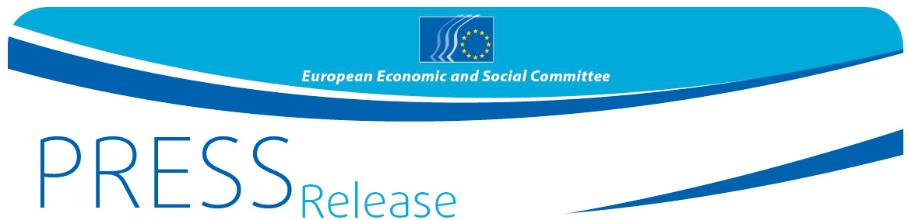
No 01/2019 | 30 January 2019
EN

Students from Türk Telekom Social Sciences High School in Ankara
to speak their mind at Your Europe, Your Say! on European elections 2019

On 6th of February at 10 a.m the Türk Telekom Social Sciences High School in Ankara will welcome Arno Metzler, president of Diversity group of the European Economic and Social Committee, to prepare for the 10th edition of Your Europe, Your Say, the youth assembly which will take place in Brussels on 21 and 22 March under the slogan "#YEYSturns10: Vote for the future!"

Türk Telekom Social Sciences High School in Ankara is one of the thirty-three schools from across Europe that will come to Brussels on 21 and 22 March to debate their views, hopes and expectations about the forthcoming European elections.
Arno Metzler, will work with the 16 to 18-year-old students ahead of the March meeting in Brussels. They will be ready to share ideas about the 2019 European elections and to have answers on specific thematic questions:

- What in your view should be done to increase voter participation in the EP elections?
- How can we strengthen representative democracy in the future?
- What kind of political engagement exists beyond the European elections, and how would you take part in it?

During the YEYS plenary, the participants they will vote on three proposals for the European Parliament to take on board in its campaign for the European elections Furthermore, the YEYS final report will be considered from the European Parliament as the young's Europeans choice on "what Europe we want to live in".

Background
The 33 schools were selected, among a record of 1038 applications, to participate in this initiative using an electronic name picker. One school from each of the 28 EU Member States and five
candidate countries (Albania, the former Yugoslav Republic of Macedonia, Montenegro, Serbia and Turkey) will be involved.
Called "Your Europe, Your Say!" (YEYS), the event is organised by the European Economic and Social Committee, the voice of civil society at European level, and is the Committee's flagship event for young people.

Through this initiative, the EESC aims to ensure that the views, experiences and ideas of the younger generation are taken on board in EU policy-making.

Further details about YEYS2019 are available on the event's official page, and you can watch the YEYS 2018 video here.

For more information, please contact:

EESC Press Unit – Silvia Aumair
+ 32 (0)2 546 xxxx – Mobile: + 32 (0) 473 72 29 99
press@eesc.europa.eu
@EESC_PRESS
VIDEO: Europe at work

______________________________________________________________________________
The European Economic and Social Committee represents the various economic and social components of organised civil society. It is an institutional consultative body established by the 1957 Treaty of Rome. Its consultative role enables its members, and hence the organisations they represent, to participate in the EU decision-making process. The Committee has 350 members from across Europe, who are appointed by the Council of the European Union.
_______________________________________________________________________________

