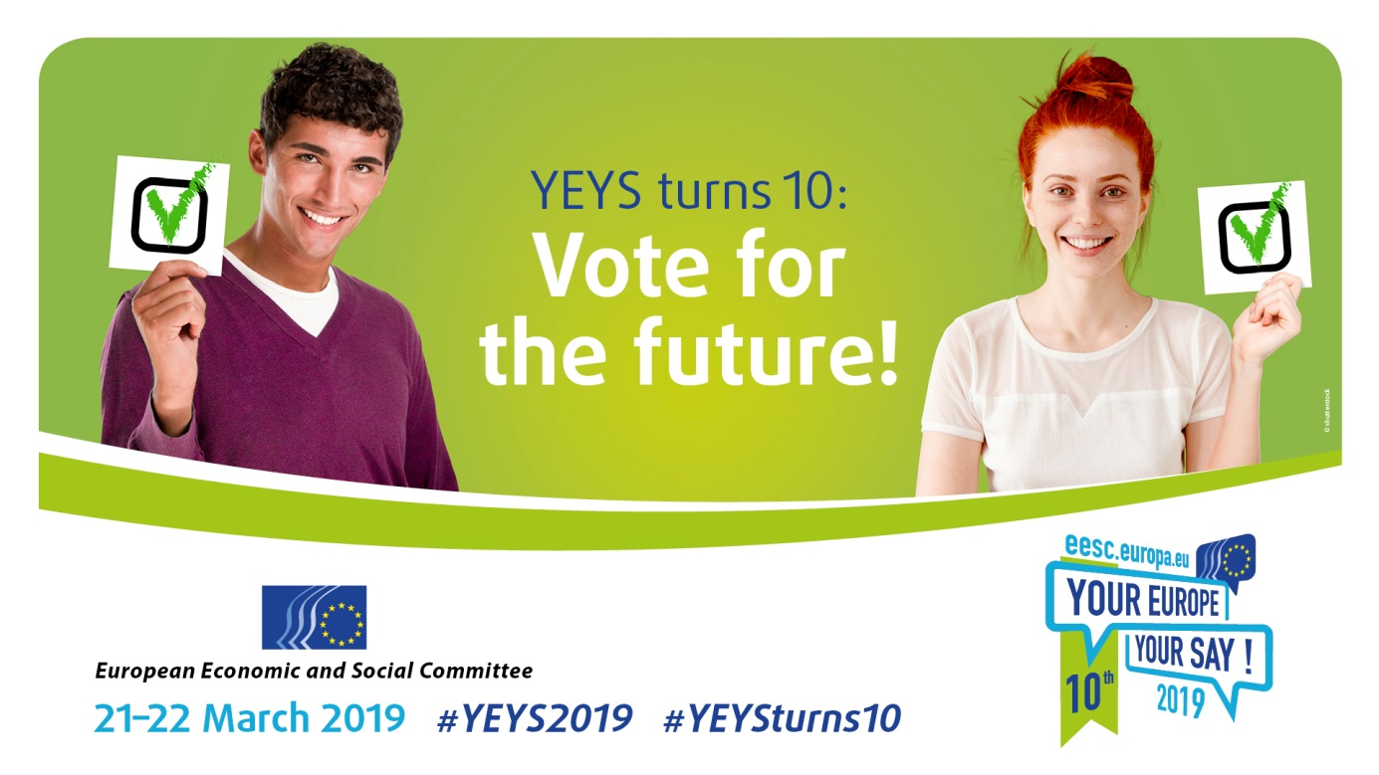

**EN**

**YEYS TURNS 10: VOTE FOR THE FUTURE!**

**21-22 March 2019**

**WORKING DOCUMENT FOR PARTICIPATING SCHOOLS**

# **The European Economic and Social Committee**

The European Economic and Social Committee (EESC) is a consultative body of the European Union. It was set up in 1957 by the Treaty of Rome.

The Committee is made up of 350 members from civil society organisations in the 28 Member States. They are arranged into three groups: Employers, Workers and "Diversity Europe" (the latter representing a wide range of groups, from environmentalists and farmers to consumers, organisations for people with disabilities, NGOs etc.). The EESC's members use their knowledge and experience to improve European decision-making.

The Committee's mission is to make the voice of organised civil society heard. The European Parliament, Council and Commission are legally obliged to consult the EESC when passing many new laws. The EESC draws up opinions on these and other issues, which are agreed by consensus between the three groups. As a result, the opinions issued by the Committee reflect the interests of the whole of organised civil society (employers, workers and various interests), based on compromise and mutual respect.

# **Your Europe, Your Say!**

The EESC launched *Your Europe, Your Say!* in 2010, as an annual event bringing secondary-school students and their teachers from every Member State and EU candidate country together in the heart of the EU. The students debate proposals on a specific theme and agree on a resolution to be put to EU decision-makers.

One school is selected at random from each country and sends three students aged 16 or over and their teacher to Brussels to take part in their own simulated EESC plenary session, discussing a topical issue. YEYS 2019 will take place on 21-22 March 2019. In the run-up to the event, EESC members will visit the schools selected to talk about the Committee's work and answer students' questions.

YEYS is a unique opportunity for young people to meet and share experiences, listen to their counterparts from different countries and learn more about the way other people live. In Brussels, students will debate and vote on the subject of the elections to the European Parliament and their role in shaping the European policies to come. Moreover, *Your Europe, Your Say!* provides an enriching and unforgettable experience not only for the young people taking part, but also for us at the EESC.

2019 will mark the tenth anniversary of YEYS, and special activities will be organised to celebrate this.

# **YEYS 2019**

On 23-26 May 2019, European citizens will vote in the European Parliament election. As one of the three major institutions of the European Union, the Parliament is decisive for the future of Europe and of its citizens; widespread participation in the elections is therefore crucial for democracy. To increase voter turnout, the EP has launched the [www.thistimeimvoting.eu](http://www.thistimeimvoting.eu/) campaign.

The European Economic and Social Committee, as the home of European organised civil society[1], is participating in efforts to improve voter turnout and has decided to place the European elections at the centre of its annual youth event *Your Europe, Your Say!* (YEYS). Young people are Europe's future, and they will determine the direction of the EU in the years to come. As a result the EESC has always placed particular emphasis on involving young people in its policy debates.

The theme of YEYS 2019 will be **YEYS Turns 10: Vote for the Future!** Participants will be invited to reflect on the elections to the European Parliament, its role in the democratic process at EU level, ways to increase voter turnout and, last but not least, the relationship between young people and political and social engagement, especially considering the fact that some participants may already be able to vote in May 2019 (for example, in Austria 16-year-olds are eligible to vote).

# **The European Parliament, elections and young people**

Together with the Council of the European Union, the European Parliament holds the legislative power in the EU and decides on the EU budget. The importance of the EP has been growing steadily over the years, since the first assembly directly elected by the peoples of Europe in 1979.

Nowadays, the European Parliament has the power to approve the new European Commission and its individual members; as in any parliamentary democracy, the government needs the parliament's trust in order to take office.

During the campaign for the 2014 elections, a new system of leading candidates (*Spitzenkandidaten*) was introduced, according to which the European Commission's new president would be the candidate put forward by the political group that had been most successful in the elections. Because the elections were overall won by political parties that are members of the European People's Party, the Parliament elected their candidate Jean-Claude Juncker as Commission President for the 2014-2019 term of office.

Back in 1979, when the first European elections took place, voter turnout stood at 63%. At the last elections held in 2014, turnout was only 42.54%[2]. The reasons for this decrease include the financial and economic crisis, which in many European countries eroded voters' trust in the leading parties and in the European process more generally.

If we take that percentage of 42.54% and break it down by age, we observe that those who voted the least are young people: Europe-wide, only 30% of those aged between 16 and 29 years went to vote, a percentage even lower than the mere 40% of 16-24-years-olds who take part in national elections (56% for 25-29 year-old voters: see page 8 of [*Youth and Political Parties*](https://www.youthforum.org/sites/default/files/publication-pdfs/Toolkit%20Youth%20and%20Political%20Parties%20-%20w%20Key%20Recommendations.pdf), a study published in 2018 by the European Youth Forum).

Available data suggest that something similar could happen in 2019. According to the [April 2018 *Eurobarometer survey*](http://www.europarl.europa.eu/news/en/press-room/20180522IPR04027/public-opinion-survey-finds-record-support-for-eu-despite-brexit-backdrop), whilst 60% of Europeans are convinced that their country has benefited from being a member of the EU, the highest proportion since 1983, only 50% declare themselves to be interested in the upcoming elections.

To sum up: despite the improvement in the general perception of the EU and the importance of the Parliament for European decision-making, it remains to be seen whether the majority of voters will actually take part in the elections in May.

# **General questions**

To help students and their teachers formulate ideas and prepare for the debates in Brussels, here are some questions that may arise during YEYS 2019:

## The functioning of modern democracy

* Which institutional system does your country have? (republic or constitutional monarchy, parliamentary, presidential, semi-presidential...)
* The main institutions and bodies of the European Union are: the European Parliament, the European Council and the Council of the European Union, the European Commission, the Court of Justice of the European Union, the European Court of Auditors, the European Central Bank, the European External Action Service, the European Economic and Social Committee and the European Committee of the Regions. Which are the main institutions and bodies of your country?
* Which body is central to the institutional system of your country?

## Young people and modern society

* Which kind of society would you like your country and Europe to have?
* Are there other ways to get involved in society apart from voting?
* Are you engaged in politics, or do you think you will be in the near future?
* How many people of your age that you know are interested in politics? Are they in the majority or the minority, and why?
* What do you expect from the new European Parliament (EP)?

## Young people and voting

* What's the legal voting age in your country?
* Will you vote when you reach that age? Why, or why not?
* Why is voting important for people's participation in the development of your country and/or of the European Union?
* Why do you think young people are less likely to take part in elections than older people?
* How could voting as opposed to not voting help to improve the situation of young people? (environment, employment, social rights, stability, etc.)

## The role of the media and social networks

* What role do the media play in your everyday life? Do you think they can influence the way people think and act?
* What do you think, more specifically, of the role of the media in Europe? Do you think that they convey European and democratic values?
* Can you propose ways to promote European and democratic values through the media? Do you think this will help create a better society?
* What about social networks: do they convey more positive or negative messages? How can we contribute to ensuring that social networks promote European and democratic values?

# **Specific questions**

1. What in your view should be done to increase voter participation in the EP elections?
2. How can we strengthen representative democracy in the future?
3. Which kind of political engagement exists beyond the EP elections, and how would you take part in it?

These three questions above will form the basis for the three sub-topics of YEYS. Here are some hints for reflection on these sub-topics:

**Question 1:** What in your view should be done to increase voter participation in the EP elections?

It is sometimes argued that voters are less engaged in European elections than in national elections because they feel that the supranational level is further away from them than the national level. However, there may be other explanations: for example, the fact that we tend to know our national politicians better than those of the other countries can have an influence on our readiness to vote for a certain *Spitzenkandidat* or not. Also, if politicians from other countries don't speak our language, they can't participate in television debates on an equal footing with national politicians, so they will be less present in our mass media.

Solutions proposed by European youth organisations such as the European Youth Forum or AEGEE (the European students' forum) include the following: transnational lists; making electoral laws more uniform; voting rights for 16-year-olds; maintaining the *Spitzenkandidaten* system; a quota for young people in decision-making bodies.

1. What do you think of these ideas?
2. What are your ideas?

**Question 2:** How can we strengthen representative democracy in the future?

Representative democracy is the system according to which citizens elect representatives for a certain term (typically 4 or 5 years) and the latter take care of legislation and government until the next elections; between elections, voters can influence their representatives' activity through direct democracy tools like referenda and petitions. Nowadays, though, the rise of social media and on-line activity has led to the creation of new direct democracy tools such as online voting and polls.

1. What do you think of the new direct democracy tools?
2. How can we use them without compromising representative democracy as enshrined in our constitutions?
3. How can we ensure that direct democracy decisions rely on genuine information and are not biased, for example by fake news?

**Question 3:** Which kind of political engagement exists aside from the EP elections, and how would you take part in it?

Democracy is based on free and accurate information as well as on participation. In a society where only part of the population takes part in decision-making (i.e. where many feel disempowered and therefore don't vote), democracy tends to be weaker and to deteriorate. While young people generally vote less than other parts of the population, they are often engaged in other ways (volunteering activities, street demonstrations, etc.).

1. How can modern democracy channel young people's energy and engagement in a way that brings about real change in society?
2. How can alternative participation interact with more traditional political engagement?
3. How can young people participate so as to really shape the future development of society?
4. How can the different generations work together for the future, and how can young people continue to feel involved in society and in politics as they grow older and go through the different phases of their lives?

Possible sources for reflection:

[(2015) Study on *Young people and Democratic Life in Europe: What next after the 2014 European Elections?*](https://www.youthforum.org/sites/default/files/publication-pdfs/YFJ_YoungPeopleAndDemocraticLifeInEurope_B1_web-9e4bd8be22.pdf)

[(2018) *Youth & Political Parties - a toolkit for Youth-friendly politics in Europe*](https://www.youthforum.org/sites/default/files/publication-pdfs/Toolkit%20Youth%20and%20Political%20Parties%20-%20w%20Key%20Recommendations.pdf)

# **Further information**

## Your Europe, Your Say!

**[cid:image005.png@01D0186C.20D92260](http://instagram.com/youreurope/)** youreurope [https://encrypted-tbn0.gstatic.com/images?q=tbn:ANd9GcQWUnASnFh5TlqPrEptF_94efxdCgC-B9GePWbGNle7I137uP9vWW3vnLat](https://www.facebook.com/youreuropeyoursay/) youreuropeyoursay **[cid:image004.png@01D0186C.20D92260](https://twitter.com/youreurope)** youreurope

**#YEYS2019 #YEYSturns10**

YEYS website: [www.eesc.europa.eu/YEYS2019](http://www.eesc.europa.eu/YEYS2019)

YEYS video from 2018: [www.eesc.europa.eu/en/agenda/our-events/events/your-europe-your-say-2018/video-2018](http://www.eesc.europa.eu/en/agenda/our-events/events/your-europe-your-say-2018/video-2018)

YEYS report from 2018: [www.eesc.europa.eu/en/agenda/our-events/events/your-europe-your-say-2018/documents](http://www.eesc.europa.eu/en/agenda/our-events/events/your-europe-your-say-2018/documents)

## The European Parliament and the 2019 elections

EP website: [www.europarl.europa.eu](http://www.europarl.europa.eu)

Election campaign: [www.thistimeimvoting.eu](http://www.thistimeimvoting.eu)  
The UE for its regions: [www.what-europe-does-for-me.eu](http://www.what-europe-does-for-me.eu/)

## The EESC

EESC website: [www.eesc.europa.eu](http://www.eesc.europa.eu/?i=portal.en.the-committee)

_____________

1. "Organised civil society" comprises all those groups and organisations in which people work cooperatively – whether at local, national or European level. These groups often act as intermediaries between decision-makers and citizens, and enable people to get actively involved in improving their living conditions.
2. Data from the *European Parliament Election Study 2014*.