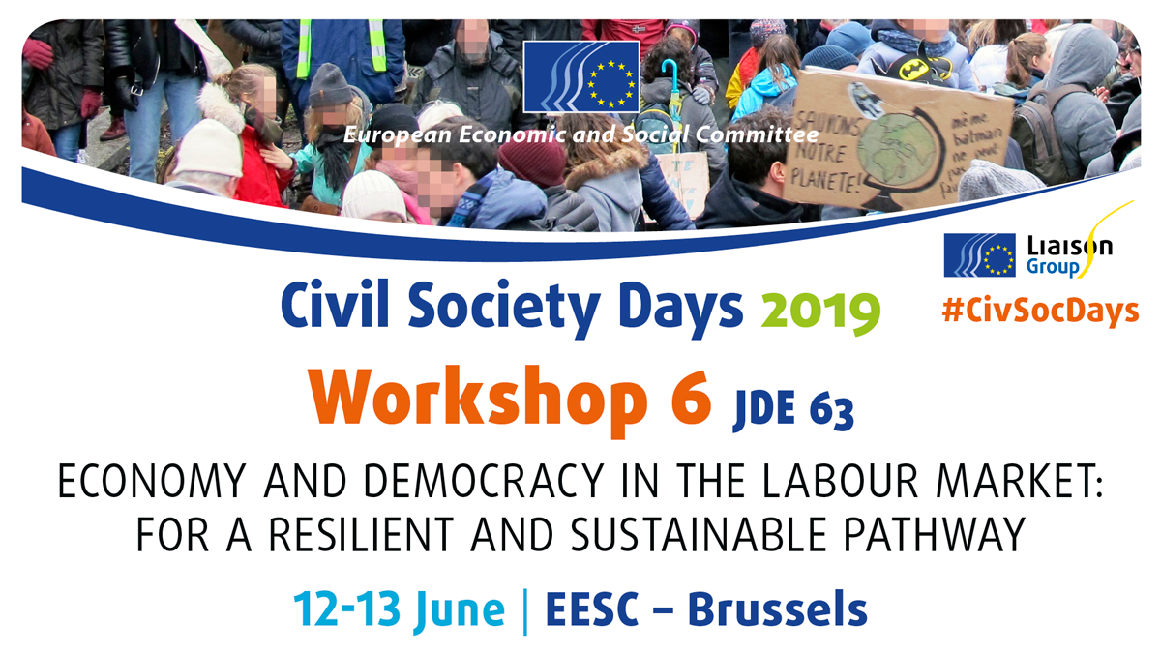

Organised by SOLIDAR, AEDH and the Section for Economic and Monetary Union and Economic and Social Cohesion (ECO), EESC

The workshop consisted of three successive panels with debates between the speakers and participants about how to establish a sustainable and more resilient EU economy, capable of absorbing internal and external shocks. In particular, the concept and practice of democracy at work was discussed as an example of, and potential driver for, a sustainable democracy.

The scene was set for the packed audience by Javier Doz, EESC member. He introduced the EESC's own-initiative opinion "Towards a more resilient and sustainable European economy", of which he was rapporteur, due to be discussed in the plenary. He provided definitions and terms of reference useful for a discussion on sustainability, making his main point being that it was not sustainable for our economic model to fail to take into account the distribution of anything but wealth. GDP should be superseded as the main indicator. In fact, the real determinants for assessing wellbeing went far beyond GDP and included the social as much as the environmental dimension affecting people's lives. The Sustainable Development Goals had to be fully embraced by the political agenda, he stated, in order to govern in a sustainable manner the transition towards a green economy, the digital revolution and the ongoing demographic and climate-related transformations. The SDGs would not just come about by themselves, though, and Mr Doz stressed the need to finance investments in social infrastructure that was essential to achieving the goals set out in Agenda 2030 and, at the end of the day, a sustainable society.

Mr Doz's introduction provided an outline for the second panel, more grounded in practice than theory, where the highlights were the contributions by Diana Dovgan, secretary general of CECOP, and Olivier Leberquier, president of the SCOP-TI workers’ cooperative.

Ms Dovgan explained why the cooperative model was the way forward for a participatory society and also how cooperatives contributed to the achievement of the Sustainable Development Goals. Indeed, the cooperative model saw equality and democracy as the core drivers. These values were not only underpinned in Agenda 2030, but also created a multiplier effect for businesses and actions both within organisations and beyond, with a positive spill-over effect for the community surrounding cooperatives. Moreover, at a time when there were demands for democracy to become more participatory, cooperatives offered a model for a participatory decision-making process. In a nutshell, cooperatives were a democracy lab, said Ms Dovgan, and for democracy at work to become a more widespread reality, alliances between the cooperative movements, trade unions and civil society were essential. Nevertheless, democracy labs also encountered difficulties and obstacles.

Mr Leberquier gave a impassioned account of an example by recounting his personal story, deeply intertwined with that of the SCOP-TI workers' cooperative. He captured the audience’s attention as he talked about how he and his co-workers had responded to Unilever's threatened relocation of tea production by organising a workers’ buyout. His story was one of 1 336 days of workplace occupation and a struggle against the odds, a story of overcoming hardship for the many. It made the case for hope against a backdrop of increasingly difficult working conditions for so many people in the EU and beyond, even though sceptics may suggest that this was just a lone case of a happy ending.

To counter any such objections, Aline Hoffmann – head of Europeanisation of the Industrial Relations Unit and coordinator of the European Workers’ Participation Competence Centre at ETUI – illustrated and provided evidence that democracy at work was incontrovertibly the way forward to better societies. Her presentation not only broadened the scope of the debate but also explained how the mutually reinforcing relationship between democracy at work and civic democracy operated in practice. Indeed, democracy at work was a way of implementing the fundamental right to self-determination and the principle of bringing democracy to all spheres of life. Moreover, it made the case for stakeholders’ interests prevailing over those of shareholders, and it did not entail absolute control of the company by any one party. Finally, it led to equality-driven company boards. Overall, it had clearly helped to achieve the SDGs in a manner that was better and faster, not least by improving the life satisfaction of those involved.

The panellists' interventions and the related discussions with the audience were summarised on flipcharts to help the discussion develop consistently and reach the final recommendations of the workshop.

Final recommendations

A resilient and sustainable European economy needs democracy at work. Important components are freedom of organisation, workers' participation and social dialogue.
- The EESC should come up with concrete policy proposals on how to reinforce democracy at work in an own-initiative opinion, based on the evidence that democracy at work and civic democracy are mutually reinforcing
- The existing tools for democracy at work already entailed in the acquis communautaire should be enhanced and consistently implemented.

