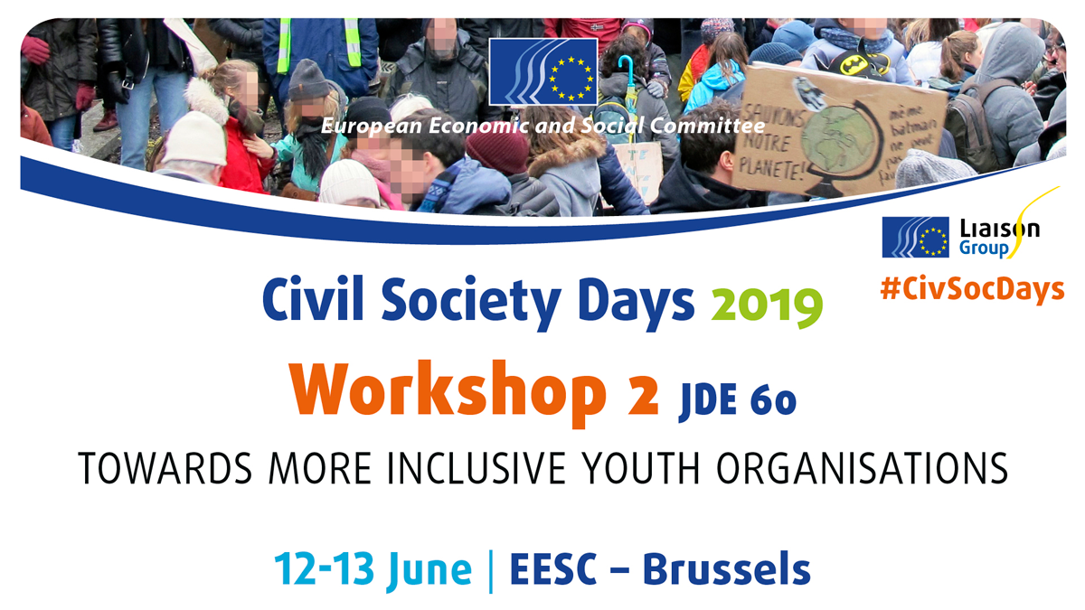
Organised by the Young European Federalists (JEF), the European Youth Forum and Rurality – Environment – Development (R.E.D.)

The workshop consisted of three main sessions. It kicked off with the moderator of the workshop and the president of the Young European Federalists (JEF), Milosh Ristovski, briefly outlining why working towards more inclusive youth organisations was important for resilient and sustainable democracy in Europe.

Mr Ristovski pointed out that sustainable democracy was impossible to achieve without involving all parts of society in democratic processes and promoting citizens’ engagement, saying that young people from different backgrounds could be activated through civil society's youth sector.

The participants were first split into four main discussion groups according to discuss the following questions, where they were asked to identify challenges that youth organisations faced in being more inclusive:

- What challenges do you face in attracting diverse groups of young people to your membership? Why?
- What challenges do you face in ensuring diversity in the governance of your organisation? Why?
- What challenges do you face in reaching out to diverse groups of young people? Why?
- What challenges do you face in creating sustainable structures to ensure diversity within your organisation, and why?

Participants identified challenges related to communication and appealing to different groups of young people, financial constraints in supporting the participation of young people from more disadvantaged socio-economic backgrounds or young people with disabilities, and the lack of capacity of youth organisations for broader outreach, to name just a few.

After identifying the main challenges, workshop participants were invited to seek inspiration for solutions and best practices for inclusion from experts in the panel discussion.

The panellists presented their respective organisations, the work they did and how it linked in with the topic of the workshop. The main focus was on sharing best practices and providing suggestions on how (youth) organisations could become more inclusive.

One message that came from Pedro Puig-Calvó, from the Association Internationale des Mouvements Familiaux de Formation Rurale (International Association of Family Movements for Rural Training), was that when we thought about the inclusion of young people in rural areas, we relied a bit too much on online means, forgetting that in rural settings the necessary infrastructure was not always there. He also stressed that organisations had to change from the inside to facilitate active inclusion. Ivana Davidovska from the European Youth Forum picked up on that by mentioning the work her organisation was doing with its membership to reflect on the inclusiveness of the platform; the membership had developed guidelines to facilitate inclusion in its governance and events.

Amy Stapleton from Voices of Young Refugees in Europe pointed out that refugees were not a homogenous group, that being a refugee was a status and not the only characteristic defining a person. Refugees should thus be approached according to their different needs, including language, because this was a very prominent barrier to refugee participation. Loredana Dicsi from the European Disability Forum contributed to the debate by pointing out that very often people had multiple disabilities that have to be addressed simultaneously in order for them to be able to participate. A tailored strategy on disability with a dedicated budget for inclusion would be advisable for organisations to become more inclusive.

The workshop demonstrated that much more could and should be done if youth organisations were to be more inclusive. However, the institutions needed to support those efforts. Workshop participants then broke out into two groups to develop the following recommendations:

Recommendation 1
Digital solutions for young people in decision-making
- Invest in research and practice in using new digital solutions for including diverse groups of young people in decision-making. These tools should be created in partnership with the institutions, expert organisations and young people directly.

Recommendation 2:
Provide more funding schemes and capacity-building opportunities for organisations to become more inclusive
- Create more, and more accessible, funding programmes particularly for projects that mainstream diversity, inclusion and supported training programmes in order to strengthen the capacity of organisations (inclusive project management, monitoring, evaluation of inclusion).

