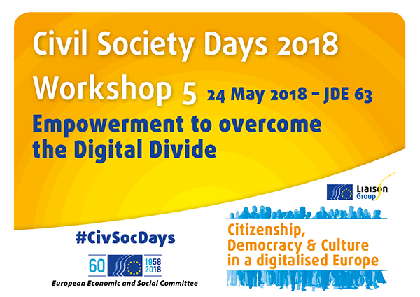

Organised by AGE Platform Europe and the European Disability Forum

Since the early days of Information and Communication Technologies to the latest breakthrough technologies today, digitalisation has completely reshuffled our way of working, socializing, providing services, doing politics… This digitalisation process is still ongoing leaving us with a lot of unresolved challenges. Among them, the digital divide remains a salient issue still in 2018! On the occasion of this workshop co-organised by AGE Platform Europe and the European Disability Forum, participants from grass-root organisations and social NGOs in Europe identified three recommendations calling for increased accessibility, co-creation and territorial cohesion.

Digitalisation: opportunities and threats

Digitalisation promotes the dream of optimized access to services, reduced costs, increased efficiency, and better opportunities for civic participation. It is supported by plenty of success stories where ICTs act as enablers for its users. For Alejandro Moledo, representative of the European Disability Forum, both mainstream and assistive technologies can alleviate some of the daily difficulties of people living with disabilities, allowing them to be more independent and participate fully in society. The example presented by Milad Ahmed of MacMillan Cancer Support also shows how a digital platform can help connect volunteers’ will to share a bit of their time with local people affected by cancer who would like a hand with everyday tasks.

Yet for these success stories to be written, it implies that devices comply with the “triple A” rule: availability, affordability, accessibility. Building on the example of the banking sector, Julia Wadoux from AGE Platform Europe recalled that more and more routine services are mainly, if not only, available online. If this digitalisation is not coupled with proper training for people who do not possess basic digital skills, many are and will be excluded.

Beyond the “triple A” rule, the fear of being excluded, of human beings to be replaced by technology, of privacy being at threat, etc. constitute key ingredients of a distrust towards digitalisation. Yet technology acceptance cannot be forced, even for people’s own safety. If GPS trackers can be very interesting for people with dementia so they can keep going outside safely, we need to make sure that safety purposes are not taking over the right to informed consent.

Divide: the origins

“The digital divide doesn’t happen by itself, it is done”, said MEP Sirpa Pietikäinen. To understand the digital divide, it is necessary to go back to the development of ICT systems, services and products. The lack of diversity among developers, who are mostly technically educated, young white men, contributes to this digital divide. “It is very difficult for them to understand how to be inclusive of others” explains Mrs Pietikäinen. This difficulty is unfortunately not addressed by testing panels that remain too small and not diverse enough to take into account a true variety of needs. In the absence of statistics for people aged 75+ (Eurostat only cover cohorts from 0 to 74), it gets even more difficult to find evidence about the situation and attitudes of the oldest old towards technology.

The uneven geographical spread of people and infrastructures also tend to exclude those staying in remote places. The low consideration of rural territories prevents them for being considered as areas for technological investment, explained Gérard Peltre, President of Ruralité-Environnement-Développement. For rural areas to remain dynamic and meet the needs of new entrepreneurs and workers choosing to telework, high broadband coverage and strong links between rural areas and urban centres must be ensured so that wherever you are, you can access to the same services.
Co-creation, design-for-all and trainings to bridge the digital divide

Ensuring accessibility, affordability and availability to be respected will only be reinforced if a high number of users with a various range of needs are involved in the development of technologies. “Nothing about us, without us”, summarized Alejandro Moledo. This is the motto that was adopted by the EU-funded MobileAge project after it noticed that many older people do not use the Internet because the offered services do not meet their needs. Prof. Herbert Kubicek explained how the project team engaged with older people and intermediaries involved in public or care service provision to question whether the product answers the needs of final end users.

At the core of the workshop discussions was also the “design-for-all” approach. Recalled several times, it was considered as the best option to strike for products and services to be as inclusive as possible. The design-for-all approach acknowledges human diversity while taking up the challenge to stretch accessibility until it is accessible for most. Thus, Julia Wadoux gave the example of the loss of ability when ageing that is different for each person.

EESC Member Tatjana Babrauskiene underlined that we are still lagging behind even among the so-called “digital natives”; statistic shows some do not have basic digital skills. Training and capacity-building are thus of key importance to achieve accessibility for all. In Greece, classes teaching tablet use are provided to older people so they get the basic digital skills to access digital devices, as explained by Myrto-Maria Ranga from AGE member 50Plus-Hellas. Trainings also need to target designers, developers and manufacturers so they take on board the design-for-all approach in their practice. That is why AnySurfer intervenes in web agencies to advise them on how to make their products accessible and in schools to teach future professionals about digital accessibility.

The importance of accessibility and supportive legislations

Plenty of issues and proposals for actions came up in the discussions. Yet the accessibility of ICT products and services to walk the same path as security or data protection in the digital world got a short majority of votes. The issue is sadly still of date since the work of AnySurfer, a project aiming at improving accessibility of websites, digital documents and applications, and presented by Sophie Schuermans, permitted to evidence that only 18% of websites are accessible in Belgium.

The proposal of a European Accessibility Act currently under trilogue negotiations between the European Commission, Parliament and Member States popped up in the debate several times as an important piece of legislation that, if ambitious enough, could create standards and requirements able to mainstream accessibility in Europe. Serge Novaretti of the DG CNECT confirmed that inclusiveness and accessibility are at the heart of policies developed by the European Commission. It is notably reflected in the Tallinn declaration on e-government, and this political stand will be further implemented thanks to a new label on citizen-centric cities.

A role for the Civil Society

The initiatives presented at the workshop provided evidence of the civil society proactivity in the field of digital accessibility. Yet with many remaining excluded, civil society must team up with other stakeholders, including decision-makers, to voice the concerns and preferences of the most vulnerable and systematically address the risks of exclusion brought by digitalisation.

Read AGE and EDF Press Release online:
http://www.age-platform.eu/press-releases/accessibility-co-creation-and-territorial-cohesion-identified-key-policy-issues

