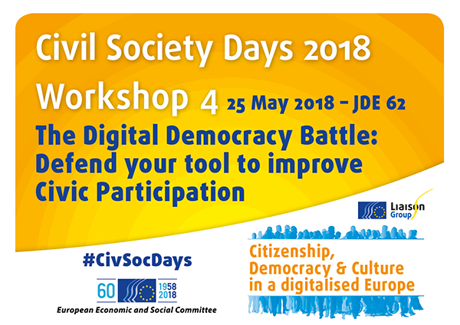

Organised by the European Citizen Action Service (ECAS) and Volonteurope

The workshop aimed to explore the potential of new e-democracy tools for more direct participation of citizens in decision-making processes. These digital tools can allow citizens to contribute with their ideas to policy-making and in the best cases, engage with their decision-makers to co-create legislations. The number of these methods and platforms has increased over the past years, as citizens are demanding more possibilities of active and direct involvement in democratic processes. The workshop stimulated a debate on the different type of e-participation tools, engaging the audience on which kind of tool citizens perceive as more effective and society would need most to contribute to active civic engagement.

Elisa Lironi, ECAS’ Digital Democracy Manager, began the workshop by introducing the speakers and the different e-participation tools that will be presented. Each tool presents unique features and functionalities tailored for specific use and serving different purposes, but all of them aim to explore new possibilities of active and direct citizens’ involvement in democratic processes. She explained the workshop’s structure and underlined the growing importance of e-participation tools that can contribute to a more open and inclusive form of policy-making. After a presentation of each tool by the speakers, the floor was open to the participants who could “challenge” the tools by asking questions to the panellists. She concluded her remarks highlighting how digital democracy tools allow citizens to contribute on different aspects and levels of decision-making processes, and they can be particularly beneficial for society.

Tom de Grunwald, presented SwapMyVote an e-participation tool created to overcome the democratic deficit emerging from the first-past-the-post voting system in the United Kingdom. During elections in the UK, a lot of votes in some constituencies are wasted because they are dominated by one party. Voting in one of these constituencies has become irrelevant for some citizens, because their candidates may have just a tiny chance of being elected. SwapMyVote would allow people who feel their vote may be wasted to swap with someone in another constituency already dominated by a certain party. He pointed out that the system is perfectly legal and the application helps citizens to connect with someone else that wants to swap its vote providing also information about the most recent polls in the selected constituency. He remarked that in the last UK general elections, more than six million people voted tactically and the tool received support from all the political parties. He concluded that SwapMyVote is an e-participation tool aimed to improve citizens’ democratic representation as it allows citizens’ votes to become more valuable. Although the tool was created for the UK’s political landscape, it is intended to be used in other countries all over the world, particularly where the first-past-the-post voting system is in place.

Doru Frantescu, Director of VoteWatch Europe, provided an overview of YouVoteEU, the most recent initiative undertaken by VoteWatch Europe, alongside other four civil society organizations in the context of the 2019 European elections. YouVoteEU is a project that includes the development of an innovative monitoring platform for more transparency in EU decision-making. The platform will be running mainly during the 2019 European Elections in order to gather the candidates of the European Parliament, who will get the chance to better promote their agenda among the electorate, and the citizens, who will get the chance to assess how their preferences match the views of the candidates, based on their previous voting behaviour. It is a voting advice application that will collect actual facts and decisions raising citizens’ awareness. Furthermore, EP candidates, citizens, stakeholders, and organisations will benefit from the platform as different views will be equally represented on it. He remarked that YouVoteEu is particularly important for citizens because it provides information about the voting behaviour of their representatives in the European Parliament and it will help distinguish between pure speculations and actual facts. He concluded affirming that YouVoteEu it also allows stakeholders to assess the proposals of the EU elections’ candidates.

Aline Muylaert, Co-Founder, of CitizenLab introduced an online platform that focuses on connecting local governments to citizens. She explained that in the past years citizens’ trust in governments has declined and there is a strong demand for more transparency and increased citizens’ involvement in the policy-making processes. CitizenLab’s tool aims at engaging the so-called “silent majority” by helping local governments to choose the right participation method, such as consultations, crowdsourcing or even co-creation. CitizenLab developed a method based on two criteria to achieve this objective: the degree of citizens’ influence in policy-making and the different policy phases where they can contribute. For example, citizens can generate ideas that can easily be submitted through petitions while governments engage citizens through a participation project and manage the input received. The tool is particularly useful for local governments to understand citizens’ needs based on data insights. She explained that more than 75 governments worldwide run their citizens engagement projects on CitizenLab and she presented three case studies stressing the good results achieved in very different situations. CitizensLab empowers citizens and combines a top-down and a bottom-up approach through online personalised engagement that improves the transparency of decision-making.

Nicolas Patte, Director of Communication of Cap Collectif, presented participatory budgeting as a method that allows citizens to assign part of a budget to projects proposed and chosen by them. The advantage of participatory budgeting is that opens a number of possibilities for citizens to propose where they want to allocate a certain budget and it is one of the few e-participation tools in which there is an immediate evidence of its impact. Although there are different ways of implementing participatory budgeting, Cap Collectif developed a methodology in 5 steps in order to build a relationship of trust over time and they also created a network that act as a learning community. Their participatory budgeting experiences allowed citizens to allocate around 5% of a city’s budget. He concluded by stressing the importance of making e-participation processes easy and transparent so that citizens will use these tools more often, thus enhancing civic participation.

After a Q&A session where the audience engaged the speakers and challenged the tools presented, the workshop ended with an online poll where participants answered different questions related to the e-participation tools. The results of the poll produced three main recommendations related to e-participation tools: At a local level, co-creation/crowdsourcing e-tools should be more often used to increase citizens’ engagement. At a national level, monitoring e-tools for more transparency should be more often used to support civic participation. At EU level, monitoring e-tools for more transparency should be more often used to support civic participation.

