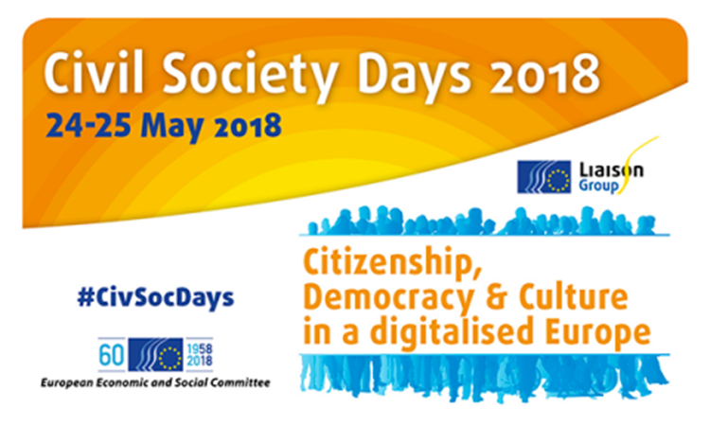
Workshop 3
Cybersecurity and data protection: at the service of the general interest
JDE 62
Thursday, 24 May 2018, 16:00 – 18:00
Organised by Association Européenne pour la défense des Droits de l'Homme, European Civic Forum and the EESC section for Transport, Energy, Infrastructure and the Information Society (TEN)

Programme
16:00 – 16:15 Opening and keynote speech
Pierre Jean Coulon, EESC Member, President of the Section for Transport, Energy, Infrastructure and the Information Society (TEN)
16:15 – 17:00 Panel: Fundamental rights
- Surveillance by intelligence services: safeguarding privacy through effective oversight
Mario Oetheimer, Head of Sector Information Society, Privacy and Data Protection - European Union Agency for Fundamental Rights.

- Corporate surveillance
Chris Wyllie, Cambridge Analytica
- Better workers’ online protection (title tbc)
EDRi
- Debate

17:00 – 17:55 Panel: European sovereignty
- "Cybersecurity act"
Laure Batut, EESC Member, President of the EESC Study group TEN/646 Cybersecurity act
- RGPD, c'est pour demain!
Maryse Artiguelong, Board Member, Association Européenne pour la défense des Droits de l'Homme (AEDH)
- Les ONG face à l'enjeu complexe de la protection des données
Guillaume Vassault-Houlière, CEO, Yes We Hack
- Debate

17:55 – 18:00 Conclusions & Recommendation
- Jan Robert Suesser, Vice President, European Civic Forum

Background information next page

Concept
Background
The workshop focuses on the issue of data protection in the European Union, in a context marked by the necessary EU response to increased cyber crises and associated risks (malware, dissemination of false information, attacks on public services).
The cybersecurity package was adopted by the Commission on 13 September 2017. This package aims to give the EU the means to apply the Directive on Security of Network and Information Systems (NIS), increase the capacity of the European Union Agency for Network and Information Security (ENISA), create a certification framework for software and IT product cybersecurity, respond to external cyber-attacks and propose ways of fighting cybercrime.
In addition, increasing surveillance at European level and the methods employed are being developed even as the legal frameworks supposed to accompany it are gradually put in place in this rapidly-developing area; how can institutions and associations ensure due respect for fundamental rights?
Methodology
Divided into 2 panels, the participants will first have the opportunity to debate and build recommendations with panelists on civil liberties and counterbalance to State and corporate surveillance, in order to preserve their fundamental rights online.
In a second time, two panelists will address the issue of European sovereignty in the digital competition. Both panels will take place in a classical format, with interventions from the speakers and inputs from the audience. A moderator will ensure the respect of the speaking time as well as the interactivity with the audience.
As an ice-breaker, the organisers will screen a short extract from the documentary NOTHING TO HIDE, as a preliminary introduction. (48:01 à 54:39)
After the presentations and questions, the participants and speakers will split into two groups, in order to draw a key recommendation from each panel, which will be then included in the final recommendations of the Civil Society Days.

Expected output
The objective is to identify one or two key recommendations. These recommendations will be proposed for inclusion in the list which will be formally adopted in follow-up to the Civil Society Days by the Liaison Group between the EESC and the civil society organizations.

