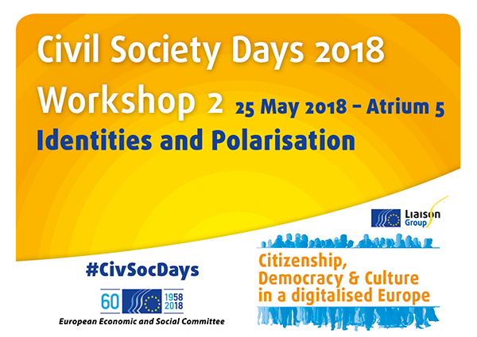
Organised by the European Volunteer Centre (CEV) and the European Federation for Intercultural Learning (EFIL)

I. Introduction
The session took the form of a “World Cafe” interactive discussion and included an overview of the current situation related to the development of identities and tendency to polarisation in the current digital world. The experts and participants contributed with their perspectives and examples of practices on how to use digital tools for bringing people together and counteract “othering”, hate speech and polarisation starting from these questions:
- What are the dangers and risks associated with digitalisation in a population of increasingly disempowered citizens as a result of shrinking civic space and reduced emphasis on civic education and critical thinking skills in education systems as concerns identities and polarization?
- The ways in which civil society can contribute to reducing polarisation and further increase intercultural awareness and understanding amongst citizens?
- How digital technologies can be best harnessed for this purpose in different circumstances and become part of solutions?

The overall objective was to consider the contribution that digital technology makes to how citizens view their own and other’s cultural identities and what is, and can be, civil society’s response.

II. World cafe discussions

a. Online Extremism & Radicalisation - causes and prevention.
Moderator: Hannah Wright Head of Research Breakthrough Media
The question that the group sought to answer was: “How can the potential of digitalisation be harnessed to provide alternative and counter narratives to extremist views in order to offer the sense of belonging that many who are radicalised are seeking?”. In addressing this question further questions were also raised:
- How important is language for integration? Eg, do you need to speak German to integrate properly in Germany? How important, if at all, is learning the languages of immigrant communities?
- Can schools and other formal and non-formal education providers do more to encourage civic participation, if we consider it as fostering integration?
- Policies should acknowledge that there are challenges facing some immigrant communities, like Islamophobia. But how do we do this without bringing attention to the lack of solutions/actions?
- Is extremism the right word to use when describing the challenges we face? Why aren’t all forms of extremism from different political perspectives mentioned equally.
- How do we ensure that civil society remains credible, as working with government is often inevitable in these situations?
- How do we empower civil society to respond to these challenges when it is often under fire itself in the context of shrinking civic space in Europe?
Participants underlined some causes and prevention measures:
- Offline is better suited to challenging extremist narratives than online, as people can talk through issues and communicate with trust.
- Countering narratives directly can lead to entrenching of ideas, rather than critical thinking and reflection.
- Fake news and disinformation abounds, and is hard to counter.
- Online initiatives can struggle to appear credible.
- Work in schools and with NFE providers might be more appropriate than pumping resources into online. There is a captive audience and a level of trust (hopefully) in teachers as messengers.
- Often, civil society lack the skills to produce slick and sophisticated content that might challenge that of extremist organisations. Whose responsibility is it to upskill civil society in this regard?

b. Non-formal education fostering competence for the digital world.
Moderator: Izabela Jurczik-Arnold, Head of Training at European Federation for Intercultural Learning (EFIL)

During the world cafe three main questions were analysed and answered by participants:
- What are the examples of NFE schemes & projects which foster competences for the digital world?
- What are these competences?
- How can the potential of NFE be better used to prevent polarisation, especially in the online context?
All the rounds agreed that Non-Formal Education (NFE) doesn’t, but it should also be a part of formal citizenship education.
The competences NFE can foster are: to help the intercultural dialogue through the use of strategic wording; the critical attitude to credibility in order to create strong awareness on citizens; the non-violent communication in a digital wording world that is becoming more and more aggressive, by spreading openness to difference and enhancing empathy.

Non-formal Education (NFE) is focused on the needs of the learner but in order to foster competences for the digital world participants underlined:
- Need to develop skills for having a constructive dialogue
- Need for competencies to analyse and read information

NFE must have a background in Formal Education (especially in primary school), but room of movement from FE should be guaranteed to NFE, as a more flexible kind of education, adapting faster to changes than Formal Education. Assuming this, a more trained and aware FE, allowing the development of NFIL environments, fosters digital competences.
A guarantee is Intercultural Dialogue achieved and assured through openness to otherness and the importance of empathy.

But to break the NFE bubble while communicating with people of opposite believes in a non-violent way, crucial steps are:
- Use of Soft SKills such as #nohate communication and capacity of being critical (competences needed to both structure a message online and to behave positively online and included in school communication);
- Be understanding when participating in delicate dialogues;
- Some control of the content by CSOs;
- Use of reliable websites (like Historiana Europeana) where reliable stands for validated, edited, controlled, eurated, referenced.

c. Erasmus+ Virtual Exchanges - new online educational programme.
Moderator: Jose Diez Verdejo, European Commission DG EAC Unit C3 – International Cooperation

This discussion focussed on how Erasmus Virtual Exchanges can reduce polarization and increase intercultural awareness and understanding.
The conclusions drawn focussed on a number of different aspects:
1) EVE on smartphones:
- Possibility to post/share with peers in the virtual exchange programme (asynchronous)
- Sharing knowledge/ successes of the participation on social media with peers
- Virtual Exchange complement in - person: be more inclusive
2) Language used:
- Opportunities for individuals to just sign up and participate
- Facilitators act as translators to have exchanges between 2 countries? (eg Hungary-Tunisia)
  - Maybe more for asynchronous exchange
  - Also use google translate, duolingo, etc.
- Involve young people studying Arabic (English + French & arabic)
3) Young people involvement by giving incentives:
- Recognising their skills (badges, certificates, etc);
- Give incentives to Youth organisations to engage people (particularly those not in HE). Youth Organisations need to get people on board, acting as facilitators.
4) Connect with employment agencies
5) Synergies between HE and NFE to provide IT facilities

III. Conclusions (Final recommendations on the ways in which civil society organisations (CSOs) can contribute to reducing polarisation and further increase intercultural awareness and understanding amongst citizens, and how digital technologies can be best harnessed for this purpose in different circumstances and become part of solutions:
- Online initiatives with specific learning outcomes eg critical thinking, openness to difference, intercultural dialogue should be promoted & expanded.
- Morecross-sector & multi-institutional actions including synergies between Formal & Non-Formal Education should be undertaken in order to reach a wider diversity of citizens
- CSOs should be supported to have greater outreach to promote & demonstrate equality, inclusivity & participation in civic life, including in the online context.

