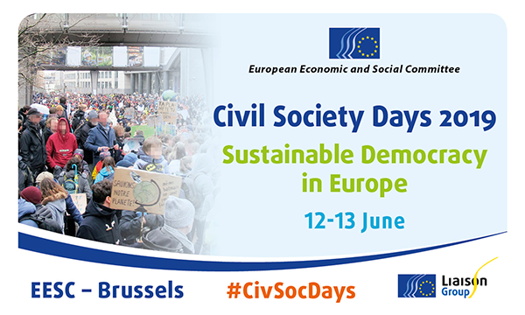
Workshop 2
Towards more inclusive youth organisations
JDE 60
Wednesday, 12 June 2019, 14:30 – 17:30
Organised by:
Young European Federalists (JEF), European Youth Forum
and Rurality – Environment – Development (R.E.D.)

Programme:
12 June 2019, 14.30 - 17.30. Moderator: Milosh Ristovski (JEF Europe)

14:30 - 14:40 – Introduction to the Civil Society Days, short presentation of the program of the workshop.
14:40 - 14:50 – Introduction of the first discussion:
- division of the participants in four groups
- presentation of the discussion questions per group. The aim of the discussion is to discuss challenges and share experiences, without touching upon solutions. Questions to the small group (one question per group):
a. What challenges do you face in attracting diverse groups of young people to yourmembership? Why?
b. What challenges do you face in ensuring diversity in the governance of your organisation? Why?
c. What challenges do you face in reaching out to diverse groups of young people? Why?
d. What challenges do you face in creating sustainable structures to ensure diversity within your organisation, and why?

14:50 - 15:15 – Time for discussion in the small groups
15:15 – 15:25 – Presentation of the group discussions.
15:25 – 16:45 – Panel discussion sharing best practices in answering the challenges identified in the previous group discussion:
- Pedro Puig-Calvó Secretary General, Association Internationale des Mouvements Familiaux de Formation Rurale
- Amy Stapleton, Voices of Young Refugees in Europe (VYRE)
- Loredana Dicsi, Internal Communication & Membership Officer, European Disability Forum
- Ivana Davidovska, Membership and Capacity Building Officer, European Youth Forum
- Moderated by Milosh Ristovski, Secretary General, JEF Europe
16:45 – 17:15 – World café style among the participants and panelists in small groups to formulate policy recommendations on how to support youth organisations and other civil society actors in reaching out to more diverse groups of young people.
17:15 – 17:30 – Presentation of the recommendations and closing remarks.

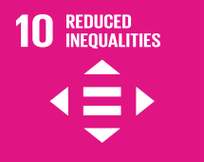
Concept
The sustainability and resilience of our democracies is essential for the Future of Europe, especially during these turbulent times in which we live, both in urban and rural areas. To create a more sustainable society and economy, we need to focus on inclusivity and diversity: sustainable democracy is impossible without involving all parts of society in the democratic processes and promoting citizenship engagement.

In the youth sector, we witness the biggest engagement of youth rights activists coming more from urban areas and less diverse backgrounds, while the engagement and representation of other groups of young people remain relatively low. To ensure that democratic civic engagement is sustainable in the long run, it is important to promote involvement in youth civil society among young people from different backgrounds: from rural areas, young migrants, persons with disabilities, and others.

This workshop will reflect on the main challenges youth civil society faces internally, and in working with young people all over Europe. It will give space to the organisations working on inclusion of different groups to share their best practices and help shape solutions to the challenges identified. Together with all the participants, we will make recommendations to policy makers on how institutions can support youth civil society in reaching out to more diverse groups, as this is an important step towards a more inclusive European democracy.

