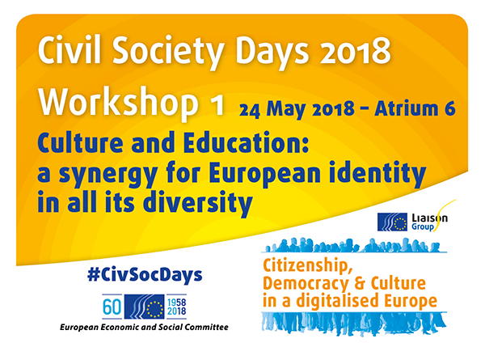
Organised by the Lifelong Learning Platform (LLLP), Culture Action Europe (CAE), the European Federation for Intercultural Learning (EFIL) and the EESC Section for Employment, Social Affairs and Citizenship

The workshop consisted of three distinct sessions. In the introduction, Ms Christa Schweng, President of the SOC section in the Economic and Social Committee, opened the workshop and reminded participants that education and culture are the drivers of our society. She leaned upon their role in shaping future and present citizens, and warned participants that education is not only meant to access the job market, but that it is first and foremost a means of self-development.

The participants then split into three separate break-out sessions, where they were able to tackle three different subjects in an interactive and participatory way. The three break-out sessions:

- European culture and heritage in digital times - Corinne Szteinsznaider, Coordinator of Michael Culture Association, Teresa Badia, Secretary General of Culture Action Europe
- From education to citizenship in diverse societies - Joke Van der Leeuw Expert from EUROCLIO, and Brikena Xhomaqi, Director of Lifelong Learning Platform (LLLP)
- Intercultural Learning through online and in-person encounters, Izabela Jurczik-Arnold and Alma Dóra Ríkarðsdóttir, European Federation for Intercultural Learning

Participants of the workshop 'European culture and heritage in digital times' explored various themes related to the attempt of overcoming power imbalances and shaping the circulation of cultural practices and a shared past in the digital world. The workshop opened a dialogue about the prospective notion of cultural diversity flourishing in the new digital world through different subject matters including education, governmental institutions, languages, and contemporary creation based on a shared past. From the discussion, a key recommendation was to build links between culture and education to ensure cultural expression online and the skills necessary to decode and critically assess cultural content online. Digital archives and digitisation were also discussed. Participants agreed that the process of digitisation needs to include diversity as a core criteria, reflecting a nuanced understanding of who contributed to our past.

Ms Van der Leeuw-Roord opened the second break-out session highlighting the role of education in defining citizenship and a sense of belonging to a community. Stemming from the necessity to address the role of civil society organisations and education sectors, the session sought to tackle the ways in which education can contribute not only to the definition of citizens, but also to the active participation in communitarian life. Participants brought their perspective to the discussion: one of the most essential steps was deemed to bring public authorities closer, and establish true cooperation between public bodies and all education sectors. This was considered to be necessary in order to truly empower educators. Linked to this topic, participants agreed that teachers and trainers need to have the means - in terms of resources, funding, training, and space and time - to be able to thoroughly address citizenship issues within their education programmes.

In the third break-out session Izabela Jurczik-Arnold and Alma Dóra Ríkarðsdóttir introduced the concept of intercultural exchanges and how these have evolved over time, shifting from being an organised mobility experience, to a more spontaneous experience, happening also at local level and including online interactions. Intercultural encounters can definitely happen also online and are all around us, but what makes them meaningful intercultural learning experiences is the facilitated and guided reflection. Participants discussed how blended learning combining in-person and online and media literacy would be the key for fostering intercultural learning in digital societies. A particular focus should be put in training educators in using online tools and being aware of their assets, and downsides, in order to be able to choose pedagogical methods accordingly.

At the end of the three break-out sessions, participants were brought back together to vote on the main recommendations. A word cloud was introduced to best describe the flow of the discussions, and it was noticeable that the most voted word was “diversity”. Afterwards, participants had the opportunity to vote for the recommendations that the whole workshop would have brought to the plenary.

Final recommendations
- Civil society organisations can have a role in ensuring a plurality of voices
- More efficient communication by EU about benefits and achievements + avoid propaganda
- Facilitation and reflection are needed for intercultural learning online or in-person
- Promote media literacy of educators and learners to ensure that the appropriate tools - online or in-person.- are used to find information and learn
- Build synergies between education&culture for cultural expression and citizenship in all educational settings and lifelong learning
- Invest in tools to overcome barriers of understanding brought by cultural diversity (eg. translation)

