3rd meeting of the EU-Georgia Civil Society Platform

Tbilisi, 22 March 2018

main obstacles for successful implementation
of the Chapter 4 of Title IV: Sanitary and Phytosanitary Measures
of the EU-GEORGIA Association Agreement

Drafted by members of the EaP CSP GNP: The Centre for Strategic Research and Development of Georgia (CSRDG), The Biological Farming Association Elkana

Summary
Five main problematic issues in implementing the SPS chapter of the EU-Georgia Association Agreement have been identified by two Georgian NGOs active in this area. Those are:
- Big share of food market still occupied by the unregulated producers and sellers of food, on the one hand and smallholder farmers have market access problems on the other hand
- Weak traceability and identification of sources of unsafe food,
- Limited introduction of HACCP,
- Lack of data collection (or its initiation) for proper assessment of food-related risks,
- Inadequate provision of information to population on specific cases of identified unsafe food products on the market.
The Association Council should be requested to devote more attention to eradication of these problems and related backwardness of the reforms.

According to the article 55 of the Association Agreement Georgia has taken on an obligation to consistently harmonise its food-related legislation with the EU Acquis Communautaire to ensure that Georgian food is as safe as the European. A list of some 273 European legislative acts was adopted by the Association Council to be transposed into Georgian legislation for that purpose.

Although the country in General tries to follow the prescribed timelines of transposition of the EU acts into Georgian legislation, there are some important drawbacks which need timely attention and correction. We find 5 main aspects where backwardness in developments with regards the food safety related reform is the most troublesome:

Uncontrolled production and distribution of food products and market access problems of smallholder farmers

The issues related to uncontrolled production and distribution of food products on the one hand and market access problems of smallholder farmers on the other hand are the major problems of Georgian consumers and producers related to the particular gaps in the Georgian food safety legislation. These gaps, especially concerning limited access of smallholder farmers to markets, are also one of the main reasons behind Euroscepticism in rural areas of Georgia.

EU Regulation 852/2004 suggests that “food hazards present at the level of primary production should be identified and adequately controlled ... However, in the case of the direct supply of small quantities of primary products, by the food business operator producing them, to the final consumer or to a local retail establishment, it is appropriate to protect public health through national law, in particular because of the close relationship between the producer and the consumer.”
Georgia is considered to have already approximated its legislation with the named regulation. However the vague formulations of the relevant Georgian legislation does not provide for proper transposition of the above cited principle into the Georgian legislation. Specifically, definitions of the food business operator, are controversial, leave much space for speculation and fraud, at the same time keeping the small farmers undecided about their rights and obligations.
Georgian legislation defines four types of business operators and two types of physical persons in the food sector. Out of these 6 types, five are potentially market oriented and one is only intended for domestic use. As it is demonstrated in the figures below the food safety related requirements for those different types of operators are extremely confusing and leave plenty of grey areas for illegal and uncontrolled production and distribution of food products, leaving the law-abiding farmers, producers and other food business operators in an unfavorable position. The main problem here is that the said vagueness in the law allows dishonest producers to register themselves as “physical persons” and by that avoid obligation (and costs) of applying food safety requirements, which naturally results in unfair competition on the market.
Finally we want to pay attention to the possible market access restrictions for SMEs, traditional producers and family farms. The main reasons behind are:

- Simplified hygiene rules do not require recordkeeping which is not acceptable for markets having responsibility of full traceability system;
- Simplified hygiene rules are not adequate for traditional production and not at all apply to family production, which leaves them behind the distribution system.
This issues are of particular importance in Georgia where 50% of the population is directly dependent of the income from their farming activities and most of the local producers are small or medium size. So, these are the issues of both consumer protection and social safety for thousands of citizens of Georgia.
This was main conclusion of the discussions Organized by ELKANA recently in the framework of the “Lessons learnt Workshop Series” under the European Neighborhood Program for Agriculture and Rural Development (ENPARD), and the EU funded project “Supporting Agricultural Co-operation in Georgia.” The participants were very much concerned that those conditions put the smallholder farmers and traditional product producers in the unfavorable position. It was stressed that the food safety regulations should be organized in a way not to restrict smallholder farmers and traditional product producers from the markets.
We understand that the issue referred is complex and requires resources and long-term vision for solving, taking into account the local specific circumstances, however we believe that this is one of the most critical parts of the well-functioning food safety system in Georgia and should be solved urgently.
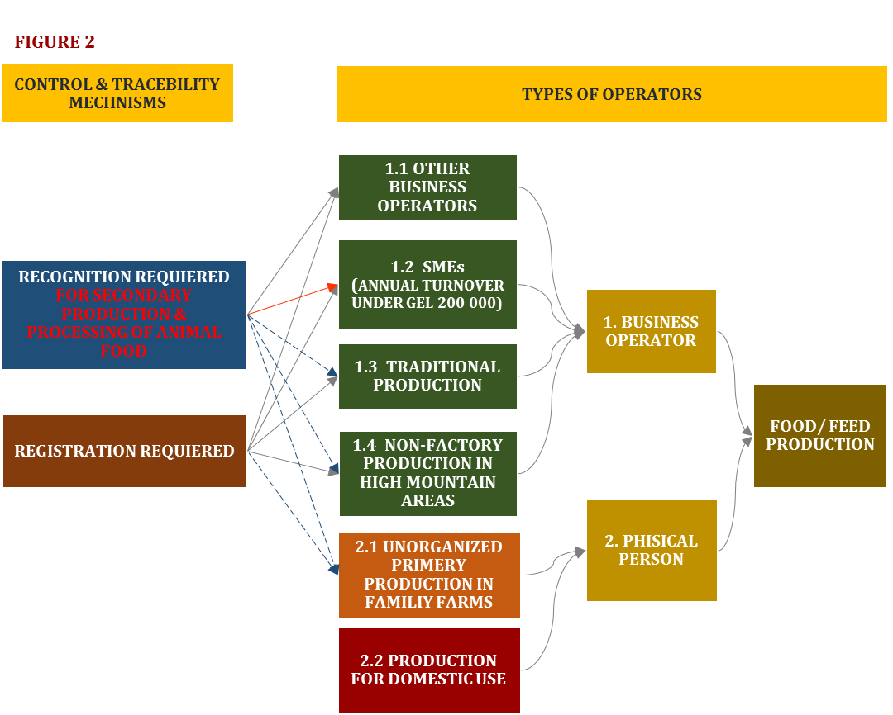

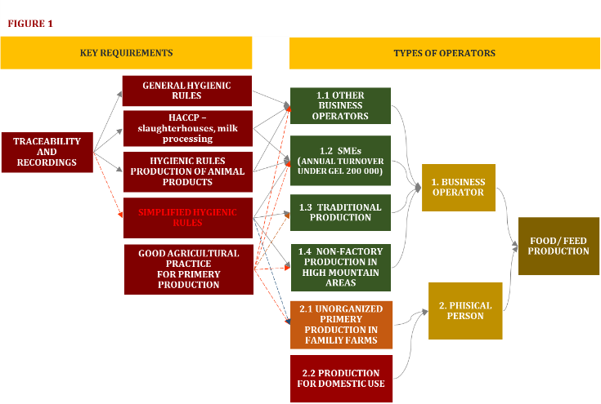
Therefore we recommend that the Government of Georgia:
  - Works on clarification of the scope of the Code of “Food/Feed Safety, Veterinary and Plant Protection” to avoid vagueness and grey areas;
  - Sets up an effective identification system which would prevent dishonest producers to pretend being a family production, SMEs or non-factory production in the high mountains;
  - Develops more appropriate and adequate rules for SMEs, traditional production and non-factory production in the high mountains, including simplified hygiene rules, derogations for the approval of secondary production and processing of food of animal origin;
  - Develops tailor made rules for particular traditional products and an alternative food safety system for the family producers (both primary and primary processing as cheese, matsoni, dried fruits etc.) in case they want to access local or national retail markets by developing simplified rules for home production and introducing schemes like group internal control.

Traceability

One of the very first packages in the list of food-related EU acts to be transposed into Georgian Legislation is so-called Food Law and Hygiene Package of EU - the bunch of acts ensuring the very basics, the necessary framework for food safety. They encompass the main elements of EU’s approach to ensuring food safety: distribution of responsibilities between the producer and the state, process-based and risk-based approach, coverage of all producers and all processes (from farm to fork approach), traceability of food and rapid alert system for informing all stakeholders about the unsafe products. It is crucial that this approaches only work in integration, none of them can ensure food safety without enacting all the others.

The traceability of food products is one of the most important elements of food safety control in EU and according to major EU regulation in food safety field, shall be established at all stages of production, processing and distribution. EU “Experience has shown that the functioning of the internal market in food or feed can be jeopardised where it is impossible to trace food and feed. It is therefore necessary to establish a comprehensive system of traceability within food and feed businesses so that targeted and accurate withdrawals can be undertaken or information given to consumers or control officials, thereby avoiding the potential for unnecessary wider disruption in the event of food safety problems”.

Both the Regulation 178/2002 establishing the traceability among the main principles of the EU food law and the Implementing Regulation 931/2011 specifying some additional requirements for traceability of the food of animal origin are included in the list of acts for approximation under the Annex XI-B of the EU-Georgia Association Agreement. In fact, Georgia is considered to have already approximated its legislation with those regulations from 2015 and the food traceability is required by the Georgian legislation.

Though implementation of those requirements of the law is questionable. For example, during its ordinary monitoring of the activities of public entities involved in implementation of food law, the CSRDG discovered that during 2013-2017 the National Food Agency (NFA), responsible for food safety control in Georgia, has identified dozens of samples of food on market with high level of lead contamination (among those were basic food items like beef cuts) though there was not a one case when the foodstuff was traced back in a way that the source of such contamination could be identified and eliminated. In some cases the National Environment Agency (NEA) was informed and requested to assist the NFA but with no result.

It is obvious that despite the provisions of the law identification of food contamination sources, even in cases where the contamination is quite a dangerous one, like high levels of lead in the food, seems to be a great challenge for Georgian authorities. Respectively authorities fail to eliminate contamination causes and carry out preventive measures for spreading of contaminated food.

We recommend that the Government of Georgia closely follows the requirements already incorporated in the Georgian legislation with regards to traceability of food products and does its best to identiry sources and reasons of food contamination /unsafe food on the market.

HACCP

As it is stated out in the par.12 of the preamble of the Regulation (EC) No 852/2004 of the European Parliament and of the Council of 29 April 2004 on the Hygiene of Foodstuffs, food safety is a result of several factors: legislation should lay down minimum hygiene requirements; official controls should be in place to check food business operators' compliance and food business operators should establish and operate food safety programmes and procedures based on the HACCP principles.

That means that in order to ensure safety of the produced food, the food business operators have to implement two sets of requirements: a) the more general and sometimes sector-oriented requirements of hygiene and good practices; and b) the very specific, concrete requirements derived from the specific setup and technology of each production line and production process. As the food production processes and lines vary widely and technologies might change quickly, those requirements are not written out in any formal documents but are to be elaborated by each business operator on the spot, in a process called HACCP (Hazard Analysis and Critical Control Points System). No food operation, except the short list like the distribution of pre-packaged food with the long shelf life, can reliably result on producing safe food without this second stage - the HACCP. Therefore the Article 5 of the 852/2004 regulation requires all food business operators carrying out any stage of production, processing and distribution of food after primary production to have established HACCP system.

Though this requirement was formally transposed into the Georgian legislation through general introduction of the concept as a separate article of the 2012 Food Safety Code of Georgia, it does not mean that the procedure is obligatory. Instead, for the list of the specific sectors for which this concept is obligatory the same article refers to the Governmental implementation acts. So far those implementing acts only require HACCP for two types of food businesses: the slaughterhouses and the milk processing enterprises. The only addition to this list since 2012 are the enterprises producing hazelnut kernels for export.

It is quite understandable that Georgia, as a country not so long ago freed from its soviet past and under strong influence of the 2004-2011 blow to the extreme Right ultra-libertarianism, cannot implement all of the EU’s thorough food safety legislation quickly and at once. But the legislation is not only to rule the present, but also to set a path (sometimes quite a long one) to the further development and to give the society, including the businesses, direction and impetus for the right development. Therefore timely transposition of the EU acquis into the Georgian legislation, even with the postponed implementation dates, serves important purpose of setting the official course of development not only for state and its citizens, but also for economics, thus influencing direction of its development and acceptance of the planned reforms by the business community.

Unfortunately both recent and previous Georgian Governments were very reluctant in giving the business correct messages and directions through setting the clear timelines for acceptance and implementation of basic principles of EU food law. HACCP is a vital system to enhance food safety. No food safety could be ensured without its introduction to at least such high risk sectors as production of meat and meat products; poultry and poultry products; fish products etc. And is it worth noting that the HACCP system is a flexible one so as to be applicable in all situations, including in small businesses. So there are no excuses to continue postponing its proper introduction into the legislation.

Our recommendation therefore is the Government of Georgia to urgently develop and adopt a clear timeline of HACCP introduction into all food sectors in Georgia.

Risk analysis

Another backwardness in AA implementation has to do with the inconsistency in implementation of different articles of AA by Georgia. Namely, requirements of the Article 55 of the AA (Gradual Approximation) are being implemented without due regard to the requirements of the Article 51 of the AA (Multilateral Obligations).

Specifically, Article 51 of the Association Agreement reaffirms the obligations of the Parties under the WTO SPS agreement; and the paragraph 1.e of the Article 50 of the AA specifically mentions implementation of SPS agreement as one of the means to facilitate trade in commodities covered by sanitary and phytosanitary measures, whilst safeguarding human, animal or plant life or health. Thus it could be stated that the AA requires Georgia not only to harmonize its food legislation with that of EU but also to implement its obligations under the WTO SPS Agreement.

WTO SPS agreement stipulates that the countries “shall base their sanitary or phytosanitary measures on international standards, guidelines or recommendations, where they exist”. Where such standards, guidelines or recommendations do not exist or a country wants to introduce or maintain sanitary or phytosanitary measures which result in a higher level of sanitary or phytosanitary protection than would be achieved by measures based on the relevant international standards, guidelines or recommendations, it may do so only on the basis of scientific assessment of risks to human, animal or plant life or health. In short, it could be summarised, that according to the WTO SPS the SPS measures of the country are to be based either on International standards or the risk analysis.

Paragraph 7 of Article 5 of WTO SPS Agreement further stipulates that “In cases where relevant scientific evidence is insufficient, a Member may provisionally adopt sanitary or phytosanitary measures on the basis of available pertinent information, including that from the relevant international organizations as well as from sanitary or phytosanitary measures applied by other Members”. In such cases, it requires though to “seek to obtain the additional information necessary for a more objective assessment of risk and review the sanitary or phytosanitary measure accordingly within a reasonable period of time”. That means that in cases where EU food safety norms/criteria are not based on international standards they can serve as a basis for the relevant Georgian norms only on a temporary basis and Georgia should seek to obtain additional information to adequately assess the relevant risks and review its regulations accordingly.

It should be noted that major part of EU food regulations are indeed based on international standards, guidelines or recommendations as requested by WTO SPS Agreement. But in some cases, the relevant international standards, guidelines or recommendations either do not exist or do not provide for the level of health protection appropriate for the EU. In such cases the EU regulations are based on risk assessments undertaken in accordance with the techniques developed by the relevant international organizations. To complain with the WTO SPS requirements Georgia also have to build up its relevant regulations on proper assessment of the relevant risks within the country. Simple translation of EU microbiological criteria and their enactment as Georgian normative act could only be sufficient on temporary basis and only if it is supplemented by real process of collection of the information necessary “for a more objective assessment of risk” (as required by the Paragraph 7 of Article 5 of WTO SPS Agreement).

Such a case is the microbiological criteria for food safety. So far, no international standards exist for ensuring microbiological safety of food and the existing guidelines and recommendations are not sufficient to ensure the high level of consumer health protection declared by the EU as its aim. Therefore the EU microbiological criteria for food safety are based on relevant risk assessments. Thus simple copying of the European microbiological criteria into the Georgian legislation contradicts the WTO SPS requirements. To avoid that, it is necessary that the country at least starts preparatory work (data collection) for assessment of the risks of the microbiological hazards covered by EU criteria on the territory of Georgia. At the same time directing more attention to the hazards and risks specific to Georgia (and not presented in EU) and developing SPS measures for their avoidance or abatement.

Since 2016 Georgia has gradually set up the formal institutional structure and distribution of responsibilities for the analysis of food-related risks. Responsibilities for the three separate but inter-connected parts of the risk assessment process has been distributed among the Government institutions, the Ministry of Environment Protection and Agriculture being the main institution responsible for risk management (including initiation of risk assessments), the Scientific Research Centre under the Ministry being the main institution for scientific assessment of risks and both named institutions responsible for risk communication activities. This system already produced some documents having to do with the assessment of food-related risks to human health and even issued recommendation to the Government on regulation of trans-fats in food, but deeper analysis of those documents reveal their extremely low quality which makes them next to useless. The main reason behind this is lack of specific, country-related data on spread of specific diseases and the factors affecting those, intake of different food by different groups of population, exposition of different groups of population to hazards in food and its impact on health conditions of the population. Understandably, without such data the Institute can only provide overviews of information available from abroad. The Institute itself lacks resources to actually undertake some research and collect the data necessary for better quality risk assessments. Therefore, it should be concluded, that Georgia does not comply with the WTO SPS requirement to “seek to obtain the additional information necessary for a more objective assessment of risk and review the sanitary or phytosanitary measure accordingly within a reasonable period of time” thus also contravening the Article 50 of the Association Agreement. The relevant policy paper has already been submitted to the Georgian authorities by the CSRDG through the EaP CSP GNP in 2016 and the meetings and discussions with the relevant authorities were held, but with no effect so far.

Our recommendation with this regards would be the Georgia Government to respect all undertaken international agreements referred in AA, including the WTO SPS Agreement requirements. For that reason the Ministry of Environment Protection and Agriculture, as a food-related risk management authority, has to initiate risk assessments or at least their preparatory stage (for ex. a research to collect the necessary data) to check the adequacy of the introduced EU microbiological criteria for Georgia.

Alerting the population on unsafe food products

According to the EU’s Food Law, “where there are reasonable grounds to suspect that a food or feed may present a risk for human or animal health, then, depending on the nature, seriousness and extent of that risk, public authorities shall take appropriate steps to inform the general public of the nature of the risk to health, identifying to the fullest extent possible the food or feed, or type of food or feed, the risk that it may present, and the measures which are taken or about to be taken to prevent, reduce or eliminate that risk”.

As mentioned above, Georgia is considered to have approximated its legislation to the Regulation 178/2002 already in 2015, so the above requirement has been transposed into the 2012 Code on Food/Feed Safety, Veterinary and Plant Protection. The responsibility for public information is an obligation of the National Food Agency.

CSRDG has monitored how NFA fulfilled the above-mentioned obligation during 2015-2017 and identified dozens of cases, when NFA did not distribute warnings to the population about unsafe food that it has discovered on the market. The very last and vivid example of this practice is the fact that the during 2017 NFA has detected 33 cases of spices on Georgian market containing excessive levels of lead, while it has named concrete products and their producers only in 4 cases. Although the NFA claims that it removed all the lots of the lead-contaminated spices detected, still failing to publicise names of producers and sellers in 29 cases means that the consumers, who have already purchased contaminated spices, were not allowed to refrain from consumption of dangerous products. Taking into account the weakness of NFA in terms of tracing back the contaminated food products (described above), the withdrawal of whole lots of contaminated spices is also doubtful. Thus only active warning of consumers on the dangers of spices placed on market would protect them from consuming the dangerous product - with listing all parameters which would help the consumer to identify the dangerous product, such as: name and brand-name (if available), package and label indications, color, condition, places of selling etc. Unfortunately, despite its legal obligation to do so, the NFA regularly fails to issue such warnings. Obviously it values interests of entrepreneurs much higher than interests of consumers.

Our strong recommendation in this case is to the NFA to keep the letter of the law and properly inform and warn the public when the dangerous food products are identified on the market, with giving away all the necessary characteristics of the food to allow the consumers to easily identify them and refrain from their consumption.

Regulation (EC) No 852/2004 of the European Parliament and of the Council of 29 April 2004 on the hygiene of foodstuffs, Par 10 of the Preamble.
Regulation (EC) No 178/2002 of the European Parliament and of the Council of 28 January 2002 laying down the general principles and requirements of food law, establishing the European Food Safety Authority and laying down procedures in matters of food safety, Art. 18, p. 1.
Regulation (EC) No 178/2002 of the European Parliament and of the Council of 28 January 2002 laying down the general principles and requirements of food law, establishing the European Food Safety Authority and laying down procedures in matters of food safety, p. (28).
COMMISSION IMPLEMENTING REGULATION (EU) No 931/2011 of 19 September 2011 on the traceability requirements set by Regulation (EC) No 178/2002 of the European Parliament and of the Council for food of animal origin.
Law of Georgia Code on food/feed safety, veterinary and plant protection; Decree of the government of Georgia №577 On adoption of general principles of traceability in the fields of food/feed safety, veterinary and plant protection.
The hygiene requirements are just pre-requisites for food safety. They are not enough to ensure that the food operator is producing safe food. See for ex. Commission Notice on the implementation of food safety management systems covering prerequisite programs (PRPs) and procedures based on the HACCP principles, including the facilitation/flexibility of the implementation in certain food businesses, C/2016/4608, OJ C 278, 30.7.2016, p. 1–32.
In the most recent consolidated version that is article 17¹ of the Code of Georgia for Food/Feed Safety, Veterinary and Plant Protection.
Decree of Government of Georgia #90 of 7th March 2012 on Special Hygiene Rules for Food on Animal Origin, Art 5 of the Rules.
The Government of Georgia Decree #261 of 25th May 2017 on Amendments to the Government of Georgia Decree #185 of 18th April 2016 on Approval of the Technical Regulation for Hazelnuts”.
See for ex. MEMO/05/498 Questions and Answers on the new EU rules on food and feed hygiene and controls, Brussels, 22 December 2005
Article 3.1 of the WTO Agreement on the Application of Sanitary and Phytosanitary Measures.
As per the par 3 of Article 3 and par 1 of Art 5 of the WTO Agreement on the Application of Sanitary and Phytosanitary Measures.
As required in the par 1 of the Article 5 of the WTO Agreement on the Application of Sanitary and Phytosanitary Measures.
Regulation (EC) No 178/2002 of the European Parliament and of the Council of 28 January 2002 laying down the general principles and requirements of food law, establishing the European Food Safety Authority and laying down procedures in matters of food safety, Art. 10.
Law of Georgia Code on food/feed safety, veterinary and plant protection, art. 22.

