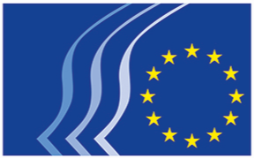
EN
European Economic and Social Committee

Brussels, 15 May 2019

RESOLUTION
Let's turn out and vote for a united Europe
_____________

Let's turn out and vote for a united Europe

On the eve of the elections for the European Parliament and taking into consideration the Declaration on the Future of Europe agreed by the EU27 heads of state or government in Sibiu (Romania) on 9 May 2019, the European Economic and Social Committee calls on EU citizens to use their right to vote.

The EU is founded on common values – democracy, protection of human rights, freedom of expression, the rule of law, tolerance, justice, equality, solidarity and democratic participation. These values need to be continuously defended and protected as they make it possible for Europeans to live in an open society where each and every citizen is respected and where a European identity, in addition to our national identity, unites us.

Today we face common and complex challenges:

- Climate change
- Social, economic and territorial inequalities
- Poverty
- Unemployment, especially among the young
- Shrinking civic space
- Migration
- Security and terrorism
- Corruption

And nationalism is not the answer.

Only through a united Europe can we make real progress on these issues.

We stand for a Europe which puts the needs of its citizens at the heart of its policies and actions and ensures that economic, social and environmental challenges are tackled together in a sustainable manner; A Europe which guarantees quality of life and employment, a favourable environment for investment and entrepreneurship, as well as increased economic and social cohesion.

We also stand for a Europe which provides opportunities for young people to fulfil their potential and promotes their active participation in the European political processes.

We, as representatives of civil society organisations are working together for an EU that delivers and more effectively meets the expectations and needs of its citizens.

We urge citizens across Europe to turn out and vote in the forthcoming European elections. We call on civil society organisations to join our efforts to mobilise a positive vote for a united Europe.

_________________

