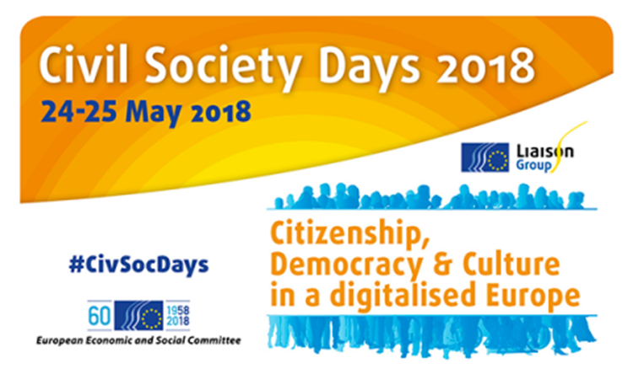
Recommendations

More than 220 civil society organisations and citizens from across Europe with backgrounds in policy making, business and education sectors participated in the CivSocDays 2018. They have been prepared by 12 European civil society organisations in cooperation with the EESC Liaison Group and EESC sections.

The following main recommendations were adopted by vote in the closing session as results of the discussions and exchanges in the six workshops:

- Build synergies between education and culture on the topics of cultural expression and citizenship in all educational settings and in a LLL perspective;

- CSOs should be supported to have greater outreach to promote and demonstrate equality, inclusivity and participation in civic life, including online;

- Control and oversight of surveillance shall be enhanced and civil society should be involved in the oversight mechanisms of surveillance;

- At a local level, co-creation/crowdsourcing e-tools should be more often used to increase citizens engagement;

- Accessibility should walk the same path as security or data protection. It should be a core aspect of ICT products and services;

- AI can and should augment workers and not replace them;

- Support and promote a Charter of digital fundamental rights of the EU.

