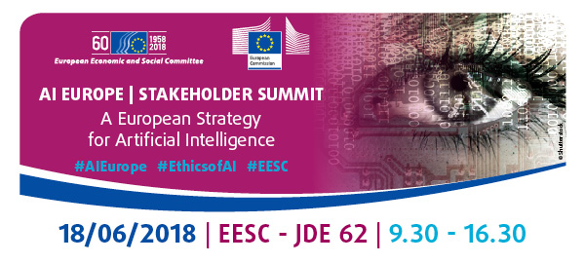

WORKING GROUP III: INDUSTRIAL COMPETITIVENESS IN AI
AI for the Benefit of Humankind

#AIEurope #EthicsofAI #EESC

This Working Group will explore the opportunities of using AI to solve major societal challenges such as healthcare, climate change, disaster relief, poverty, inequality, etc. The aim is to untap (hidden) opportunities of AI and bring people together that normally would not find each other.

Chair and moderator: Indrė Vareikytė, Member of the EESC

Co-referent: Elena Sinel, Founder, Acorn Aspirations, Teens in AI & Sara Conejo Cervantes, Artificial Intelligence Task Force, Teens in AI

Co-referent: Nicholas Hodac, Government and Regulatory Affairs, IBM

Co-referent: Karine Perset, Internet Economist, OECD

Co-referent: Preetam Maloor, Strategy and Policy Advisor, ITU

