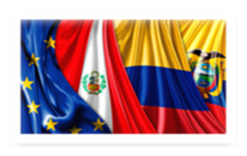

Multi-Party Commercial Agreement between the EU, Colombia, Peru and Ecuador
Title of Trade and Sustainable Development
The meeting of representatives of civil society, December 11, 2018
The draft of the joint meeting program (Brussels-Lima-Bogotá-Quito)

- Opening words

- Balance on compliance with labor obligations in the member states of the agreement
- Balance on compliance with environmental obligations in the member states of the agreement
- Balance on compliance with commercial obligations in the member states of the agreement
- The participation of civil society in the implementation of the Agreement
- Discussion on key messages from civil society to the Parties

