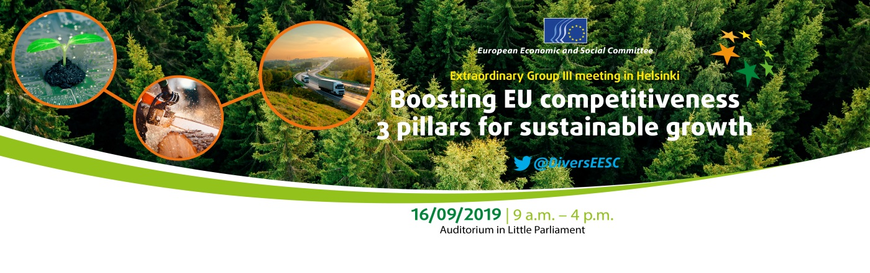
Annex Building of the Finnish Parliament, Arkadiankatu 3, 00101 Helsinki

PROGRAMME

8.45 a.m.  9.30 – 10.15 a.m.  10.15 – 11.30 a.m. | Registration & Welcome Coffee  Opening Session  - Mr Arno Metzler, President of the Diversity Europe Group  - Mr Jari Partanen, State Secretary  - Mr Johannes Koskinen, Chairman of the Eduskunta's Finance Committee  - Mr Juha Marttila, President of the Central Union of Agricultural Producers and Forest Owners  - Mr Jyrki Mäkynen, President of the Federation of Finnish Enterprises (Suomen Yrittäjät)  PILLAR I: BIOECONOMY AND CLIMATE NEUTRAL EUROPE  Moderator: Mr Simo Tiainen, Member of the Diversity Europe Group, Director of the Central Union of Agricultural Producers and Forest Owners  - Mr Juha Nousiainen, Senior Vice President - Carbon-neutral Milkchain, Valio  - Ms Salla Ahonen, Vice President, Sustainability, NESTE  - Mr Mindaugas Maciulevičius, Vice-president of the Diversity Europe Group – Rapporteur of the NAT/758 Opinion Communication updating the 2012 Bio-economy Strategy  - Q&A
11.30 a.m.  12.45 p.m.  12.45 – 2 p.m.  2.30 – 3.45 p.m.  3.45 p.m. | PILLAR II – DIGITALISATION  Moderator: Ms Baiba Miltoviča, Vice-president of the Diversity Europe Group, International and EU Affairs Adviser of the Latvian National Association for Consumer Protection (LPIAA)  - Mr Pekka Ala-Pietilä, Chair of the EU’s High-Level Expert Group on Artificial Intelligence (AI HLG)  - Mr Joonas Mikkilä, Head of Digital and Educational Affairs, Federation of Finnish Enterprises (Suomen Yrittäjät)  - Ms Evangelia Kekeleki, Member of the Diversity Europe Group  Co-rapporteur of the TEN/691 Opinion Transport, energy and SGI as drivers of sustainable EU growth through digital revolution  - Q&A  Lunch Buffet  PILLAR III – INFRASTRUCTURE  Moderator: Mr Pasi Moisio, member of the Diversity Europe Group, Head of the Brussels office and permanent representative to the EU for the Federation of Finnish Enterprises and a consortium of eight Finnish sectoral associations within transport and mobility  - Ms Anna-Kaisa Itkonen, European Commission, Spokesperson for climate action and energy  - Mr Jorma Mäntynen, Director of the Business and Logistics Unit, WSP Finland Ltd  - Ms Sabina Lindström, Director-General of the Networks department, Ministry of Transport and Communications  - Q&A  Closing remarks  Mr Arno Metzler, President of the Diversity Europe Group

