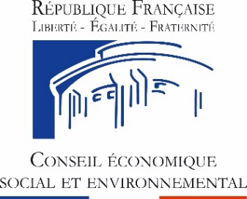
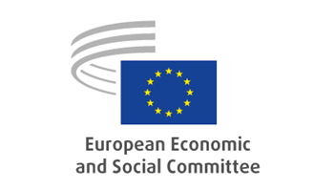

Annual meeting of the presidents and secretaries-general
of the Economic and Social Councils of the EU and the EESC
9 September 2020 (videoconference)

The challenges of contemporary participatory democracy in a Europe that is rebuilding itself: an initial contribution from the Economic and Social Councils and similar institutions
to the Conference on the Future of Europe

Programme (04/09/2020)

Wednesday, 9 September 2020
2.00 – 3.00pm | Connection tests – access to the INTERACTIO platform
3.00 – 4.30pm | Welcome adress: Patrick Bernasconi, president of the Economic, Social and Environmental Council and Luca Jahier, president of the European Economic and Social Committee  Panel discussion: « The contribution of the ESCs to the Member States' recovery plans»  Moderated by Carole Couvert, vice-president of the Economic, Social and Environmental Council  Intervention by Karl-Heinz Lambertz, member of the European Committee of the Regions and Brikena Xhomaqi, co-chair of the EESC-Liaison Group
4.30-4.45pm | Adoption of a joint document
4.45 – 5.00pm | Technical break
5.00 – 6.30pm | Formal sitting:  «The Conference on the Future of Europe and the role of ESCs»  Opening address: Luca Jahier, president of the European Economic and Social Committee  Dubravka Šuica, vice-president of the European Commission (video-message)  Klára Dobrev, vice-president of the European Parliament  Clément Beaune, secretary of State for European Affairs, government of the French Republic  Enrico Letta, dean of the Paris School of International Affairs at Sciences Po (Paris)  Closing address: Patrick Bernasconi, president of the Economic, Social and Environmental Council

Interpretation: 2/2 from FR/EN into FR/EN

