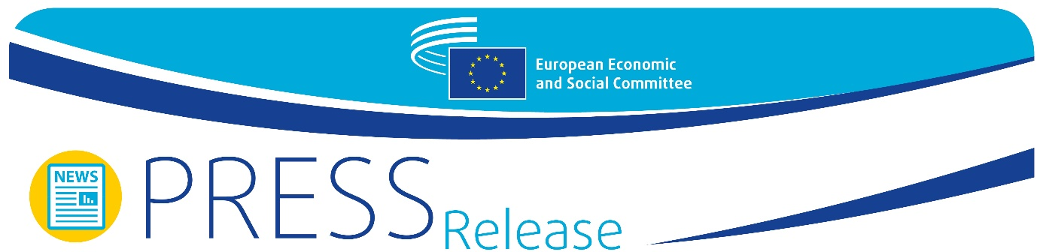
No 7/2022 | 23 February 2022

EESC says EU needs to turn to a prosperity-oriented economic framework

The European Commission relaunched the public debate on the review of the EU economic governance framework in October 2021, almost a year after it was put on hold. Following up on this relaunch, the European Economic and Social Committee (EESC) and the European Commission's Directorate-General for Economic and Financial Affairs (DG ECFIN) held a joint online conference as part of the public debate. The event, split into two presentations and panel discussions, aimed to engage civil society so as to build consensus on the future of the economic governance framework.

"The biggest challenge for the EU now is to ensure a balanced recovery throughout Europe, while laying down a path towards a resilient and sustainable future", said EESC President Christa Schweng in her opening keynote speech. "Instead of a return to normal, the Committee advocates for a turn to a revised and rebalanced prosperity-oriented economic governance framework." She also highlighted the need to involve all key stakeholders, including civil society organisations, "to ensure the transparency and accountability of the framework and to establish a balanced economic policy across the EU".

The Commissioner for Economy, Paolo Gentiloni, followed on: “The Commission’s objective is to build a consensus on the new economic governance well in time for 2023. This will not be an easy task, but we must seize this unique opportunity to align our fiscal rules with our ambition for strong, sustainable and inclusive growth in Europe. The involvement of civil society and social partners in the review is key to the success of this process. This conference is a great occasion to bridge different perspectives and work to find new solutions together."

Social cohesion, debt sustainability and growth

Margarida Marques MEP kicked off the first session of the day by presenting the European Parliament's report on the review of the macroeconomic legislative framework, for which she was rapporteur. This was followed by a panel discussion and Q&A session on social cohesion, debt sustainability and growth. The panel, chaired by the President of the EESC's Section for Economic and Monetary Union and Economic and Social Cohesion, Stefano Palmieri, considered a variety of issues, including what drives public debt, how to deliver fair outcomes and whether the focus should be on consolidating public finances or prioritising structural reforms.

Re-designing the framework for the twin transition

The second session was dedicated to how a renewed economic governance framework could resolve the investment gap challenge to achieve the climate and digital transition. As an introduction to the debate, EESC rapporteur Dominika Biegon presented her own-initiative opinion "Reshaping the EU fiscal framework for a sustainable recovery and a just transition". The EESC's main proposal is to introduce a golden rule for public investments, in combination with an expenditure rule, which could also complement the EU Recovery and Resilience Facility. It also calls for debt reduction paths to be made more flexible and more country-specific and for national parliaments, the European Parliament, and civil society to be given a more prominent role in the EU’s economic governance framework.

DG ECFIN Director-General Maarten Verwey closed the event with four takeaway conclusions:

1. Fiscal policy remains key in the twin transition and the recovery in the EU
2. Public and private investment must be intensified, and actively promoted by the framework
3. There is a need for the framework to be simplified and for stronger national ownership
4. The macroeconomic imbalances procedure should be flexible enough to pick up new emerging risks

"The European Commission is still in listening mode at the moment, but intends to come up with a proposal by mid-2022", he concluded.

For more information, please contact:
EESC Press Unit – Thomas Kersten
+32 (0)2 546 8931
thomas.kersten@eesc.europa.eu
@EESC_PRESS
VIDEO: The EESC from the inside

If you no longer wish to receive these messages, please send an email to: press@eesc.europa.eu

The European Economic and Social Committee represents the various economic and social components of organised civil society. It is an institutional consultative body established by the 1957 Treaty of Rome. Its consultative role enables its members, and hence the organisations they represent, to participate in the EU decision-making process.

