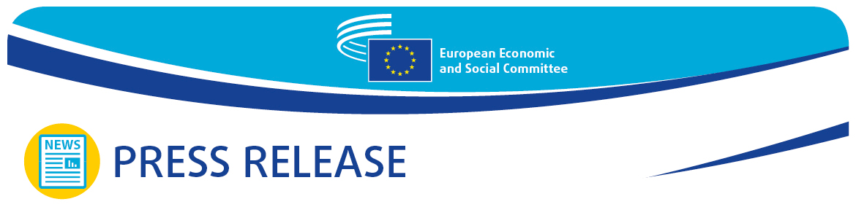
PRESS RELEASE No 22  EN | Date 18 May 2022

In front of the EESC members President Charles Michel comments on prospect of Ukraine EU membership and calls for the creation of a European Geopolitical Community.

The May plenary session of the European Economic and Social Committee (EESC) hosted a debate led by its President Christa Schweng and the President of the European Council Charles Michel on Europe's response to this turning point in history. For the first time Charles Michel introduced the idea of the creation of a European geopolitical community.

Opening the debate, the EESC president Christa Schweng referred to the devastating consequences of the war for the Ukrainian people, the soaring food and energy prices, underlining the importance of achieving the green and energy transition with the involvement of the organised civil society.

The EESC president also stressed: "United we must face the consequences of the war in Ukraine and the geopolitical challenges ahead. It is high time to explore using frozen Russian assets in the post-war reconstruction. Europe must evolve from a champion in crisis management to a world champion in shaping the future".

"The Kremlin has been wrong: about its own military capabilities, about the strength of Ukrainian resistance, about European determination and unity" said the president of the European Council, Charles Michel. To underpin his statement about European unity, he referred to the European summit in Versailles where the EU leaders took far reaching decisions on joint energy and defence policies, domains which had until then be essentially governed by national decision making.

Charles Michel proposed a new approach to enlargement negotiations. Given the slow progress of the negotiations with the Western Balkan countries and fresh membership applications by Ukraine, Georgia and Moldova the EU should envisage a " proportionate and managed integration" approach. According to Michel, "A solution would lie on a gradual and progressive integration during the accession process". When a country meets the necessary standards in a given sector or reaches certain benchmarks it would benefit from European programs and funding.

European Council president also talked about the creation of a European geopolitical community as the EU assumes greater political leadership. Foreign policy would be a major area of cooperation within this Community. "The aim is to forge convergence and deepen operational cooperation to address common challenges, peace, stability and security on our continent", said the president.

A conference will be held around or after summer and will bring together the 27 EU leaders and those of the partner countries to discuss the concrete steps for this new project.

On the other hand, president Michel clarified: "This initiative is in no way intended to replace enlargement or to find a new excuse to procrastinate. Nor is it a guarantee for those to participate that they will one day be a member of the EU".

In the debate that followed, the EESC members expressed their views on the economic and social aspects of this new political context, insisting on a more social and inclusive Europe based on the common fundamental rights and values.

Oliver Röpke, president of the EESC's Workers' Group stressed "Russia's aggression against Ukraine and the Covid-19 pandemic clearly demonstrated the importance of the decisions we are asked to take about the future of our Union. The Conference on the Future of Europe was only a starting point for a long-needed renewed discussion on implementing some fundamental changes".

Séamus Boland, president of the EESC's Diversity Europe Group, underlined that "The EU needs emergency measures to alleviate the high prices faced by consumers, it should massively increase the tariffs on Russian energy and should remain united around our European values".

The president of the EESC's Employers' Group, Stefano Mallia, said: "We cannot afford to be divided on the war in Ukraine. We must maintain the unity of action, when it comes to impose large-scale sanctions against Russia or offering Ukraine a European perspective. This comes also with creating trade corridors so that we can increase imports of Ukrainian goods".

Closing the debate, the EESC members underscored the need for the European Council to endorse the proposals delivered at the Conference of the Future of Europe and include the social partners in this new economic and social structural plan.

_______________________________________________________________________________
The European Economic and Social Committee represents the various economic and social components of organised civil society. It is an institutional consultative body established by the 1957 Treaty of Rome. Its consultative role enables its members, and hence the organisations they represent, to participate in the EU decision-making process.
_______________________________________________________________________________

