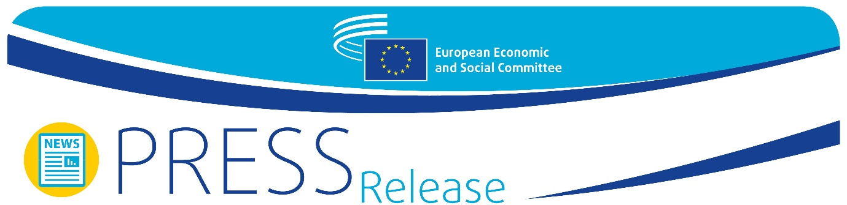
EN | Brussels, 3 June 2020

Next Generation EU recovery plan – An unprecedented exercise in solidarity

A few days after the European Commission presented its proposal for a major recovery plan to face the consequences of the COVID-19 pandemic, on 2 June the European Economic and Social Committee (EESC) held a webinar to assess its suitability. All participants agreed on the importance of this ambitious initiative, an example of the solidarity and the political will of all EU Member States in times of uncertainty.
The recovery plan proposed by the Commission, called Next Generation EU, consists of extraordinary funding of € 750 billion to be invested across three pillars: a new recovery and resilience facility of € 560 billion which will be allocated to Member States with a mix of loans and grants (45/55%); a new Solvency Support Instrument with a budget to support private companies; and a third pillar, called "Addressing the lessons of the crisis", that includes a new health programme, EU4Health, to strengthen health security and prepare for future health crises.
All participants in the webinar, called "Recovery Now: How to turn the Commission's #NextGenerationEU plan into a success, leaving no one behind" agreed on the timely and ambitious response given by the European Commission in its proposal.
Valdis Dombrovskis, Executive Vice-President of the European Commission, highlighted the quick response of the EU institutions to the crisis, with a safety net already in place to protect workers and people's incomes: "Member States should use these instruments to save jobs and ensure liquidity, specially for SMEs. The money is already there, and it is reaching companies and citizens".
This was also the main message delivered by Luca Jahier, President of the EESC, who mentioned the unprecedented capacity of solidarity shown by the EU: "Europe has done in two and a half months more than in the four years that followed the financial crisis; this is the result of an enormous political consensus". He also pointed to the strongly positive reaction of the financial markets after the plan was announced, and explained that this was because the proposal shows solidarity, clear goals and is in line with the main EU strategic priorities, namely the Green Deal and digitalisation.
This view was also shared by Irene Tinagli, Chair of the Committee on Economic and Monetary Affairs (ECON) of the European Parliament: "This proposal shows that the EU is ready to do whatever is necessary to overcome the crisis; this will only be possible if all EU countries work together in a determined way", said Ms Tinagli.
Amélie de Montchalin, French Minister of State for European Affairs, was of the same opinion, and mentioned the importance of preserving the internal market as "no country can overcome this crisis on its own". She also pointed out that the Commission's proposal includes not only an ambitious recovery plan, but also a long-term investment plan "to ensure the EU finds its place in a complex world".

The issue of implementation
All participants in the webinar outlined that the key challenge is now that citizens and companies benefit as soon as possible from the recovery plan.
"What matters most now is implementation. This is mostly in the hands of individual Member States, but we need clear rules to make sure that money reaches the people that need it", said Luca Jahier.
On this topic, Valdis Dombrovskis explained that most of the funding will be accompanied by proposed allocation that will take into account the circumstances of each Member State: prosperity, unemployment rate, prevalence of the COVID-19 pandemic, etc. "Member States must prepare recovery plans that are in line with the needs identified and with EU strategic policies", Mr Dombrovskis said.
Irene Tinagli said that all the procedures should be accelerated and insisted on the need to ensure that "the plans go hand in hand with the needs", avoiding the pro-cyclical effects that other plans have had in the past. She also recalled that we are at the beginning of the process, so it is still hard to say how fit for purpose the recovery plan will be.
The issues of timing and implementation were also mentioned by Amélie de Montchalin, who insisted that all proposals should be in place after the summer. "We know we cannot fail, and the only way to succeed is to work together. We need to be courageous: this is not a technical agreement, it’s an agreement on a vision", she argued.
Luca Jahier concluded that the vision is already there, and it is a vision of solidarity and political ambition: "The EU has faced the worst crisis of its history, but it has also given the fastest response. Now I am more convinced than ever that we are at the beginning of a real rEUnaissance. We will not have a second chance".

For more information, please contact:

EESC Press Unit – David Gippini Fournier
+ 32 (0)2 546 92 76
david.gippinifournier@eesc.europa.eu
@EESC_PRESS
VIDEO: How has the EESC made a difference?

_________________________________________________________________________
The European Economic and Social Committee represents the various economic and social components of organised civil society. It is an institutional consultative body established by the 1957 Treaty of Rome. Its consultative role enables its members, and hence the organisations they represent, to participate in the EU decision-making process.
_________________________________________________________________________

