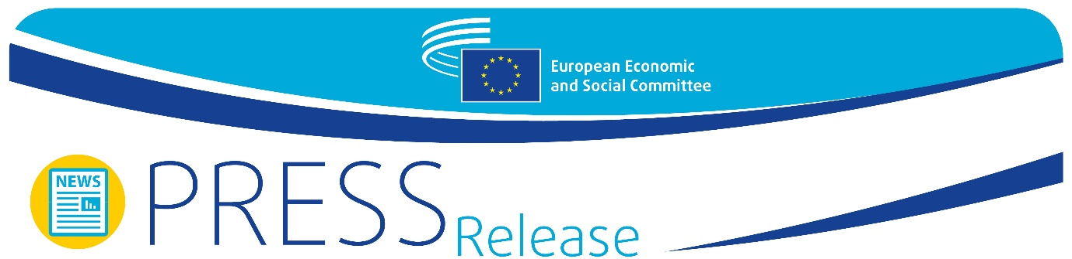
Ref. No.: 14/2020  EN | Brussels, 10 June 2020

Michel Barnier at the EESC plenary on Brexit:
"We expect the UK to respect its engagements"

At its June plenary session the European Economic and Social Committee (EESC) hosted a debate with Michel Barnier, Head of the EU Task Force for Relations with the United Kingdom. Barnier informed of the state of play of Brexit negotiations and expressed his disappointment over the attitude of the British government which, in his opinion, was not respecting the Political Declaration signed in October 2019: "We expect the UK to respect its engagements", said Barnier.
On 5 June, the EU and the UK concluded their fourth round of negotiations with no substantial progress according to Michel Barnier, who regretted the "lack of willingness" on the British side to reach an agreement on the four topics that were on the table: fisheries, a level playing field, governance of the future relationship and police and judicial cooperation in criminal matters. "We can only take note of the fact that there has been no substantial progress since the beginning of these negotiations, and that we cannot continue like this forever", added Mr Barnier.
In the absence of progress in the negotiations, the question of time is beginning to become pressing, especially given the United Kingdom's refusal to extend the transition period beyond the end of 2020. "If there is no joint decision on such an extension, the UK will leave the Single Market and the Customs Union in less than seven months. Taking into account the time needed to ratify a deal, we would need a full legal text by 31 October at the latest, in less than five months. We must use this time in the best possible way", Mr Barnier said.
Luca Jahier, president of the EESC, deplored the current situation and the risk of the negotiations failing. "We are convinced that a no-deal scenario would have a very high cost, but we have to show that we are not ready to reach a deal at any cost." He also commented that the only positive outcome of Brexit is that “it has made it possible for the EU to face the COVID-19 crisis more united than ever and put in place an unprecedented recovery plan in less than three months”.

The support of the EESC
Barnier engaged in a debate with EESC members, who showed their interest about the role of organised civil society in the future relationship between the EU and the UK and expressed their full support to Barnier’s work.
Stefano Mallia, member of the Employers’ Group and Chair of the EESC Brexit Follow-up Group, insisted on the “economic and social devastation” caused by the COVID-19 pandemic which, in his view, should be “a good enough reason to get an agreement”. He also insisted in the importance of preserving the Single Market: “What makes the EU strong is our Single Market, so any deal signed with the UK has to contribute to its consolidation”.
Oliver Röpke, President of the Workers' Group, expressed his disappointment with the attitude of UK’s government: “We all want to avoid a no deal scenario, but the British government is aware of this and it might be part of its strategy. Compromises are necessary, but we have to insist on the level playing field”, he said.
Carlos Trias Pinto, John Bryan, Arnold Puech d’Alissac and Ionut Sibian, members of the Diversity Europe Group, commended Barnier’s work as Head of the EU Task Force for Relations with the United Kingdom and expressed their hope that an agreement will be reached within the deadline fully respectful with the EU interests.

Negotiation framework
The impact of the COVID-19 pandemic on the negotiations was also mentioned by Michel Barnier, who admitted that holding face-to-face meetings in the upcoming weeks and months could improve efficiency, but insisted that "the lack of progress in these negotiations is not due to our method, but to the substance".
Michel Barnier reminded those present that the only valid framework for the negotiations was the Political Declaration signed between the EU and the UK in October 2019, setting out the future of the relationship. "Yet round after round, our British counterparts seek to distance themselves from this common basis", said the EU chief negotiator. "We cannot accept this backtracking on the Political Declaration and we will insist on the full respect of the Withdrawal Agreement", he made it clear.
One of the key issues addressed in the negotiations between the EU and the United Kingdom is the future of trade and tariffs. On this topic, Barnier reminded that during its 47 years of EU membership, the UK built up a strong position in the EU market in a number of strategic areas: financial services, business and legal services, and also as a regulation and certification hub and a major entry point in the EU single market.
“We must ask ourselves whether it is really in the EU interest for the UK to retain such a prominent position. We cannot accept the UK’s attempts to cherry-pick parts of our Single Market benefits”, concluded Mr Barnier, who added: “However good the agreement we reach with the UK, our trade relationship will never be as fluid as it is today”.
However, Michel Barnier expressed his hope that the negotiations would make it possible to find a "landing zone" between the United Kingdom and the European Union in the course of the summer or by early autumn at the latest.
“We want a very ambitious economic partnership, but it must reflect the long-term economic and political interests of the EU. This is not a dogmatic or technocratic position. We will never compromise on our European values or on our economic and trade interests to the benefit of the British economy”, said Mr Barnier. “What we now need to make progress are clear and concrete signals that the UK, too, is open to work on an agreement”, he concluded.

For more information, please contact:

EESC Press Unit – David Gippini Fournier
+ 32 (0)2 546 92 76
david.gippinifournier@eesc.europa.eu
@EESC_PRESS
VIDEO: How has the EESC made a difference?

_________________________________________________________________________
The European Economic and Social Committee represents the various economic and social components of organised civil society. It is an institutional consultative body established by the 1957 Treaty of Rome. Its consultative role enables its members, and hence the organisations they represent, to participate in the EU decision-making process.
_________________________________________________________________________

