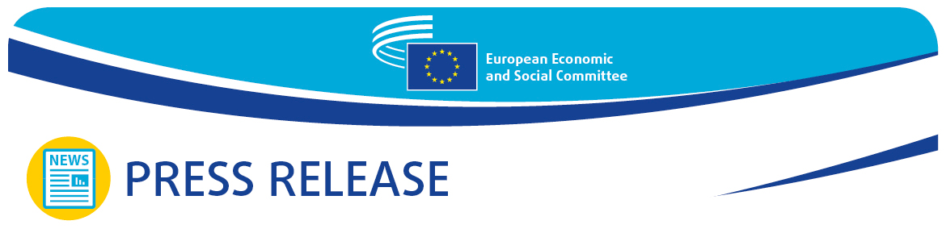
No 66/2022  EN | 14 December 2022
EN

Euro-Med - Civil society organisations key to keeping the economy and society running

The December plenary session of the European Economic and Social Committee (EESC) featured a debate on the reconstruction and resilience of the Euro-Mediterranean region following the COVID-19 pandemic.

The social partners and civil society organisations must be systematically involved in order to ensure that the EU's Southern Neighbourhood recovers fully from the COVID-19 crisis.

This is the main take-away of the debate on the Euro-Mediterranean region which took place at the EESC plenary session on 14 December 2022.

Highlighting the key role played by regional cooperation and dialogue and by the network of local civil society organisations in particular, the Committee's president Christa Schweng said that "The Union for the Mediterranean and its parliamentary assembly as well as the Anna Lindh Foundation are very important partners for the EESC; they are also major pillars of the Euro-Mediterranean partnership. The memorandum of understanding between the EESC and the Anna Lindh Foundation is an important step towards further strengthening and deepening this partnership."

Álvaro Albacete Perea, deputy secretary-general of the Union for the Mediterranean, spoke about how important strengthening the relationship between the EU and the Southern Mediterranean region is for unlocking a wide range of opportunities for sustainable growth and contributing to the EU's energy transition.

On the same wavelength, Josep Ferré, executive director of the Anna Lindh Euro-Mediterranean Foundation for Dialogue Between Cultures, referred to the vast synergies which could be tapped, stressing that it was about time that the EU approached migration as an asset, and not as a threat.

The remarkable potential of digitalisation is also key for economic and social progress across the Euro-Mediterranean region.

The own-initiative opinion on Digital transition in the Euro-Mediterranean region, drawn up by Dolores Sammut Bonnici and adopted at the plenary session, stresses that the digital transition is essential for inclusive economic development and job creation throughout the Euro-Mediterranean region. It also points out that it is important to reduce the digital divide between individual countries, between urban and rural areas and between generations.

Ms Sammut Bonnici believes that the development and promotion of digital skills is a top priority for the economy simply because digital literacy has become so important. Further training on digital matters is therefore needed at all levels of education.

For more information, please contact:

EESC Press Unit – Marco Pezzani
+32 (0)2 546 97 93 · Mob. +32 (0)470 881 903
marco.pezzani@eesc.europa.eu

@EESC_PRESS
VIDEO: The EESC from the inside
_______________________________________________________________________________
The European Economic and Social Committee represents the various economic and social components of organised civil society. It is an institutional consultative body established by the 1957 Treaty of Rome. Its consultative role enables its members, and hence the organisations they represent, to participate in the EU decision-making process.
_______________________________________________________________________________

