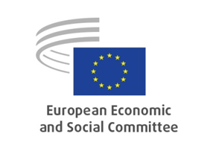

Points for consideration by the participants

- What are your views on the country specific recommendations (CSR) that Ireland has received this year? In your view, have they been targeted to the right areas? Which ones are inappropriate? Which ones are missing?

- How do you see the relationship between the national reform programme that the Irish government has submitted and the CSRs you received this year? How are the post-COVID recovery instruments covered in these two documents?

- To what degree do you agree with the national reform programme submitted by the Irish government? To what degree does the Irish government implement the national reform programme?

- How do you judge the degree of implementation of the CSRs by the national reform programme (NRP) throughout recent years? Why is the degree of implementation the way it is?

- What kind of support should/could European level bodies (European Commission, European Economic and Social Committee, the European Fiscal Board) provide to foster better national level coordination and ownership of the European Semester (ES)?

- How do you see your role and the role of civil society organisations at large in the process?

_____________

