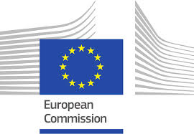
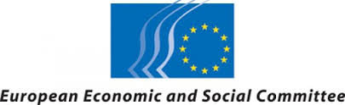
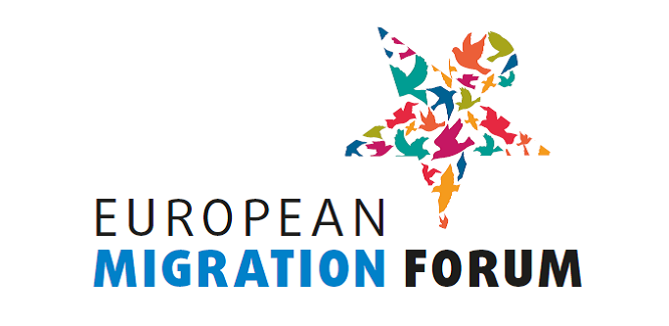

BUREAU OF THE EUROPEAN MIGRATION FORUM
Minutes of the meeting of 3 October 2018

Participants:

Bureau members:
- Cristian Pirvulescu, European Economic and Social Committee (EESC)
- Laura Corrado, European Commission (EC), DG Home Affairs
- Fernando Biague (Intercultural Research and Education Centre), Bureau member representing civil society organisations at national level
- Silvia Giulini (Generation 2.0 for Rights, Equality and Diversity), Bureau member representing civil society organisations at national level
- Kadri Soova (PICUM), Bureau member representing civil society organisations at European level

Staff:
- Justyna Głodowska-Wernert, European Commission (EC), DG Home Affairs
- Vincent Catot, European Commission (EC), DG Home Affairs
- Annemarie Wiersma, European Economic and Social Committee (EESC)
- Triin Aasmaa, European Economic and Social Committee (EESC)
- Maria Månsson, European Economic and Social Committee (EESC)

- Summary of the consultation with civil society organisations on the topic of the 5th European Migration Forum

Annemarie Wiersma explained that the Forum Secretariat had received 15 replies to the questionnaire. The answers to the first question (on the preferred topic) were as follows:

Legal pathways for migration – what next? | 9.5 votes
From global to local | 4.5 votes
Towards a future-proof migration system | 1 vote

One respondent preferred both topic 1 and 2, so they both received 0.5 points.

Given the low response rate and following suggestions from civil society during the public consultation meeting in the morning, the Forum Bureau decided to re-open the questionnaire and extend the deadline to 12 October. All recipients would be asked to further disseminate the questionnaire within their networks.

Depending on the additional responses to the questionnaire, the topic of the next Forum might be a mix of the proposed topics 1 and 2. The sub-themes would be decided following an analysis of the proposals made by the respondents to the questionnaire. One workshop could focus on integration.

- Planning for the 5th meeting of the Forum

It was agreed that the next EMF would take place on 3 and 4 April 2019.

- Planning of next Bureau meetings

It was agreed to possibly organise another Bureau meeting on 18 October during which a final decision on the topic could be taken, depending on the outcome of the survey.

The Bureau also agreed to meet early February to discuss the list of organisations selected to be invited and the draft programme.

- AOB

-

_____________

