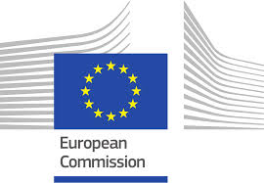
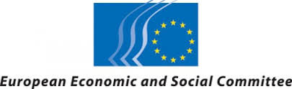
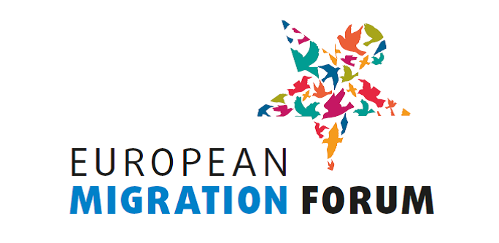

BUREAU OF THE EUROPEAN MIGRATION FORUM
Minutes of the meeting of 16 January 2018

Participants:

Bureau members:
- Irini Pari, European Economic and Social Committee (EESC)
- Laura Corrado, European Commission (EC), DG Home Affairs
- Pablo Rojas Coppari (Migrant Rights Centre Ireland), Bureau member representing civil society organisations at national level
- Annica Ryngbeck (Social Platform), Bureau member representing civil society organisations at European level
- Kadri Soova (PICUM), Bureau member representing civil society organisations at European level

Staff:
- Justyna Głodowska-Wernert, European Commission (EC), DG Home Affairs
- Maria-Claudia Martins-Geneix, European Commission (EC), DG Home Affairs
- Annemarie Wiersma, European Economic and Social Committee (EESC)
- Johannes Kind, European Economic and Social Committee (EESC)
- Triin Aasmaa, European Economic and Social Committee (EESC)
- Valeria Atzori, European Economic and Social Committee (EESC)
- Anna Morandi, European Economic and Social Committee (EESC)

General comments

Pablo Rojas Coppari announced that he will leave the Migrant Rights Centre Ireland to work in Irish Diplomatic Service and for that reason he cannot continue his activities as a member of the Forum Bureau. Nevertheless, he will attend the Forum in March.

Annica Ryngbeck will be leaving Social Platform, and hence the Forum Bureau. Her mandate ends at the next Forum, so she will not need to be replaced in the Bureau. She will share the contact of the colleague working on the issue of integrating migrants into the labour market.

Irini Pari will leave the Forum Bureau in March/April due to the mid-term renewal of the EESC.

Johannes Kind briefly introduced the new colleagues who will deal with the organisation of the Forum during the absence of Annemarie Wiersma.

- Debrief of EMF presentation in LIBE Committee meeting of 11 January 2018

Irini Pari gave an overview of the EMF presentation in LIBE Committee meeting.

She pointed out that for some obvious reasons (Thursday afternoon, direct after lunch break) the presentation was not very well attended, but those present showed great interest in the presentation of the Forum. The main objective was to launch a more structured and regular cooperation with the LIBE Committee. Irini Pari introduced the work and the participatory, inclusive structure of the EMF; Kadri Soova presented the outcome of the last meeting of the EMF in March 2017. The presentation was followed by a constructive discussion during which the members of the LIBE Committee acknowledged that European Parliament and civil society need to work closer together.

The members of the Forum Bureau decided that in order to use this positive momentum in an optimal way a Thank You Letter shall be sent to Mr. Claude Moraes, the Chair of the LIBE Committee, with the aim to propose that the Forum Bureau is once more invited to present the outcome of the event in one of the LIBE committee meetings taking place in the first half of 2018. Annica Ryngbeck suggested that the presentation of the EMF could be linked with the work of the European Parliament to get more attention from the MEPs.

The members of the Bureau discussed the ways how to introduce EMF among different institutions (e.g. the Council) and Permanent Representations more efficiently.

- Validation of selected civil society participants for the fourth EMF

Annemarie Wiersma presented the results of the evaluation procedure. She introduced the process and criteria used to select participants.

Following the call of the expression of interest, 150 eligible applications were received. There were also some not eligible applications, e.g. from commercial companies or international organisations (not selected through the open call, ILO etc.). They were contacted and explained why they could not be selected.

The applicants were evaluated based on the information they provided in their applications, i.e. organisation's mandate and activities, experience on the topics that will be discussed in the workshops, expectations, potential contribution etc. 125 NGOs were selected: 27 migrant-led, 33 grassroot level, 24 EU level, 68 national level organisations. Three Member States – Slovenia, Malta and Croatia – are not represented because there were no applications from these countries. But two non-EU organisations were selected: 1 from Serbia and 1 from Canada.

The Forum Bureau discussed the proposed list of the participants for the fourth EMF carefully and in detail. Taking into account the remarks made, the list of the participants was confirmed.
The invitation letters would be sent out shortly after the meeting and the registration deadline would be 9 February.

Annemarie Wiersma introduced in short the list of LRAs proposed by Committee of the Regions. Members of the Forum Bureau stressed that – in order to ensure a meaningful outcome of the Forum – also geographical balance of the participants is important and over-representation of some countries should be avoided. Therefore they proposed a few suggestions to be put forward to the Committee of the Regions.

Following the meeting of the Bureau one of the organisations from the list of LRAs proposed by the Committee of the Regions notified that they were no longer interested in participation in the Forum, hence a first LRA from the reserve list was invited.

- Discussion of the draft programme for the fourth EMF

There were no specific remarks on finalised draft of the programme.

Justyna Głodowska-Wernert presented three potential candidates for the second testimony. The Bureau agreed on one candidate.

Laura Corrado informed the Bureau that the drafts of the background papers for the workshops would be ready by the end of January.

People involved in the workshops will gather for a short meeting on 6 March before the Forum starts.

Annemarie Wiersma gave an overview of the interpretation arrangements agreed with the representatives of the interpreters. (5-5 interpretation regime during the plenary sessions and EN-FR-IT-ES during the workshops).

- AOB

Annica Ryngbeck informed the Forum Bureau that the Open Society Foundation has created a fellowship programme to put together an Advisory Board of people with a migrant background from different cities around Europe. They have contacted Annica Ryngbeck to explore the possibilities for the European Migrant Advisory Board to meet with the Forum Bureau. Having discussed the matter, the Forum Bureau decided that the Advisory Board would be invited to the consultation on the topic for the next meeting of the EMF. Annica Ryngbeck will send the Forum Secretariat the contact details of the coordinator of the programme.

N.B. as a follow-up of the discussions at the Bureau two representatives from the European Migrant Advisory Board were invited to the 4th EMF.

