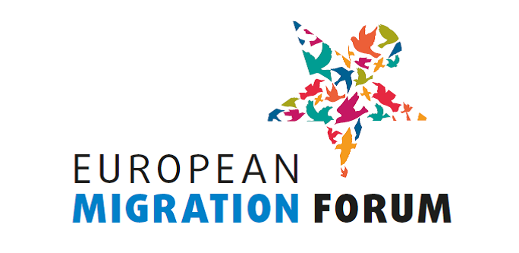

BUREAU OF THE EUROPEAN MIGRATION FORUM
Minutes of the meeting of 13 February 2019

Participants:

Bureau members:
- Christian Privulescu, European Economic and Social Committee (EESC)
- Laura Corrado, European Commission (EC), DG Home Affairs
- Fernando Biague (Intercultural Research and Education Centre), Bureau member representing civil society organisations at national level
- Silvia Giulini (Generation 2.0 for Rights, Equality and Diversity), Bureau member representing civil society organisations at national level

Staff:
- Vincent Catot, European Commission (EC), DG Home Affairs
- Annemarie Wiersma, European Economic and Social Committee (EESC)
- Triin Aasmaa, European Economic and Social Committee (EESC)

- Validation of selected civil society participants for the fifth EMF

Annemarie Wiersma presented the results of the evaluation procedure. She introduced the process and criteria used to select participants.

Following the call of the expression of interest, just over 200 applications were received. There were also some not eligible applications, e.g. from commercial companies, organisations based outside the EU or international organisations.

The applications were evaluated based on the information provided about the organisation's mandate and activities, experience on the topics that will be discussed in the workshops, their expectations for the Forum, and their potential contribution. 123 NGOs were selected: among which were 23 migrant-led, 36 grassroot level and 23 EU level organisations. Four Member States – Malta, Estonia, Slovenia and Slovakia – are not represented because there were no applications from these countries; one application was received from Luxembourg but did not pass the selection procedure.

The Forum Bureau discussed the proposed list of the participants for the fifth EMF in detail. It was agreed to re-assess some applications to see if some organisations could be added to the list of selected organisations. The updated list would be sent to the Bureau members not present at the meeting for their comment.

The Forum Bureau decided that the members of the Forum Bureau are entitled to attend the Forum on behalf of their organisations without answering the open call for interest. Other organisations that did not apply to the call for interest could not be invited.

The invitation letters would be sent out shortly after the final approval of the list in written procedure and the registration deadline would be 13 March.

Annemarie Wiersma introduced in short the list of LRAs proposed by Committee of the Regions. The Forum Bureau noted with some surprise that no representative of Germany was in the list and asked the Forum Secretariat to ask the CoR if no applications from that country had been received.

- Discussion of the draft programme for the fifth EMF

Vincent Catot presented the draft of the programme with some changes that were proposed by the Commission. Taking into account the proposed changes, the draft programme was approved.

- AOB

