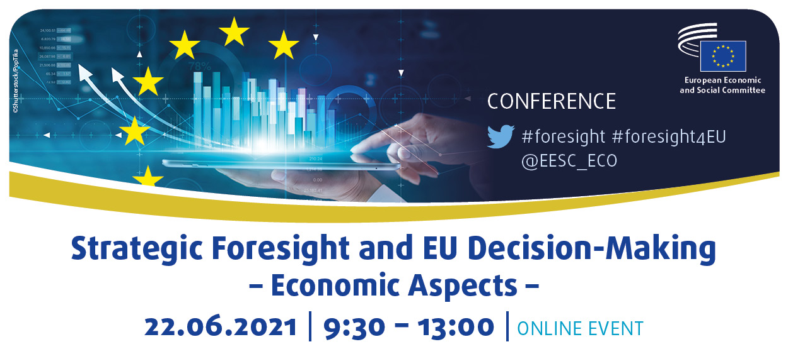

Minutes

ECO section president Stefano Palmieri welcomed participants and underlined the importance of strategic foresight, which was a practice increasingly used in government, large companies, and in non-profit organisations. Mr Palmieri made reference to a recent EESC opinion that contained many comments and policy proposals to influence and shape the future path that strategic foresight should take following the Commission´s first annual foresight report. He pointed out that when dealing with the uncertainty of the future, there was a distinction between forecasting, on the one hand, and foresight, on the other. By using strategic foresight, we tried to anticipate trends and issues that might emerge, and look at their potential implications, challenges and opportunities. Ultimately, we wanted to draw useful insights for strategic planning, policy-making and preparedness. By using strategic foresight, we got an idea of how we should act in the present to shape the future in the way we wanted it to be. Mr Palmieri also referred to the variety of different methods employed in foresight.

Eamonn Noonan, Policy Analyst, Strategic Foresight and Capabilities Unit, European Parliamentary Research service (EPRS), introduced ESPAS, the European Strategy and Policy Analysis System. Whilst foresight activities had also been carried out previously in different EU institutions, ESPAS was now tying these activities together. In the economic sphere, a lot of economic forecasting was being done, but foresight still had an important role to play. Many issues flagged up in the ongoing debate framed by the COVID-19 crisis were economic issues, concerned with restoring and protecting the economy. Mr Noonan gave the examples of economic governance, unemployment, sustainable social protection systems, completing EMU and an integrated migration policy. Current broader economic challenges in Europe were higher public spending, the twin transitions (green and digital), vulnerable employment and the arrival of widespread teleworking. At the international level, Mr Noonan mentioned global economic stress, international financial woes, the sovereign debt crisis, US-China tensions, and social unrest and political turmoil. Scenario-planning was a vital aspect of foresight, as elites often found it difficult to discuss dark scenarios. Furthermore, communication was very important, through involving different stakeholder groups, establishing a direct link to decision-makers, and related coordination efforts. Ultimately, commitment was needed, whatever direction we wanted to take.

Fabiana Scapolo, Acting Head of Unit, Head of the Competence Centre on Foresight, Joint Research Centre, European Commission, explained that strategic foresight was used as a proven model for shaping future policy with the aim of increasing economic progress, overcoming the limitations of economic models and looking at disruptive elements. As examples of recent Joint Research Centre (JRC) foresight activities, Ms Scapolo mentioned the future of the customs union, the industry landscape vision, and the future of farmers. Defining megatrends was an important feature of foresight. In the EU, strategic foresight was implemented through annual reports, ad hoc cooperation, inter DG cooperation and through ESPAS. Strategic foresight was important for identifying, understanding and steering change. Economic aspects were interconnected with many other issues.

Duncan Cass-Beggs, Counsellor for Strategic Foresight, Strategic Foresight Unit, OECD, explained how strategic foresight was being applied to achieve the net-zero emission target. He underlined that this was an economic policy issue; that we had to use strategic foresight and look beyond the futures we expected; that it was an ongoing collaborative process; and that climate emergencies were not the only risks - there was also the digital change arising from superintelligence, for example. Mr Cass-Beggs claimed that there was a huge amount of uncertainty about how the world would change at the same time; virtual work, for example, was going to be a big game changer, and also had considerable implications for the net-zero emission target. He stated that when facing the impossibility of predicting the future, we had to be open to a wide variety of possible scenarios. Some of the greatest uncertainties regarding the future of the economy were brought about by the expansion of blockchain and the related access to finance, by cybersecurity, and by the concentration of economic power.

Andrej Stuchlik, Senior Policy Adviser, European Investment Bank (EIB), noted that recently we had been looking at strategic foresight largely from a foreign policy perspective: The latest EU buzzword in this context was “strategic autonomy”. Undeniably, this discussion touched upon many economic aspects, such as future energy prices, for instance. However, the current approach remained rooted in security policy concerns and was not a genuinely economic one. Mr Stuchlik argued in favour of drawing attention away from vulnerabilities towards capabilities, and made a case for strengthening the Single Market. Furthermore, he stressed that the so-called “twin transitions” could actually become a nucleus of economic growth in the near future, through investing in climate action and the digitalisation of the EU's economies. Mr Stuchlik further claimed that we were still underestimating the disruptive economic impact of climate action and sustainable finance.

Sandra Parthie, rapporteur for the EESC opinion on strategic foresight, took the floor and stated that a change of mind-set was necessary, and that the added value of strategic foresight needed to be clearly shown, as well as how foresight influenced the policy-making process. She called for foresight to be applied to a broad range of topics.

In the following Q&A round, the following members took the floor: Mr Doz Orrit, Ms Calistru, Mr Marin, Mr Pietkiewicz, Mr Marchiori, and Mr Dandea. They addressed the elements missing from economic governance; the most pressing issues to be tackled; the need for a participative process and the mechanisms used to achieve that; inequalities between EU Member States and, in this context, price convergence vs wage convergence and the transfers of capital and labour; macroregions in the EU, and the need to invest in new technologies.

Mr Stuchlik replied that foreign policy and energy policy were closely related and that a "climate diplomacy" was needed. He pointed out that EIB investment was relatively limited in volume and therefore in its impact. At the EIB, forecasting and megatrend analysis were applied. He also noted that not all EU Member States were starting out from the same point in the ongoing transitions.

Mr Cass-Beggs pointed out that we were seeing a once-in-a-generation investment volume with public funds. Spending needed to be futureproof and limited to long-term objectives, and at the same time monitored and adjusted where required. In terms of governance, a number of bodies needed to build up foresight capacities, and establish the key uncertainties. Learning from each other was paramount. Foresight needed to be grounded in evidence, with extrapolations then being made on the basis of that evidence.

Mr Noonan provided examples of foresight: in the 2019 ESPAS report, climate issues were a main element. From the past, the transition in South Africa and scenarios developed by an oil company to anticipate oil price shocks could also be included. Currently, taxation, the Stability and Growth Pact, as well as health and education topics needed attention. A considered decision was better than an unconsidered one, and in this context, foresight could help equip us better to take reasoned decisions.

Ms Scapolo mentioned the future of the customs union as an example where foresight had been really embedded. The JRC had developed scenarios than could be used by policy-makers to make futureproof decisions. She invited interested parties to get in touch with the JRC.

In the second panel, Mr Desbiey, Group Head of Foresight, AXA Insurance Group, pointed out that projections of the future were inherent to insurers' business models. Possible futures were explored by anticipating related threats and opportunities and by detecting weak signals and emerging trends. The aim was to ensure that short-term initiatives were based on a long-term perspective. His insurance company employed three full-time staff dealing with foresight, focussing on health, socio-economic and environmental questions. It was important to cross the lines between different disciplines and to work together with others, especially with counterparts in other big companies. Methods employed in his company included speculative design and a joint project to imagine fictional companies of the future, by using fiction with the help of authors.

Ms Ponce Del Castillo, Senior Researcher for Foresight, European Trade Union Institute (ETUI), explained that since 2010, foresight had been used at the ETUI, for example in the field of worker participation, occupational health and safety and the digital economy. Foresight work was supported by a field manual for use in practice. The manual included 11 strategic roadmaps on how the ETUI could be transformed in our changing world, grounded in the use of different methodologies. Her team had developed methodologies on how foresight could be used in trade unions, and organised related trainings for facilitators and trade union leaders. As a result, 60 trade union foresight projects had been developed across Europe. It was above all crucial to convey the importance of embracing change and uncertainties.

Mr Borges de Castro, Associate Director and Head of the "Europe in the World" Programme at the European Policy Centre (EPC), underlined the importance of the mind-set, as uncertainty and unpredictability were likely to continue. He claimed that democracies often needed considerable time to decide, whereas other systems could act faster. Therefore, our democracies needed to be made faster. Foresight was a process, not an event, and was also a call for action. Foresight specialists were facilitators, who did not provide answers, but who were "cleaning the windows to see more clearly". Citizens and those participating had to be aware of the limits of foresight. Methods of foresight often consumed a lot of human, financial and time resources. Therefore, foresight results had to be shared to find synergies, for example through an open-source platform. What was framed as uncertainty contained both positive and negative elements, and certain events could quickly turn things upside down.

Mr de Jouvenel, Managing Director, Futuribles International, stated that foresight was not a science, but was producing visions of the future to help take decisions, which needed to be usable. Analyses had to be based on the latest scientific progress. Good foresight triggered action, and a process to involve different stakeholders was important. Foresight had evolved since the 1930s, most importantly in the social and military fields (the cold war). Today, we saw increasing demand for foresight, because actors understood that the future was not just an extension of the present. To face challenges, close cooperation between stakeholders was paramount. Multidimensional and cyclical economic challenges to be addressed were the global crisis, digitalisation and anthropological transformations.

The ECO section president concluded the conference by summarising some of the key conclusions of the debate: foresight was not only for institutions, but also for other stakeholders, for example in civil society. It required however a major effort in terms of human, financial and time resources. We needed to address future challenges in a strategic way. Some current problems were the result of not having recognised weak signals in the past. We had to use the opportunities offered by foresight and turn conclusions into practical action. Sharing information and networking were important. He closed the event by stating that the EESC would continue to discuss foresight and to contribute to the debate.

_____________

