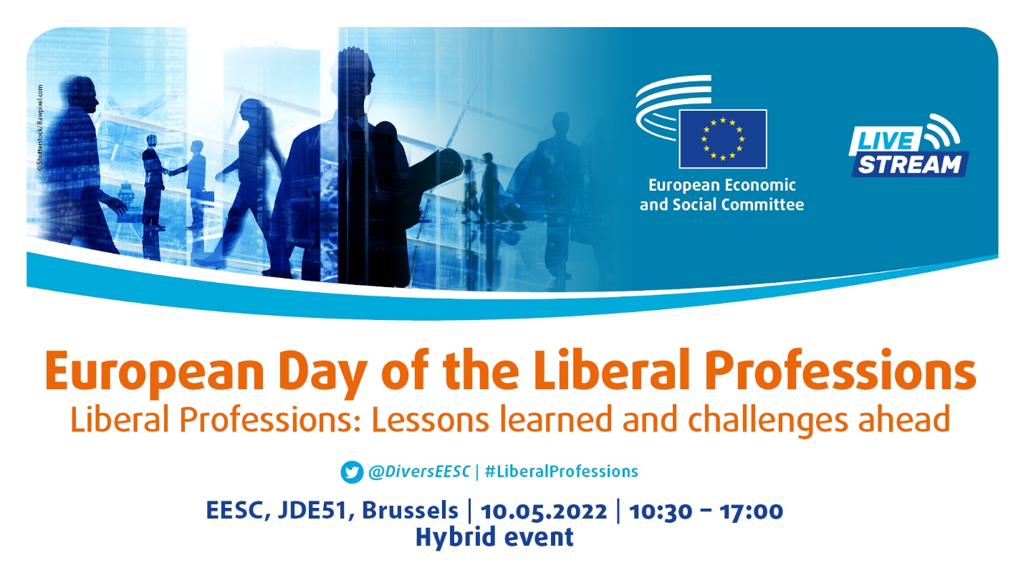

LISTE DES PARTICIPANTS / LIST OF PARTICIPANTS

Participant | Organisation
BÖHME Martin | Membre du group Diversité Europe /  Member of the Diversity Europe Group
CSER Ágnes | Membre du group Diversité Europe /  Member of the Diversity Europe Group
GONDARD-ARGENTI Marie-Françoise | Membre du group Diversité Europe /  Member of the Diversity Europe Group
IOANNIDIS Athanasios | Membre du group Diversité Europe /  Member of the Diversity Europe Group
MENSI Maurizio | Membre du group Diversité Europe /  Member of the Diversity Europe Group
MINEIRO AIRES Carlos | Membre du group Diversité Europe /  Member of the Diversity Europe Group
RELIĆ Danko | Membre du group Diversité Europe /  Member of the Diversity Europe Group
RIZZO Benjamin | Membre du group Diversité Europe /  Member of the Diversity Europe Group
CALDERONE Marina Elvira | Porte-parole / Co-spokesperson
KOLBE Rudolf | Porte-parole / Co-spokesperson
Bardone Anna Maria | Oratrice / Speaker
Bökamp Heinrich | Orateur / Speaker
Colavitti Giuseppe | Orateur / Speaker
Diamanti Sabrina | Oratrice / Speaker
Kearns Thomas | Orateur / Speaker
Mičević Blaženka | Oratrice / Speaker
Ortega Victoria | Oratrice / Speaker
Regner Evelyn | Oratrice / Speaker
Schmidt Friedemann | Orateur / Speaker
Teuma Miriam | Oratrice / Speaker
Thürriedl Klaus | Orateur / Speaker
Told Julia | Oratrice / Speaker
ADORNI Pietro | A.I.P.A.I.
ALVES Stéphanie | Conseil des barreaux Européens
ANDERSSON Christina (eva) | ALDE/LibDem/External
ANNE Daumas | SNVEL
ANTONELLO Cinzia | Bymyself
ARKOSI Mariann kinga | Civitas Foundation for Civil Society Cluj
ARNAUDOVA Nikoleta | Council of European Dentists
BÂLICI Ștefan | Ion Mincu University of Architecture and Urbanism
BARDEGGIA Sara | Membro Segreteria di Presidenza Consiglio Nazionale Consulenti del Lavoro
BATISTA Jorge | Ordem dos Farmacêuticos
BENEKE Sten | KBV - German Outpatient physicians
BERNARD Emilien | Union nationale des professionnels de santé
BLANCO LINO Juan | ECEC
BOHOSLAVETS Mykola | International Center of diplomatic cooperations
BRAUER Hubertus | IngKammer Bau, ECEC
BURY Benedicte | bburyavocats
CALVO Dulce | Colegio de registradores
CARUSO Giuliana | Ordine consulenti in proprieta' industriale
CIAPPARA Mary anne | Malta Chamber Of Pharmacists
CITINO Ylenia Maria | Ricercatrice
DAKOVA Sonya | Bulgaria
DALUGAMAGE Shantha | Stichting Mission Lanka
DARDENNE Baptiste | European Council of the Liberal Professions (CEPLIS)
DE LUCA Rosario | Presidente Fondazione Studi Consulenti del Lavoro
DE MOL Corine | EESC
DEL GAUDIO Vanessa | CoLAP
DENKOVSKI Marijan | Macedonian Dental Chamber
DI DOMENICANTONIO Anna | Confederazione Italiana Libere Professioni
DRAZIN LOVREC Nina | Croatian Chamber of Civil Engineers
DURACCIO Francesco | Vicepresidente Consiglio Nazionale Consulenti del Lavoro
DÜRSCH Roxana | German Dental Association
FALASCHI Maria cristina | REICO Associazione Professionale di Counseling
FALENSKI Martin | Bundesingenieurkammer
FALZON Ruth | University of Malta
FERRAH Maria serine | Confederazione Italiana Libere Professioni
FONTANA Marion | European Tax Adviser Federation (ETAF)
GAJDOSIK Alfred | Ccmi ewsa
GARBELOTTO Franco | ABV e.V.
GARRIGOU Serge | UNAPL
GLORIUS Corina | KBV
GOSSET Noelle | Global
GRIGNARD Patrick | Universal Press
HAMMERSCHLAG Cornelia | Austrian Federal Chamber of Architects and Chartered Engineers
HECTOR Thomas | European Council of the Liberal Professions (CEPLIS)
HEEMANN Christoph | Ingenieurkammer-Bau Nordrhein-Westfalen
HEYDECKE Ronja | Bundessteuerberaterkammer KdöR
JACQUEMIN Bernard | UNPLIB
KLOTZKI Peter | Bundesverband der Freien Berufe
KOECHEL Felix | Bundesnotarkammer
KORDEN Michael | Kassenzahnärztliche Bundesvereinigung (KZBV)
KOUTROUBAS Theodoros | European Council of the Liberal Professions (CEPLIS)
KYNAST Britta | Austrian Bar (ÖRAK)
LA SORDA Bruna | CoLAP Coordinamento Libere Associazioni Professionali
LANGHENDRIES Margaux | UNGE - Union Nationale des Géomètres-Experts
LEDER Daphne | ECEC
LEMBREE Pascal | Novotel-Hôtel Charleroi
LENZ Horst | Ingenieurkammer Rheinland-Pfalz
LEVESQUE Philippe | FÉDÉRATION NATIONALE DES CHAMBRES PROFESSIONNELLES DU CONSEIL
LIÇA Jorge | Ordem dos Engenheiros
LUKOVIC Nikola | Chamber of engineers of Montenegro
MAKSYMCHA Yurii | International Center of diplomatic cooperations
MANCHEVSKI Aleksandar | Chamber of certified architects and certified engineers
MARCANTONIO Giovanni | Segretario Consiglio Nazionale Consulenti del Lavoro
MARINO Ignazio | Direttore Fondazione Studi Consulenti del Lavoro
MERCHÁN BERMEJO Joaquín | Consejo General de Colegios Oficiales de Graduados Sociales de España
MILLEVOLTE Alessandra | Co.L.A.P.
MIRICA Nicolae | ROMANIAN UNION OF LIBERAL PROFESSIONS
MUELLER Andreas | Bundesverband der Freien Berufe
MÚZQUIZ Gonzalo | Unión Profesional
NIEBERGALL Ralf | Bundesarchitektenkammer
NILUSMAS Nicolas | NOUVEAU POINT DE VUE (N.P.D.V.)
ORVIETO Roberto | ECEC European Council of Chartered Engineers
OUEDRAOGO Lassane | Africa Solidarity Centre Ireland
PALTANI Giuseppe | consiglio nazionale dei tecnologi alimentari
PASQUINI Elena | Ufficio Stampa Consulenti del Lavoro
PELLICER BOSSIS Laëtitia | Clinica Sanitaria Psicosalud
PISANO Susanna | Confederazione italiana libere professioni
PRITCHARD Ian | Architects' Council of Europe
RADEVSKI Kristinka | Chamber of certified Architects and certified Engineers of North Macedonia
RAPP Kathrin | Federal Chamber of German Architects
RAYNAL Nicolas | Association Française des Psychomotriciens Libéraux
REINSPERGER-MUELLEBNER Anita | BUKO (Bundeskonferenz der Freien Berufe Östereich
REIS Margarida | Diversity Europe
RICHEZ Jean-michel | SUEZ/Environment
RUWET Jean | Unplib
SASSARA Stefano | Tesoriere Consiglio Nazionale Consulenti del Lavoro
SCHÄFER Katharina S. | Klavier, Orgel & Gesang
SCHÄFER Florian | Deutscher Steuerberaterverband
SCHEIBLHOFER Gerhard | Ziviltechnikbüro Scheiblhofer
SCHWARZ Michael | Verband der Freien Berufe in Bayern e.V. (Präsident)
SCIRETTI Massimiliano | FNOPI
SELAM Alessandro | ANORC
SUBRA-ITSUTSUJI Caroline | Société française des traducteurs (SFT)
SZŐLLŐSSY Gábor | Hungarian Chamber of Engineers
TRIPPETTA Danilo | Membro Segreteria di Presidenza Consiglio Nazionale Consulenti del Lavoro
TWARDY Nina lucia | BFB
VAN ROSSEN Edward | Federatie Vrije Beroepen
VIARD Sandra | UNAPL
WANI Charles | (KSSCA) Kilkenny South Sudanese Community Association Company Limited by Guarantee
WISLEITNER Bernhard | C|f|W|A - Coaching für Wirtschaft und Arbeit
WÜSTHOFF Johannes | BDVI e.V.
YARGUI Audrey | association française de chiropraxie
ZWICK Sandra | ABDA
CASALE Massimiliano | Personnel / Staff
CHROMEKOVÁ Silvia | Personnel / Staff
KLÖTZING Jasmin | Personnel / Staff
PALOMBELLI Fausta | Personnel / Staff
REIS Margarida | Personnel / Staff

