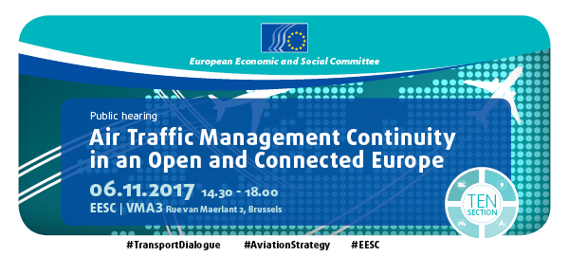

Public hearing, EESC

To respect the rights and needs of passengers, workers, and industry, social dialogue is a must in air traffic management

On 6 November 2017, the European Economic and Social Committee invited stakeholders from the aviation field to a public hearing on "Air Traffic Management Continuity in an Open and Connected Europe". The public hearing aimed at providing an overview of causes of disruptions in traffic, with a particular focus on air traffic management (ATM) issues.

The hearing was organised as a part of the ongoing work of the Committee on the aviation package "Aviation: An Open and Connected Europe" published by the Commission earlier this year. While the package contains several documents, including a revision of the regulation on safeguarding competition in air transport along with interpretative guidelines on rules on ownership and control of EU carriers and public service obligations, the EESC decided to focus the hearing on ATM issues. This is because it saw the significant need to organise an exchange of views among stakeholders, in particular trade unions, air traffic management bodies, and airlines, in this often contested field of aviation – against the backdrop of the European Commission's Staff Working Document "Practices favouring ATM Service Continuity". The EESC – as an institution with significant experience in balancing interests and organising social dialogues – could offer added value to policy-makers and stakeholders alike.

Following a short welcome by Mr Pierre Jean Coulon, President of the Section Transport, Energy, Infrastructure, Information Society" of the EESC and an introduction by Mr Jacek Krawczyk, Rapporteur of the opinion "Aviation: An Open and Connected Europe" (TEN/641) and President of the Employer Group of the EESC, Mr Henrik Hololei, Director-General of Directorate-General MOVE of the European Commission, reflected in his keynote speech on the significant benefits citizens enjoyed thanks to 25 years of EU aviation policy, including lower prices, employment opportunities, more choice, better service quality, and greater social cohesion. However, this positive evolution faces various challenges, from taking advantage and managing new technologies (from drones to artificial intelligence) and external competition to disruptions in air traffic. Air traffic management is only one among many factors that require attention. What is however important to address the challenges in ATM is to bring together stakeholders and create a forum to exchange information and find compromises among social partners and wider civil society. It is for this reason that Mr Hololei welcomed that the EESC held a public hearing specifically on the issue of ATM.

The first panel pursued a diagnostic objective. Moderated by Director Filip Cornelis of DG MOVE, it brought together the intergovernmental air traffic manager body Eurocontrol (Director Joe Sultana), the governmental Air Navigation Service DGAC of France (Director Maurice Georges), the leading airline Lufthansa/Eurowings (Eurowings CEO Thorsten Dirks), and trade unions (Charles-Andre Quesnel, President of ATM Committee, European Transport Workers Federation; Jean-Denis Larrere, Member of the Executive Board, Air Traffic Controllers European union Coordination). The presentations and interventions of the panellists documented that strikes are indeed one of the causes of disruptions in air traffic management – and are thus seen by industry and air traffic managers as a challenge. However, other factors, from air traffic management capacity to bad weather, account for a significant share of disruptions. Trade union representative therefore expressed concern about the focus of the European Commission's Staff Working Document "Practices favouring ATM Service Continuity" on industrial action and how the identified practices affect the right to and effectiveness of strikes.

The second panel defined as its objective to identify solution to challenges to ATM continuity. Moderated by Mr Jacek Krawczyk, the panel was composed of representatives of the national Civil Aviation Authority ULC from Poland (Michal Witkowski, Vice-President), of the Civil Air Navigation Services Organisation (CANSO) (Gunter Martis, Director EU Affairs), of the trade union European Transport Workers Federation (Francois Ballestero, Political Secretary for Civil Aviation), of European airlines via Airlines4Europe (Thomas Reynaerts, Managing Director), of the ATM research body Single European Sky ATM Research SESAR Joint Undertaking (Alain Siebert, Chief Economist), and the global airline industry via IATA (Pete Curran, Safety and Flight Operations Europe). A central message of the panel is that an effective social dialogue is of key importance to reduce the number of strikes. However, industry representatives and trade unions in particular disagreed on whether measures beyond establishing a dialogue, such as minimal service requirements and early notification periods, would improve service continuity and help create the trust necessary for social dialogue to become effective. The trade union representative wondered whether by reducing the effectiveness of strikes, trade unions would not be forced to call for strikes more often.

In his concluding remarks, Mr Cornelis from DG MOVE noted how important it was to bring the stakeholders together and exchange views and diagnostics even if the disagreements persisted. The European for its part would like to continue engaging with all types of stakeholders and seeks input from all sides.

Mr Krawczyk, as the final speaker, highlighted how the EESC will make good use of the diverse input received during the hearing in its work on the opinion on "Aviation: An Open and Connected Europe". The fact that all speakers agreed on the primary importance of organising a social dialogue points to common ground upon which fruitful dialogue can be built in the future, potentially leading to the type of dynamic compromise which lies at the heart of the work of the EESC.

