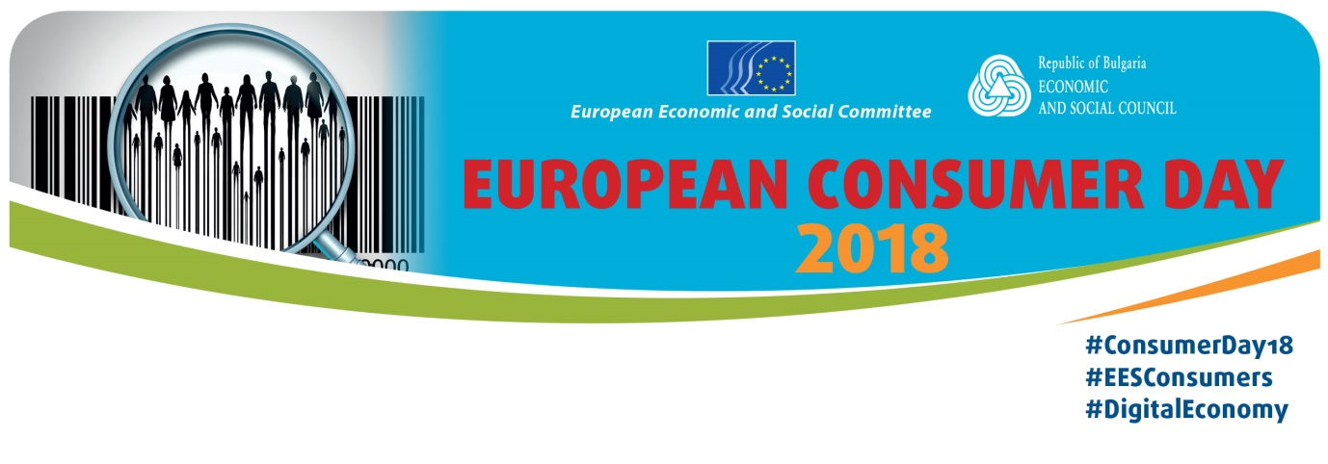
The digital economy: what deal for consumers?
20 March 2018 - Sofia, Bulgaria

Programme

9 a.m. | 9.30 a.m. | Registration and welcome coffee
9.30 a.m.  9.50 a.m. | 9.50 a.m.  10.45 a.m. | Welcome address  - Martin Siecker, President of the Section for the Single Market, Production and Consumption, EESC  - Lalko Dulevski, President of the Bulgarian Economic and Social Council  Digital consumers: the EU vision  - Emil Karanikolov, Bulgarian Minister for the Economy  - Francisco Fonseca Morillo, Deputy Director-General, Directorate General for Justice & Consumers, European Commission  - Open floor discussion
10.45 a.m. | 12 p.m. | Panel 1: The digital consumer in Europe today – which threats do we face?  Moderator: Milena Angelova, Member of the Employers' Group, EESC  - Mapping digital consumer trends in Europe – Stefano da Empoli, President, I-Com – Institute for Competitiveness  - Online dispute resolution – Ignat Arsenov, Director, ECC-Net Bulgaria  - The impact of big data on consumer choice – Meelis Kosk, Co-founder, Big Data Scoring
 |  | - Open floor discussion
12 p.m. | 1 p.m. | Lunch
1 p.m. | 2 p.m. | Debate: Digital Finance – how can consumers profit?  moderated by Bloomberg TV Bulgaria  - Georgi Atanassoff, Chairman, Bulgarian Financial Forum, representative of Better Finance for Bulgaria  - Svetoslav Dimitrov, Non-Banking Credit Association
2 p.m. | 3 p.m. | Panel 2: Opportunities for the digital consumer  Moderator: Dimitar Manolov, Member of the Workers' Group, EESC  - The digital consumer in the age of post-mass consumption – the role of the sharing economy – Michael Kuhndt, Executive Director, Collaborating Centre on Sustainable Consumption and Production (CSCP)  - Digitalisation for ever better public services for consumers – Jean Eudes Moncomble, Chair Sustainability Board, European Centre of Employers and Enterprises providing Public Services and SGIs (CEEP)  - Fostering the power of responsible artificial intelligence – Patrick Grant, Adviser, BusinessEurope  - Making technology work for consumers – Luis Neves, Managing Director, Global e-Sustainability Initiative (GeSI)  - Open floor discussion
3 p.m. | 3.15 p.m. | Coffee break
3.15 p.m. | 4.15 p.m. | Closing Panel: What is the EU doing for consumers in the digital economy?  Moderator: Bogomil Nikolov, Member of the Various interests' Group, EESC  - The free flow of data and consumer digital rights – Eva Maydell, MEP  - The challenge of high-level consumer protection in the Digital Single Market – Francisco Fonseca Morillo, Deputy Director-General, Directorate General for Justice & Consumers, European Commission  - The consumer priorities of the Bulgarian Presidency, Emil Alexiev, Head of Consumer Policy Unit, Bulgarian Ministry of the Economy  - Open floor discussion
Closing remarks:
Martin Siecker, President of the Section for the Single Market, Production and Consumption, EESC

