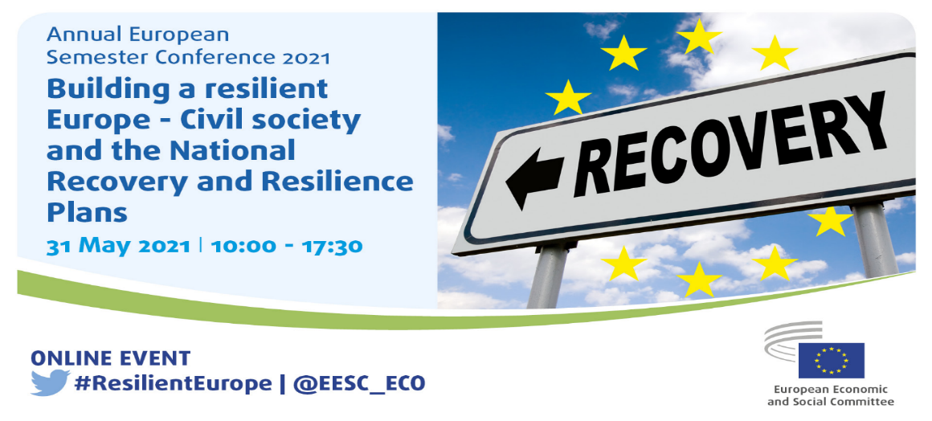

KEY MESSAGES

- Civil society involvement in the drafting processes for the National Recovery and Resilience Plans (NRRPs) is still far from sufficient in most Member States.

In broad terms, the follow-up exercise conducted in April-May confirmed the results of the survey undertaken in January-February this year, which led to the adoption of a Resolution in February on the involvement of organised civil society in the NRRPs. The general trend is that organised civil society has been informed and in many cases heard, but with only few tangible results. In a majority of the Member States, there have been no effective consultations leading to significant modifications to the initial government proposals. This is often ascribed to a lack of time for the process. A few possible exceptions where progress has been observed are Poland and – to a lesser extent – Bulgaria, Italy, Estonia and Latvia.
- The EESC calls for the real involvement of organised civil society in the implementation phase of the NRRPs.

When it comes to the implementation phase, the Member States should ensure that there is real civil society participation in the investment programmes and reform processes included in the national plans. For its part, the Commission should follow up on Article 18(4)(q) of the Recovery and Resilience Facility Regulation and ensure that it is being properly implemented in the Member States. Civil society participation in the implementation of the NRRPs will be particularly important in the following areas:
- Reform processes and investment projects related to the European Green Deal, its 2050 climate neutrality target and the interim 2030 target.
- The green and digital just transitions.
- Monitoring of the implementation of investment programmes and projects and their control systems to ensure the efficient and transparent use of funds and prevent corruption and the misuse of funds.
- Making investment programmes and projects at local level a reality through the creation of participatory structures with local and regional authorities, national authorities responsible for investment programmes and projects, the social partners and civil society organisations.
- Reform of key public services; reducing bureaucracy and red tape; reform of judicial and fiscal systems; digitalisation.
- It is particularly important that other reforms, such as labour and pension reforms, which are included in several national plans, are addressed through a strengthened tripartite social dialogue.

- If the NextGenerationEU recovery instrument is to efficiently contribute to the recovery and resilience of the economies, it is imperative that the funding swiftly reaches the national economies, despite the size of the task. The Committee encourages the Commission to give priority to rolling out rapid funding to Member States that both have the highest need and have submitted solid and feasible plans, respecting the six pillars of the RRF.
- The EESC reaffirms the key role of NextGenerationEU (NGEU) for a green, digital, sustainable and fair transition.
The EESC acknowledges the key role of the NGEU recovery plan in contributing to the green and digital transition of European economies and societies; at the same time, it underlines the need for a fair transition in which organised civil society has a high level of involvement. Speakers at the conference outlined several paths towards this transition in which the social partners and other civil society organisations, as well as local and regional authorities, have an essential role to play, for instance:
- Establishment of councils or similar structures dedicated to the just, green and digital transitions at national level and at the regional and local levels concerned.
- Development and implementation of education and vocational training plans for the workers concerned and/or the population as a whole.
- Establishment of plans for the creation of new jobs and the reintegration of the workers concerned and specific unemployment protection programmes.
- The EESC proposes the establishment of a binding conditionality principle requiring governments to involve the social partners and other civil society organisations in planning and implementing the National Recovery and Resilience Plans and other instruments under the Multiannual Financial Framework (MFF), on the basis of minimum standards defined at EU level. As consultation is not included in the RRF assessment criteria, its impact is limited and the EESC therefore calls on the Commission to perform a data-based thorough follow-up on the implementation of Article 18(4)(q) of the RRF Regulation.
- In order to strengthen social cohesion – a crucial objective of the NGEU – the EESC stresses the importance of an effective implementation of the European Pillar of Social Rights. The Committee also welcomes the political consensus built around the Plan during the Social Summit in Porto. While supporting the new headline targets on jobs, skills and poverty reduction, the EESC invites the Member States to be ambitious in voluntarily setting their own targets. The EESC also underlines that the Action Plan should be based on concreteness and tangibility, with actions that are measurable and accompanied by monitoring frameworks jointly agreed among relevant stakeholders and seeking alignment with the UN 2030 Agenda and the Sustainable Development Goals.
- The Committee intends to be closely involved in the implementation of the NRRPs and suggests two ways of doing this: at national level, encouraging its members and their organisations to carry on with the collaboration with national civil society organisations and also establish a dialogue with the respective governments and other decision-makers, including the national Economic and Social Councils, and at EU level, the Committee should continue and increase efforts to be associated with the EP and the surveillance system vis-à-vis the Commission.
- In line with the spirit of the Conference on the Future of Europe, the Committee supports the idea of a Citizens' Pillar, encompassing organised civil society and regional and local authorities and any other legitimate stakeholders. This Citizens' Pillar should be given access to governments, public administrations and national parliaments in order to ensure that reform processes are properly monitored and legitimate.
_____________

