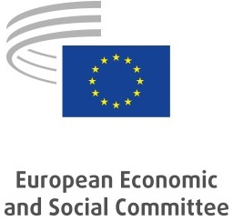 |  | 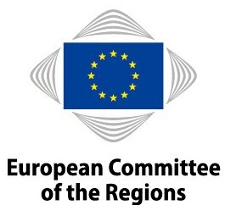
Environmental policy of
the European Economic and Social Committee and the European Committee of the Regions
In view of the EU's commitment to the environment, the European Economic and Social Committee (EESC) and the European Committee of the Regions (CoR) have undertaken to implement an environmental management system complying with the requirements of the EMAS regulation.
The environmental management system has the support of the EMAS Steering Committee and in particular the secretaries-general, as guarantors that their strategic, organisational and management activities will take environmental aspects into account.
The environmental commitment must translate into specific measures backed by the requisite human, material and financial resources.
In general, the environmental management system must enable the following:
- compliance with environmental legislation applicable to the premises covered by the system;
- prevention of pollution;
- ongoing improvements in the environmental impact of the EESC's and CoR's activities;
- active engagement and participation of all staff.
More specifically, the Committees' environmental management system must meet the following commitments:
- reducing our gas, electricity and water consumption;
- encouraging reasonable and responsible use of paper;
- encouraging sustainable public procurement in our procedures;
- reducing the use of plastics in our activities;
- encouraging sustainable and seasonal food, and fighting against food waste, including by donating food;
- greening and making events more sustainable;
- reducing the amount of waste produced and sorting it more effectively;
- reducing greenhouse gas emissions resulting from administrative operations and activities;
- promoting sustainable mobility among staff in daily commuting;
- encouraging urban biodiversity;
- informing staff and members and raising their awareness; encouraging staff to participate in the implementation of the environmental management system. Awareness-raising may also take the form of participation in regional or international initiatives.
Meeting these commitments is the responsibility of all EESC and CoR management and staff members, and they are coordinated by the operational service, EMAS. EESC and CoR members, staff members, contractors and any stakeholder or third party concerned will be informed of this environmental policy.
Brussels,
European Economic and Social Committee |  |  | European Committee of the Regions
Christa Schweng  President | Gianluca Brunetti  Secretary-General |  | Vasco Alves Cordeiro  President | Petr Blížkovský  Secretary-General

