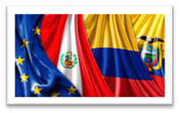

Multi-Party Free Trade Agreement between the EU, Colombia, Peru and Ecuador
Trade and Sustainable Development

Meeting of the Domestic Advisory Groups / National Mechanisms for civil society consultation
22 October 2019
9:30 - 18:30

NH Collection WTC Royal
Bogota, Colombia

Draft Programme

- Opening words
- Presentation of the topic - Business sector (to be specified)

- Presentation of the topic - Trade unions sector (to be specified)

- Presentation of the topic - Sector of NGOs / environmental organizations (to be specified)

- Debate

- Conclusions of the debate

- Discussion with TSD Authorities' representatives

- Any other business

